|  |  |  |
| --- | --- | --- |
| Initial Version of reserve level Declaration Guidelines | | |
|  | | |
| Report and determination | | |
| Published: 20 December 2017 |  |  |

Notice of Determination – initial version of reserve level Declaration Guidelines

**National Electricity Rules – Rule 11.103.2**

Date of Notice: 20 December 2017

This notice informs all Registered Participants and interested parties that AEMO has completed its consultation to develop the Reserve Level Declaration Guidelines. This first version of the Guidelines has been developed in accordance with clause 11.103.2 of the National Electricity Rules (NER).

Determination and Publication

AEMO’s final determination is to make the initial version of the Reserve Level Declaration Guidelines in the form published on the AEMO website at: https://www.aemo.com.au/Stakeholder-Consultation/Consultations/Consultation-on-initial-version-of-Reserve-Level-Declaration-Guidelines

© 2017 Australian Energy Market Operator Limited. The material in this publication may be used in accordance with the [copyright permissions on AEMO’s website](http://aemo.com.au/Privacy_and_Legal_Notices/Copyright_Permissions_Notice).

Executive Summary

AEMO has consulted on the development of the initial Reserve Level Declaration Guidelines (Guidelines), which AEMO is required to publish by 9 January 2018 under clause 11.103.2 of the NER.

No consultation requirements are specified in the NER for the first version of the Guidelines. However, AEMO released a draft of the initial Guidelines for consultation and invited submissions from interested stakeholders. Those submissions have been considered and AEMO’s responses are set out in   
this report.

Two submissions were received. In response to these submissions AEMO has:

* Altered the proposed formula used to calculate the LOR1 level in the Guidelines.
* Provided additional information in the Guidelines on the operation of the Bayesian Belief Network and assumptions used in the inputs to this process.
* Provided additional information in this report on error distributions for AEMO’s demand   
  and intermittent generation forecasting and forecasts of aggregate scheduled generating   
  unit availability.
* Agreed to consider ongoing publication of the forecast uncertainty measure (FUM) values.
* Set out in the Guidelines principles for the selection of appropriate confidence levels to be used in the determination of FUM.
* Established a process in the Guidelines to provide information to Participants on changes to credible contingency events considered relevant to the setting of the lack of reserve (LOR) levels.
* Set out in the Guidelines the conditions under which AEMO would exercise discretion regarding the declaration of LOR conditions.
* Undertaken to conduct a review of the performance of this process after summer 2017-18.

This report also sets out:

* The process used to select the initial appropriate confidence levels used in the determination of   
  the FUM.
* The initial reasonability limits for FUM values.
* Indicative values of FUM for a range of scenarios.

Contents

Executive Summary 2

1. Stakeholder Consultation Process 5

2. Background 6

2.1 NER requirements 6

2.2 Context for this consultation 6

2.3 Consultation process 6

3. Summary of material Issues 7

4. Discussion of material Issues 8

4.1 How non-scheduled generating units are taken into account 8

4.2 Details and basis for input assumptions 8

4.3 Confidence levels for FUM 9

4.4 Relevant credible contingency events 10

4.5 Alternative calculation of LOR1 11

4.6 Improved explanation of the process 11

4.7 Publication of FUM values 12

4.8 Determination of when to declare conditions 12

4.9 Reasonability limits for FUM values 13

4.10 Future developments 13

5. other Matters 14

5.1 Determination of appropriate confidence levels for FUM 14

5.2 Expected impact of new approach 16

5.3 Error distributions 17

5.4 Initial reasonability limits for FUM values 17

6. Determination 19

Appendix A. Glossary 20

Appendix B. Confidence levels for FUM 21

B.1 New South Wales 21

B.2 Queensland 22

B.3 South Australia 24

B.4 Victoria 25

Appendix C. Typical Error Distributions 27

Tables

Table 1 Consultation steps undertaken by AEMO 5

Table 2 Summary of material issues 7

Table 3 Significant increases in declared forecast conditions relative to current arrangements 16

Table 4 Indicative values of FUM for specific scenarios 16

Table 5 Table title 18

Table 6 Percentage Increase in forecast LOR2 conditions in NSW Region (in the six-year period) 21

Table 7 Increase in number TIs with forecast LOR2 conditions in NSW Region (in the six-year period) 21

Table 8 Percentage Increase in forecast LOR1 conditions in NSW Region (in the six-year period) 22

Table 9 Increase in number TIs with forecast LOR1 conditions in NSW Region (in the six-year period) 22

Table 10 Percentage Increase in forecast LOR2 conditions in Qld Region (in the six-year period) 22

Table 11 Increase in number TIs with forecast LOR2 conditions in Qld Region (in the six-year period) 23

Table 12 Percentage Increase in forecast LOR1 conditions in Qld Region (in the six-year period) 23

Table 13 Increase in number TIs with forecast LOR1 conditions in Qld Region (in the six-year period) 23

Table 14 Percentage Increase in forecast LOR2 conditions in SA Region (in the six-year period) 24

Table 15 Increase in number TIs with forecast LOR2 conditions in SA Region (in the six-year period) 24

Table 16 Percentage Increase in forecast LOR1 conditions in SA Region (in the six-year period) 24

Table 17 Increase in number TIs with forecast LOR1 conditions in SA Region (in the six-year period) 25

Table 18 Percentage Increase in forecast LOR2 conditions in Vic Region (in the six-year period) 25

Table 19 Increase in number TIs with forecast LOR2 conditions in Vic Region (in the six-year period) 25

Table 20 Percentage Increase in forecast LOR1 conditions in Vic Region (in the six-year period) 26

Table 21 Increase in number TIs with forecast LOR1 conditions in Vic Region (in the six-year period) 26

# Stakeholder Consultation Process

AEMO has consulted on the development of the initial Reserve Level Declaration Guidelines (Guidelines), which AEMO is required to publish by 9 January 2018 under clause 11.103.2 of the NER.

No consultation requirements are specified in the NER for the first version of the Guidelines. However, AEMO released a draft of the initial Guidelines for consultation and invited submissions from interested stakeholders. Those submissions have been considered and AEMO’s responses are set out in this report.

Clause 4.8.4(e) of the NER[1] will apply to AEMO’s consultation on subsequent amendments of   
the Guidelines.

The table below sets out the consultation steps undertaken by AEMO for the initial Guidelines.

1. Consultation steps undertaken by AEMO

|  |  |
| --- | --- |
| Deliverable | Date |
| Stakeholder information teleconference (jointly with AEMC) | 5 October 2017 |
| Notice of consultation released | 17 October 2017 |
| Submissions closed | 20 November 2017 [2] |
| Report and Guidelines published | 20 December 2017 |

The publication of this report concludes AEMO’s consultation.

A glossary of terms used in this report is included at Appendix A.

# Background

## NER requirements

The initial version of the Guidelines is to be made by AEMO under clause 11.103.2 of the NER by   
9 January 2018*.* The Guidelines outline how AEMO will implement the requirements of clause 4.8.4A of the NER.

## Context for this consultation

The AEMC has made a Rule that promotes short-term reliability in the NEM. The *National Electricity Amendment (Declaration of lack of reserve conditions) Rule 2017* (Rule) modifies the existing framework for declaration of lack of reserve (LOR) conditions to make the criteria and process more flexible, sophisticated and transparent. The declaration of LORs is a key way for AEMO to inform the market of potential reserve shortfalls in the NEM and to seek a market response in time to avoid the need for direct intervention.

The Rule introduces a more flexible way for AEMO to declare LORs, allowing AEMO to move from the current contingency-based deterministic approach, to one that is probabilistic. This will enable AEMO to take into account all relevant risk factors that could affect reserve levels, to more accurately forecast the risk of involuntary load shedding.

Under this Rule, AEMO is required to make and publish guidelines as to how AEMO will determine LORs. These reserve level declaration guidelines are required to:

* Describe how AEMO continually assesses the probability of capacity reserves to be insufficient to avoid involuntary load shedding given reasonably foreseeable conditions and events.
* Describe how this probability assessment applies in relation to different periods of time.
* Specify at least three probability levels at which AEMO will declare lack of reserve conditions.

## Consultation process

AEMO is not required to consult in the making of the initial Guidelines, but chose to follow the abbreviated consultation process set out in clause 4.8.4A(e), as far as practical, in developing the   
initial version.

AEMO issued a Notice of Consultation on 17 October 2017 along with a first draft of the initial Guidelines. The closing date was initially set as 14 November 2017, but was subsequently extended   
to 20 November 2017. AEMO received two submissions, which have been published on the   
AEMO website.

# Summary of material Issues

The key material issues arising from the submissions and AEMO’s continuing data analysis and process development were as follows.

1. Summary of material issues

|  |  |  |
| --- | --- | --- |
| No. | Issue | Raised by |
|  | How non-scheduled generating units are taken into account in the process | ERM Power |
|  | Details of input assumptions and basis upon which input assumptions have been derived | ERM Power |
|  | Updating details of input data used for Bayesian Belief Network (BBN) for training and sensitivity analysis | AEMO |
|  | Additional analysis and examples of error distribution | AEMO |
|  | Confidence levels chosen to determine FUM | ERM Power |
|  | Define principles for selection of confidence levels to be used for FUM | AEMO |
|  | Identification of relevant contingency events and notification of changes in contingency size | ERM Power, ENGIE |
|  | Alternative definition of LOR1 | ERM Power |
|  | Explanation of method of calculation for LOR1 and LOR2, and proposed terminology change for LCR and LCR2 | ENGIE |
|  | Improved explanation of forecast uncertainty error methodology | ENGIE |
|  | Publication of FUM values | ERM Power |
|  | Determination of when to declare conditions | ENGIE |
|  | Reasonability checking of FUM values | AEMO |
|  | Confidence level used for FUM to vary between regions and over forecasting horizon | AEMO |
|  | Review of initial Guidelines after summer 2017-18 and continued process improvement | ERM Power |

Sections 4 and 5 of this report discuss these issues in more detail, and outline any changes from the consultation draft of the Guidelines resulting from AEMO’s assessment.

# Discussion of material Issues

## How non-scheduled generating units are taken into account

### Issue summary

ERM Power’s submission expressed the view that not all significant non-scheduled generating units which are included in the operational demand forecast will be included in the LOR calculation process.

### AEMO’s assessment

Under the current forecasting models, all non-scheduled generating units fall into one of two categories:

1. Non-scheduled wind farms and some non-scheduled solar farms which are included in the intermittent generation forecasting process (using the Australian Wind Energy Forecasting System (AWEFS) and Australian Solar Energy Forecasting System (ASEFS)) and so are taken directly into account in this process.
2. Other non-scheduled generating units which are implicitly taken into account in AEMO’s operational demand forecasts process and so are also taken into account in this process.

Thus AEMO considers that all significant non-scheduled generation will be taken into account in the forecasts used for the purposes of determining LOR levels.

### AEMO’s conclusion

No change to the draft Guidelines is required to address this issue.

## Details and basis for input assumptions

### Issue summary

ERM Power proposed that the Guidelines contain a list of input assumptions and a brief statement setting out the basis on which these input assumptions have been derived. In addition, ERM Power raised two points of detail:

* Will only periods where AEMO under forecast actual demand conditions be used or will periods where demand was both under and over forecast?
* ERM would be interested in AEMO publishing input assumption data indicating the probability of both under and over forecasting by AEMO systems. ERM had a concern that if there was a strong over forecasting bias in historic data for demand forecasts then this could result in an over estimation of errors which have negative implications. ERM also had a similar concern regarding any historic bias to under forecast intermittent generation.

### AEMO’s assessment

AEMO is already intending to update details of input data to the BBN and considers that this will address ERM’s principal concern.

As regards periods of under- and over- forecasting, the historic forecasts used to educate the BBN include both under- and over-forecasting.

As regards ERM Power’s concern that a strong over forecasting bias in historic data for demand forecasts might result in an over estimation of errors with negative implications, it should be noted that:

* The process is based on assessment of historic performance in reserve forecasting and assumes that this same performance will continue to apply in the immediate future.
* Any subsequent improvements in forecasting performance would tend to result in reduced FUM values when the quarterly retraining occurs.
* There would be necessarily some lag in the correction process.

In response to ERM Power’s request for publication of data indicating the probability of under and over forecasting by AEMO systems, AEMO will publish examples of the historic probability distributions of demand, intermittent generation and generator availability for each region for a number of forecasting horizons in this report.

### AEMO’s conclusion

The Guidelines will include additional details of input data for the BBN and the associated assumptions.

AEMO considers the current approach adequately addresses concerns about periods of over and under forecasting, and accordingly no further changes are required.

For stakeholder information, AEMO has provided examples of error distributions in Appendix C of   
this report.

## Confidence levels for FUM

### Issue summary

In the consultation draft of the Guidelines, AEMO suggested that the confidence level chosen for the FUM would be a single level for all regions and forecasting timeframes. The draft did not include details of how this confidence level would be chosen.

ERM Power expressed concern regarding the initial draft proposal to use a 97% confidence level for all forecasting timeframes. ERM proposed for consideration a confidence level which reduces with increasing forecasting horizons – from 97% for six hours or less to 90% for twenty four hours or more.

### AEMO’s assessment

AEMO noted that the 97% confidence level proposed in the draft Guidelines was preliminary and subject to ongoing analysis. AEMO is also cognisant of the need to establish clear principles for the selection of appropriate confidence levels to be used in the determination of FUM.

It has now become clear from further analysis that the application of these principles will require the confidence level chosen to vary between forecasting horizons, as ERM suggests, and potentially between NEM regions.

### AEMO’s conclusion

AEMO has included the principles used for selection of the confidence levels in the Guidelines.   
Section 5 of this report details how the initial choice of confidence levels has been made. These initial confidence levels are recorded in the Guidelines for each NEM region and forecasting horizon, and will be subject to regular review (at least annually)[3] in accordance with the specified principles. As with all amendments to the Guidelines, changes to the confidence levels will only be made following the consultation process set out in clause 4.8.4A (e) of the NER.

## Relevant credible contingency events

### Issue summary

In its submission ERM said the Guidelines should require AEMO to issue a market notice when the size of the standard or normal credible contingency event used to determine LCR or LCR2 is altered or reverted to for any region.

ENGIE stated that AEMO should define the term “relevant contingency events “used in section 4 of the draft Guidelines.

ENGIE requested that the method of updating the list of relevant contingency events be specified in the Guidelines. ENGIE expressed a preference that the list be updated dynamically.

ENGIE also suggested that the terminology currently proposed for these events (LCR and LCR2) was confusing and should be replaced by SCR (single credible contingency) and DCR (double credible contingency) respectively. ENGIE also pointed out that an undefined term ‘LCR1’ is used in section 5.2 of the draft Guidelines.

### AEMO’s assessment

The LCR and LCR2 values are determined based on system conditions according to the principles set out in the document *Lack of Reserve Contingency List*, which will be published with the Guidelines. The actual values of LCR and LCR2 will change automatically with changes in system conditions, making it impractical to publish market notices each time. Cases where these automatic values need to be overridden by manual entries are discussed in more detail below.

As regards the definition of “relevant contingency events” raised by ENGIE, AEMO considers that this will be sufficiently defined through the publication of the contingency list. AEMO agrees that the process for updating of the contingency list needs to be defined.

Most situations where unusual values of LCR and LCR2 will be used will be temporary changes resulting from:

* Reclassification of a non-credible contingency event as credible. In these cases the market is always advised by a market notice under existing NER requirements.
* Unusual temporary operating conditions[4] resulting in a situation which was not anticipated. It would be appropriate for AEMO to issue a market notice where these circumstances require manual specification of LCR and LCR2 levels.

Permanent changes to the contingency list would occur only if a new class of contingencies was added to the list. The Guideline will need to include a process to be followed in making such changes. Such permanent changes are expected to occur infrequently, although the list will change on completion of AEMO’s current Short Term Projected Assessment of System Adequacy (ST PASA) Solver redevelopment project.

For the above reasons, AEMO believes that dynamic updates of the contingency events that are determining LCR and LCR2 cannot currently be justified. AEMO is willing to reconsider this in the future based upon operating experience.

AEMO notes that the terms LCR and LCR2 are similar to LOR terms, but at this stage of development these terms cannot be changed in AEMO’s systems. AEMO may be able to accommodate terminology changes as suggested by ENGIE in a future release.

### AEMO’s conclusion

The Guidelines will require AEMO to issue a market notice to alert the market when the automatically calculated values of LCR and LCR2 have been manually overridden, where the market has not otherwise been notified of a reclassification.

AEMO will specify in the Guidelines the circumstances under which the contingency list will be updated and how this change will be advised to the market.

The initial contingency list will set out two stages

1. The list applicable from 16 January until the new PASA Solver is implemented
2. The list applicable after the new PASA Solver is implemented.

## Alternative calculation of LOR1

### Issue summary

ERM Power proposed an alternative definition of LOR1 as follows:

**LOR1 = Max (FUM, LCR2)**

ERM Power was concerned that the formulation in the draft Guidelines would mean that the LOR1 level is increased whenever FUM exceeds the LCR. ERM Power believes that this will result in double counting for the same level of capacity reserves already allowed for by the addition of the value for the second largest contingency reserve.

### AEMO’s assessment

AEMO accepts the reasoning behind ERM Power’s proposal. However it has the disadvantage, as acknowledged by ERM Power, that there will be no difference between the LOR1 and LOR2 levels under some circumstances. As these circumstances will only emerge at times of very high forecast uncertainty and can be expected to be rare, AEMO believes this disadvantage is outweighed by the benefits of the proposal.

AEMO also considered whether the ERM proposal will remain consistent with the principle expressed in the Rule that the LOR1, LOR2 and LOR3 probability levels should indicate an increasing probability of involuntary load shedding. The LOR1 definition will retain the essential element of two credible contingency events, so that inherently LOR2 represents a higher probability of load shedding because it allows for one less credible contingency to occur. This remains the case notwithstanding that other elements of the determination are the same at both levels, and therefore in some cases the same value could be produced.

AEMO believes that on balance the proposal by ERM Power is superior to the LOR1 formula in the draft Guidelines, and remains consistent with the NER.

### AEMO’s conclusion

AEMO will adopt the formula for LOR1 proposed by ERM Power in the final Guidelines.

## Improved explanation of the process

### Issue summary

ENGIE suggested that the graph in Appendix B should be moved to Section 2 to improve the clarity of the explanation of how the LOR levels are calculated.

ENGIE also indicated that the explanations in Appendix A of the *Guidelines* on how the process operates are inadequate and more detail is required, including worked examples for specific scenarios.

### AEMO’s assessment

AEMO accepts ENGIE’s feedback on the need to improve the explanation of the process.

### AEMO’s conclusion

AEMO will amend section 2 and expand Appendix A of the Guidelinesas suggested by ENGIE.

## Publication of FUM values

### Issue summary

In the interests of transparency, ERM Power urged AEMO to publish the FUM as a standalone value.

### AEMO’s assessment

AEMO has proposed only to publish the LOR1 and LOR2 values at present, to avoid late changes to the main data structure due to its impact on market participant systems. However, there a number of alternative options to address the issue of transparency raised by ERM:

* FUM, LCR and LCR2 values could be automatically published on the AEMO website through a separate process.
* These values could be incorporated into the data model in the future.
* These values could be provided to a Participant in response to a special request.

### AEMO’s conclusion

AEMO will undertake an IT impact study to examine the feasibility of publishing the values of FUM, LCR and LCR2 on its website from the first quarter of 2018, and will consider the feasibility of incorporating the values in a future release of the data model. No changes will be made to the initial version of   
the Guidelines.

## Determination of when to declare conditions

### Issue summary

Section 5 of the Guidelines states that “AEMO will declare LOR Conditions when it determines there is a non-remote probability of load shedding”. ENGIE considers that section 5 then proceeds to define the LOR thresholds to be applied in a deterministic manner with no apparent reliance on subjective assessment. ENGIE therefore questions the use of the above phrase.

### AEMO’s assessment

A key requirement for the Guidelines is to set out how AEMO determines the LOR levels which in turn define whether the probability of load shedding is more than remote. Although the Guidelines do set out a process to define thresholds in a deterministic manner, AEMO is still required to apply these processes in order to determine when a declaration is to be made. There is also an element of subjective assessment. Some discretion is necessary to avoid unnecessary declarations when   
there are:

* Clearly incorrect PASA results due to software failures or network constraint equation issues.
* Situations where the forecast reserves are below the calculated level but it is clear that this is only a temporary situation and does not represent an ongoing threat to reliability.

### AEMO’s conclusion

AEMO has included details in section 5 of the Guidelines on how it would exercise its discretion in such instances and how this will be communicated to the market.

## Reasonability limits for FUM values

### Issue summary

AEMO proposes to include details in the Guidelines of how it will check FUM values to confirm they are within reasonable parameters.

### AEMO’s assessment

In the interests of transparency, AEMO believes that the Guidelines need to establish the principles that AEMO will adopt in determining ‘reasonability limits’ for checking FUM values. The Guidelines will make clear that the specific limits will be set so as to identify any unrealistic LOR levels that may result from mal-operation of the system. It is not considered appropriate to specify the reasonability limits in the Guidelines, because they should be constantly reviewed and refined as necessary to adjust to changing conditions and learnings from system operation and development. The details of the reasonability limits initially chosen are provided in Section 5.4 of this report. The purpose of reasonability limits is not to alter the desired outcomes of the process, but rather to better ensure that desired outcomes   
are achieved.

### AEMO’s conclusion

The Guidelines include a requirement for AEMO to set appropriate limits to check the reasonableness of FUM values, and state the objective that reasonability limits should be designed to achieve.

## Future developments

### Issue summary

ERM Power suggested that a review of the initial Guidelines be commenced in April 2018 so as to take into account learnings from summer 2017–18.

ERM Power was of the view that introduction of the FUM should not be seen as an improvement to forecasting processes but rather a “Band-Aid” pending undergoing improvements to the performance of AEMO’s forecasting systems.

### AEMO’s assessment

AEMO agrees that a review commencing as soon as practicable after the end of March 2018 would be appropriate, allowing a review of the operation of the new process over the coming summer period. AEMO also agrees that the introduction of this process is not a substitute for continuous improvement of AEMO’s forecasting systems and processes.

### AEMO’s conclusion

AEMO proposes to commence a review of the Guidelinesin April or May 2018, and any proposed changes will be subject to consultationin accordance with clause 4.8.4(e) of the NER. AEMO will continue with initiatives to improve the performance of its forecasting processes.

# other Matters

## Determination of appropriate confidence levels for FUM

### Description of process

The appropriate confidence level used for the forecast uncertainty measure (FUM) used in determining LOR conditions needs to achieve a balance between:

* Reducing the chance of a situation where load shedding arises due to lack of action by AEMO as a result of reserve forecasting error.
* Increasing the likelihood of unnecessary declarations due to an overly conservative   
  confidence level.

#### Relative frequency of LOR2 declarations in each region except Tasmania

The process used for this is as follows:

1. For the same confidence level for FUM, region and forecasting horizon, estimate the LOR2 level for each trading interval (TI) in the six year period ending 1 August 2017.
2. Determine number of TIs that forecast reserve value is less than this LOR2 value (i.e. LOR2 condition assumed declared for that TI).
3. Repeat the analysis for the same set of PASA Runs but this time with FUM set to zero (i.e. the current arrangement where LOR2 levels are determined solely by the contingency risks).

This process does not aim to forecast the number of LOR2 declarations in the future, but rather to provide an indication of sensitivity of the number of declarations to changes in the confidence level.

#### Relative frequency of LOR1 declarations in each Region except Tasmania

The process used for this is as follows:

1. For the same confidence level for FUM, region and forecasting horizon, estimate the LOR1 level for each TI in the six year period ending 1 August 2017.
2. Determine number of TIs that forecast reserve value is less than this LOR1 value (i.e. LOR1 condition assumed declared for that TI).
3. Repeat the analysis for the same set of PASA Runs but this time with FUM set to zero (i.e. the current arrangement where LOR1 levels are determined solely by the contingency risks).

The process does not aim to forecast the number of LOR1 declarations in the future, but rather to provide an indication of sensitivity of the number of declarations to changes in the confidence level.

The analysis above was undertaken for all regions except Tasmania for the following conditions:

* FUM based upon 94 % Confidence level
* FUM based upon 95 % Confidence level
* FUM based upon 96 % Confidence level
* FUM based upon 97 % Confidence level
* FUM based upon 98 % Confidence level

and for the following forecasting horizons:

* 2 hours ahead
* 6 hours ahead
* 9 hours ahead
* 12 hours ahead
* 24 hours ahead
* 48 hours ahead
* 72 hours ahead.

This study is based on the following assumptions:

* Use of recent past history is adequate for the limited purpose of this analysis which is to assess the sensitivity of LOR conditions to the choice of the confidence level for FUM.
* LCR and LCR2 values are assumed to be as per normal current practice.

In the case of the Tasmanian region, this approach was not feasible for the following reasons:

* The level of capacity reserves in Tasmania are usually relatively high and lack of reserve conditions are very rare.
* The LCR level is usually also relatively high and is expected to be, under most conditions, in excess of FUM values meaning that the LOR levels will be largely determined by the values of LCR and LCR2.

For these reasons it has been decided to initially set the confidence levels for FUM values in the Tasmanian region at the same levels selected for the other regions.

### Results

The results of this process are presented in Appendix B for each region except Tasmania and each of the forecast horizons specified above.

In each case the appropriate confidence level was chosen by increasing the confidence level, if this reduced risk, until a point is reached where there is a significant rise in the number of trading intervals for which there are LOR2 or LOR1 conditions.

In this context, “significant” means

* For forecasting horizons of 24hrs ahead or less, greater than 50% increase from FUM=0 case except where increase is less than:
  + For LOR1 conditions, 96 extra TIs over the six year period.
  + For LOR2 conditions, 48 extra TIs over the six year period.
* For forecasting horizons of more than 24 hrs ahead, greater than 100% increase from FUM=0 case, except where increase is less than:
  + For LOR1 conditions, 288 extra TIs over the six year period.
  + For LOR2 conditions, 288 extra TIs over the six year period.

Chosen confidence levels were then adjusted so that they decrease monotonically with increasing forecast horizon.

Finally, confidence levels were adjusted to be uniform across all regions for the same forecasting horizon without materially breaching the other criteria.

The adoption of these criteria means there will be a material increase in the number of declared forecast conditions for longer forecasting horizons. AEMO believes this is appropriate, because it reflects the significantly increased levels of forecast uncertainty for these longer forecasting horizons. The study results suggests that the significant increases in declared forecast conditions are likely to be of the following order.

1. Significant increases in declared forecast conditions relative to current arrangements

|  |  |  |
| --- | --- | --- |
| Region | Forecasting horizon (hrs) | Increased number of TIs with declared condition (per annum) |
| NSW | 24 | LOR2  increase by ~ 6 TIs |
| NSW | 48 | LOR2  increase by ~ 15 TIs |
| NSW | 72 | LOR2  increase by ~ 16 TIs |
| SA | 12 | LOR2  increase by ~  5 TIs |
| SA | 48 | LOR2  increase by ~  43 TIs |
| SA | 72 | LOR2  increase by ~   51 TIs |
| Vic | 72 | LOR2  increase by ~  5 TIs |

It should be noted that a declaration of a forecast LOR2 condition does not necessarily mean immediate intervention by AEMO, particularly for longer forecasting horizons. Once such a declaration is made, where time allows AEMO will first seek a market response before considering intervention.

The adjustment of the chosen confidence levels to ensure monotonic variation was included to reduce risk of fluctuations of LOR levels as forecasting horizon reduces.

The adjustment to achieve consistent confidence levels for all regions, subject to substantially meeting the other criteria, was included on the basis that the tolerance for risk should be consistent across the entire NEM.

For forecasting horizons other than those specifically analysed, the appropriate confidence level was chosen by extrapolating between the confidence levels chosen for the specific forecasting horizon studied in this analysis.

The final selection for each forecasting horizon up to 72 hours ahead is recorded in the Guidelines.

## Expected impact of new approach

The following table provides indications of the likely FUM values for a range of scenarios.

1. Indicative values of FUM for specific scenarios

|  |  |  |  |
| --- | --- | --- | --- |
| Region | Scenario | Hours-ahead | Approximate FUM value (MW) |
| South Australia | Hot temperatures (>35 degrees C), high wind (>1000MW) | 6 | 900 |
|  |  | 24 | 496 |
|  | Hot temperatures (>35 degrees C), low wind (<300MW) | 6 | 434 |
|  |  | 24 | 383 |
| Victoria | Hot temperatures (>31 degrees C), high wind (>800MW) | 6 | 1,750 |
|  |  | 24 | 1,192 |
|  | Hot temperatures (>31 degrees), low wind (<200MW) | 6 | 1,750 |
|  |  | 24 | 953 |
|  | Cold temperatures (<13 degrees C), high wind (>800MW) | 6 | 845 |
|  |  | 24 | 993 |
|  | Cold temperatures (<13 degrees C), low wind (<200MW) | 6 | 667 |
|  |  | 24 | 795 |
| NSW | Hot temperatures (>31 degrees), high wind (>500MW) | 6 | 2500 |
|  |  | 24 | 1,368 |
|  | Hot temperatures (>31 degrees C), low wind (<100MW) | 6 | 2,500 |
|  |  | 24 | 1,235 |
|  | Cold temperatures (<17 degrees), high wind (>500MW) | 6 | 1,011 |
|  |  | 24 | 1,574 |
|  | Cold temperatures (<17 degrees), low wind (<100MW) | 6 | 939 |
|  |  | 24 | 1,132 |
| Tasmania | Cold temperatures (<12 degrees C), high wind (>250MW) | 6 | 400 |
|  |  | 24 | 250 |
|  | Cold temperatures (<12 degrees C), low wind (<100MW) | 6 | 140 |
|  |  | 24 | 143 |
| Queensland | Hot temperatures (>31 degrees) | 6 | 859 |
|  |  | 24 | 920 |
|  | Cold temperatures (<20 degrees) | 6 | 652 |
|  |  | 24 | 746 |

Note: 6hr ahead FUM values are based on 98% CI, and 24hr ahead values are based on 95% CI.

## Error distributions

Typical error distributions for demand forecasting, intermittent generation forecasting and availability of scheduled generating units are set out in Appendix C.

## Initial reasonability limits for FUM values

The initial reasonability limits for FUM values have been chosen as follows based upon examination of the distribution of FUM values from the initial training of the BBN using data over a six year period ending 1 August 2017.

1. Initial reasonability limits for FUM values

|  |  |  |
| --- | --- | --- |
| Region | Upper Reasonability Limit for FUM (MW) | Lower Reasonability Limit for FUM (MW) |
| NSW | 2500 | 0 |
| Queensland | 1500 | 0 |
| South Australia | 900 | 0 |
| Tasmania | 400 | 0 |
| Victoria | 1750 | 0 |

These are initial values only and will be adjusted by AEMO as necessary.

# Determination

Having considered the matters raised in submissions and the additional matters described in this report, AEMO’s determination is to make the initial version of the **Reserve Level Declaration Guidelines** in accordance with clause 11.103.2 of the NER in the form published with this report on AEMO’s website. An associated initial **Lack of Reserve Credible Contingency List** has also been determined and will be published alongside the Guidelines.

1. Glossary

This document uses many terms that have meanings defined in the NER. The NER meanings are adopted unless otherwise specified. Other defined terms and acronyms are set out in the table below.

|  |  |
| --- | --- |
| Term | Definition |
| AEMC | Australian Energy Market Commission |
| AEMO | Australian Energy Market Operator Limited |
| AWEFS | Australian Wind Energy Forecasting System |
| ASEFS | Australian Solar Energy Forecasting System |
| BBN | Bayesian Belief Network |
| FUM | Forecast uncertainty measure |
| Guidelines | Reserve Level Declaration Guidelines |
| LCR | Largest credible risk – see clause 4 of Guidelines |
| LCR2 | Two largest credible risks – see clause 4 of Guidelines |
| LOR | Lack of reserve (may be followed by a number corresponding with a reserve level defined in the Guidelines) |
| LOR assessment horizon | The period of time described in clause 2 of the Guidelines |
| LOR Load Shedding | The reduction or disconnection or reduction of load (other than interruptible load). |
| LOR1 threshold | The level of capacity reserves below which AEMO may declare an LOR1 condition – see clause 2(d) of the Guidelines |
| LOR2 threshold | The level of capacity reserves below which AEMO may declare an LOR2 condition – see clause 2(c) of the Guidelines |
| MW | Megawatts |
| MWh | Megawatt hours |
| NEM | National Electricity Market |
| NER | National Electricity Rules |
| Operational Demand | A quantity (in MW) determined by AEMO representing the instantaneous demand of load (other than scheduled load) to be supplied by sent out generation of scheduled generating units, semi-scheduled generating units, and significant non-scheduled generating units. For further information about demand definitions see “AEMO Operational Demand Definition – Summary Document” |
| Rule | National Electricity Amendment (Declaration of lack of reserve conditions) Rule 2017, |
| RXS | Regional excess supply |
| RXS error | The expected difference between forecast RXS and actual RXS (see clause 3.2 of the Guidelines |
| STPASA | Short-term PASA |
| TI | Trading interval |

1. Confidence levels for FUM

The results of the process set out in Section 5.1 are set out below for each region except Tasmania. The confidence levels chosen for each forecasting horizon are highlighted in yellow.

The results are presented in the form of the two metrics which are used in the selection criteria (refer Section 5.1.2 ) namely:

* Percentage Increase = ((A/B) -1 )*100 %
* Increase in number of TIs = A – B

where

A = Number of TIs for which the LOR condition is forecast for FUM with given confidence level.

B = Number of TIs for which the LOR condition is forecast for FUM set to zero for the same set of PASA Runs as used in calculating A.

In the tables below for percentage increase, the term “NA” means that a value cannot be calculated because the value of B is zero.

It should be noted that some of the percentage increases are very large due to very low values of B.

* 1. New South Wales

1. Percentage Increase in forecast LOR2 conditions in NSW Region (in the six-year period)

|  |  |  |  |  |  |  |
| --- | --- | --- | --- | --- | --- | --- |
| Forecasting horizon (hrs) | FUM with CI_94 | FUM with CI_95 | FUM with CI_96 | FUM with CI_97 | FUM with CI_98 | FUM with CI_99 |
| 2 | 0% | 0% | 0% | 0% | 6% | 688% |
| 6 | 200% | 200% | 200% | 250% | 250% | 2,800% |
| 9 | 150% | 267% | 100% | 100% | 100% | 1,920% |
| 12 | 267% | 500% | 500% | 500% | 500% | 3,475% |
| 24 | 357% | 514% | 813% | 853% | 853% | 2,354% |
| 48 | NA | 2,200% | 3,400% | 3,500% | 5,900% | 12,200% |
| 72 | NA | NA | NA | NA | NA | NA |

1. Increase in number TIs with forecast LOR2 conditions in NSW Region (in the six-year period)

|  |  |  |  |  |  |  |
| --- | --- | --- | --- | --- | --- | --- |
| Forecasting horizon (hrs) | FUM with CI_94 | FUM with CI_95 | FUM with CI_96 | FUM with CI_97 | FUM with CI_98 | FUM with CI_99 |
| 2 | 0 | 0 | 0 | 0 | 1 | 117 |
| 6 | 4 | 4 | 4 | 5 | 5 | 168 |
| 9 | 3 | 8 | 6 | 6 | 6 | 192 |
| 12 | 8 | 15 | 15 | 15 | 15 | 278 |
| 24 | 25 | 36 | 65 | 128 | 128 | 565 |
| 48 | 72 | 88 | 136 | 140 | 236 | 488 |
| 72 | 96 | 96 | 212 | 252 | 316 | 676 |

1. Percentage Increase in forecast LOR1 conditions in NSW Region (in the six-year period)

|  |  |  |  |  |  |  |
| --- | --- | --- | --- | --- | --- | --- |
| Forecasting horizon (hrs) | FUM with CI_94 | FUM with CI_95 | FUM with CI_96 | FUM with CI_97 | FUM with CI_98 | FUM with CI_99 |
| 2 | 0% | 0% | 0% | 0% | 0% | 145% |
| 6 | 0% | 0% | 0% | 0% | 0% | 563% |
| 9 | 5% | 3% | 6% | 6% | 6% | 308% |
| 12 | 5% | 16% | 16% | 11% | 11% | 312% |
| 24 | 9% | 20% | 23% | 64% | 64% | 270% |
| 48 | 64% | 53% | 67% | 71% | 186% | 486% |
| 72 | 85% | 85% | 212% | 271% | 365% | 894% |

1. Increase in number TIs with forecast LOR1 conditions in NSW Region (in the six-year period)

|  |  |  |  |  |  |  |
| --- | --- | --- | --- | --- | --- | --- |
| Forecasting horizon (hrs) | FUM with CI_94 | FUM with CI_95 | FUM with CI_96 | FUM with CI_97 | FUM with CI_98 | FUM with CI_99 |
| 2 | 0 | 0 | 0 | 0 | 0 | 103 |
| 6 | 0 | 0 | 0 | 0 | 0 | 152 |
| 9 | 1 | 1 | 2 | 2 | 2 | 163 |
| 12 | 2 | 8 | 8 | 6 | 6 | 234 |
| 24 | 5 | 14 | 22 | 67 | 67 | 432 |
| 48 | 28 | 32 | 56 | 60 | 156 | 408 |
| 72 | 44 | 44 | 144 | 184 | 248 | 608 |

* 1. Queensland

1. Percentage Increase in forecast LOR2 conditions in Qld Region (in the six-year period)

|  |  |  |  |  |  |  |
| --- | --- | --- | --- | --- | --- | --- |
| Forecasting horizon (hrs) | FUM with CI_94 | FUM with CI_95 | FUM with CI_96 | FUM with CI_97 | FUM with CI_98 | FUM with CI_99 |
| 2 | 0% | 0% | 0% | 0% | 0% | 0% |
| 6 | 0% | 0% | 0% | 0% | 0% | 600% |
| 9 | 0% | 0% | 0% | 0% | 0% | 2700% |
| 12 | 0% | 0% | 0% | 0% | 0% | 6000% |
| 24 | 0% | 25% | 25% | 25% | 125% | 925% |
| 48 | 100% | 100% | 200% | 200% | 300% | 2900% |
| 72 | 200% | 300% | 300% | 700% | 1200% | 4800% |

1. Increase in number TIs with forecast LOR2 conditions in Qld Region (in the six-year period)

|  |  |  |  |  |  |  |
| --- | --- | --- | --- | --- | --- | --- |
| Forecasting horizon (hrs) | FUM with CI_94 | FUM with CI_95 | FUM with CI_96 | FUM with CI_97 | FUM with CI_98 | FUM with CI_99 |
| 2 | 0 | 0 | 0 | 0 | 0 | 0 |
| 6 | 0 | 0 | 0 | 0 | 0 | 6 |
| 9 | 0 | 0 | 0 | 0 | 0 | 27 |
| 12 | 0 | 0 | 0 | 0 | 0 | 60 |
| 24 | 0 | 1 | 1 | 1 | 5 | 37 |
| 48 | 4 | 4 | 8 | 8 | 12 | 116 |
| 72 | 8 | 12 | 12 | 28 | 48 | 192 |

1. Percentage Increase in forecast LOR1 conditions in Qld Region (in the six-year period)

|  |  |  |  |  |  |  |
| --- | --- | --- | --- | --- | --- | --- |
| Forecasting horizon (hrs) | FUM with CI_94 | FUM with CI_95 | FUM with CI_96 | FUM with CI_97 | FUM with CI_98 | FUM with CI_99 |
| 2 | 0% | 0% | 0% | 0% | 0% | 0% |
| 6 | 0% | 0% | 0% | 0% | 0% | 21% |
| 9 | 0% | 0% | 0% | 0% | 0% | 23% |
| 12 | 0% | 0% | 0% | 0% | 0% | 70% |
| 24 | 0% | 0% | 0% | 0% | 0% | 19% |
| 48 | 0% | 0% | 0% | 0% | 0% | 55% |
| 72 | 5% | 5% | 5% | 5% | 5% | 145% |

1. Increase in number TIs with forecast LOR1 conditions in Qld Region (in the six-year period)

|  |  |  |  |  |  |  |  |
| --- | --- | --- | --- | --- | --- | --- | --- |
| Forecasting horizon (hrs) | FUM with CI_94 | | FUM with CI_95 | FUM with CI_96 | FUM with CI_97 | FUM with CI_98 | FUM with CI_99 |
| 2 | 0 | 0 | | 0 | 0 | 0 | 0 |
| 6 | 0 | 0 | | 0 | 0 | 0 | 6 |
| 9 | 0 | 0 | | 0 | 0 | 0 | 11 |
| 12 | 0 | 0 | | 0 | 0 | 0 | 39 |
| 24 | 0 | 0 | | 0 | 0 | 0 | 9 |
| 48 | 0 | 0 | | 0 | 0 | 0 | 44 |
| 72 | 4 | 4 | | 4 | 4 | 4 | 116 |

* 1. South Australia

1. Percentage Increase in forecast LOR2 conditions in SA Region (in the six-year period)

|  |  |  |  |  |  |  |
| --- | --- | --- | --- | --- | --- | --- |
| Forecasting horizon (hrs) | FUM with CI_94 | FUM with CI_95 | FUM with CI_96 | FUM with CI_97 | FUM with CI_98 | FUM with CI_99 |
| 2 | 0% | 0% | 0% | 0% | 0% | 344% |
| 6 | 0% | 0% | 0% | 2% | 2% | 348% |
| 9 | 0% | 0% | 1% | 1% | 13% | 435% |
| 12 | 0% | 0% | 2% | 20% | 47% | 645% |
| 24 | 400% | 267% | 166% | 101% | 238% | 1,421% |
| 48 | NA | NA | 10,000% | 3,300% | 1,450% | 2,725% |
| 72 | 1,083% | 1,283% | 2,386% | 2,255% | 2,032% | 3,804% |

1. Increase in number TIs with forecast LOR2 conditions in SA Region (in the six-year period)

|  |  |  |  |  |  |  |
| --- | --- | --- | --- | --- | --- | --- |
| Forecasting horizon (hrs) | FUM with CI_94 | FUM with CI_95 | FUM with CI_96 | FUM with CI_97 | FUM with CI_98 | FUM with CI_99 |
| 2 | 0 | 0 | 0 | 0 | 0 | 275 |
| 6 | 0 | 0 | 0 | 1 | 1 | 230 |
| 9 | 0 | 0 | 1 | 1 | 9 | 296 |
| 12 | 0 | 0 | 1 | 13 | 31 | 426 |
| 24 | 16 | 24 | 53 | 70 | 169 | 1,009 |
| 48 | 160 | 256 | 400 | 660 | 1,624 | 3,052 |
| 72 | 260 | 308 | 668 | 992 | 2,276 | 4,260 |

1. Percentage Increase in forecast LOR1 conditions in SA Region (in the six-year period)

|  |  |  |  |  |  |  |
| --- | --- | --- | --- | --- | --- | --- |
| Forecasting horizon (hrs) | FUM with CI_94 | FUM with CI_95 | FUM with CI_96 | FUM with CI_97 | FUM with CI_98 | FUM with CI_99 |
| 2 | 0% | 0% | 0% | 0% | 0% | 36% |
| 6 | 0% | 0% | 0% | 0% | 0% | 20% |
| 9 | 0% | 0% | 0% | 0% | 0% | 10% |
| 12 | 0% | 0% | 0% | 0% | 0% | 9% |
| 24 | 0% | 0% | 0% | 0% | 0% | 12% |
| 48 | 3% | 1% | 1% | 1% | 3% | 13% |
| 72 | 5% | 2% | 8% | 10% | 9% | 26% |

1. Increase in number TIs with forecast LOR1 conditions in SA Region (in the six-year period)

|  |  |  |  |  |  |  |
| --- | --- | --- | --- | --- | --- | --- |
| Forecasting horizon (hrs) | FUM with CI_94 | FUM with CI_95 | FUM with CI_96 | FUM with CI_97 | FUM with CI_98 | FUM with CI_99 |
| 2 | 0 | 0 | 0 | 0 | 0 | 218 |
| 6 | 0 | 0 | 0 | 0 | 0 | 172 |
| 9 | 0 | 0 | 0 | 0 | 0 | 176 |
| 12 | 0 | 0 | 0 | 0 | 0 | 199 |
| 24 | 0 | 1 | 0 | 2 | 1 | 392 |
| 48 | 16 | 8 | 16 | 32 | 108 | 548 |
| 72 | 24 | 12 | 92 | 160 | 368 | 1,104 |

This selection satisfies the criteria, except for 72 hrs ahead, where increase in TIs for LOR2 conditions is 308, which is slightly above criteria of 288. However, the difference is marginal and is not   
considered material.

* 1. Victoria

1. Percentage Increase in forecast LOR2 conditions in Vic Region (in the six-year period)

|  |  |  |  |  |  |  |
| --- | --- | --- | --- | --- | --- | --- |
| Forecasting horizon (hrs) | FUM with CI_94 | FUM with CI_95 | FUM with CI_96 | FUM with CI_97 | FUM with CI_98 | FUM with CI_99 |
| 2 | 0% | 0% | 0% | 0% | 0% | 71% |
| 6 | 8% | 7% | 7% | 7% | 13% | 120% |
| 9 | 0% | 0% | 0% | 0% | 21% | 93% |
| 12 | 0% | 8% | 8% | 33% | 42% | 150% |
| 24 | 86% | 89% | 111% | 133% | 167% | 444% |
| 48 | NA | NA | 300% | 550% | 650% | 1,000% |
| 72 | 200% | 160% | 163% | 163% | 200% | 263% |

1. Increase in number TIs with forecast LOR2 conditions in Vic Region (in the six-year period)

|  |  |  |  |  |  |  |
| --- | --- | --- | --- | --- | --- | --- |
| Forecasting horizon (hrs) | FUM with CI_94 | FUM with CI_95 | FUM with CI_96 | FUM with CI_97 | FUM with CI_98 | FUM with CI_99 |
| 2 | 0 | 0 | 0 | 0 | 0 | 10 |
| 6 | 1 | 1 | 1 | 1 | 2 | 18 |
| 9 | 0 | 0 | 0 | 0 | 3 | 13 |
| 12 | 0 | 1 | 1 | 4 | 5 | 18 |
| 24 | 6 | 8 | 10 | 12 | 15 | 40 |
| 48 | 12 | 16 | 24 | 44 | 52 | 80 |
| 72 | 16 | 32 | 52 | 52 | 64 | 84 |

1. Percentage Increase in forecast LOR1 conditions in Vic Region (in the six-year period)

|  |  |  |  |  |  |  |
| --- | --- | --- | --- | --- | --- | --- |
| Forecasting horizon (hrs) | FUM with CI_94 | FUM with CI_95 | FUM with CI_96 | FUM with CI_97 | FUM with CI_98 | FUM with CI_99 |
| 2 | 0% | 0% | 0% | 0% | 0% | 15% |
| 6 | 0% | 0% | 0% | 0% | 0% | 26% |
| 9 | 0% | 0% | 0% | 0% | 0% | 23% |
| 12 | 0% | 0% | 0% | 0% | 0% | 19% |
| 24 | 0% | 0% | 0% | 0% | 8% | 96% |
| 48 | 0% | 0% | 7% | 7% | 7% | 47% |
| 72 | 0% | 0% | 11% | 11% | 26% | 53% |

1. Increase in number TIs with forecast LOR1 conditions in Vic Region (in the six-year period)

|  |  |  |  |  |  |  |
| --- | --- | --- | --- | --- | --- | --- |
| Forecasting horizon (hrs) | FUM with CI_94 | FUM with CI_95 | FUM with CI_96 | FUM with CI_97 | FUM with CI_98 | FUM with CI_99 |
| 2 | 0 | 0 | 0 | 0 | 0 | 6 |
| 6 | 0 | 0 | 0 | 0 | 0 | 10 |
| 9 | 0 | 0 | 0 | 0 | 0 | 6 |
| 12 | 0 | 0 | 0 | 0 | 0 | 5 |
| 24 | 0 | 0 | 0 | 0 | 2 | 24 |
| 48 | 0 | 0 | 4 | 4 | 4 | 28 |
| 72 | 0 | 0 | 8 | 8 | 20 | 40 |

1. Typical Error Distributions

As detailed in the Guidelines the BBN will initially analyse three types of forecast uncertainties which contribute to the uncertainty of reserve forecasts:

1. Forecasting of operational demand by AEMO
2. Forecasting of output of intermittent generation by AEMO
3. Forecasting of availability of scheduled generating units by Generators.

The following are graphs showing the error distributions for demand forecasts, intermittent generation forecasts and regional aggregate availability of scheduled generation over the six year period ending   
1 August 2017 for errors in the range – 800 MW to +800 MW. In these graphs a positive sign means that forecast value is greater than the actual value.

1. Typical error distributions for a range of forecasting horizons

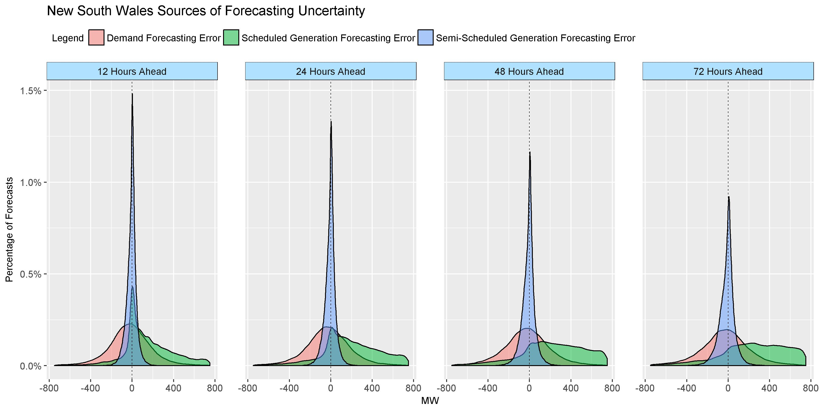

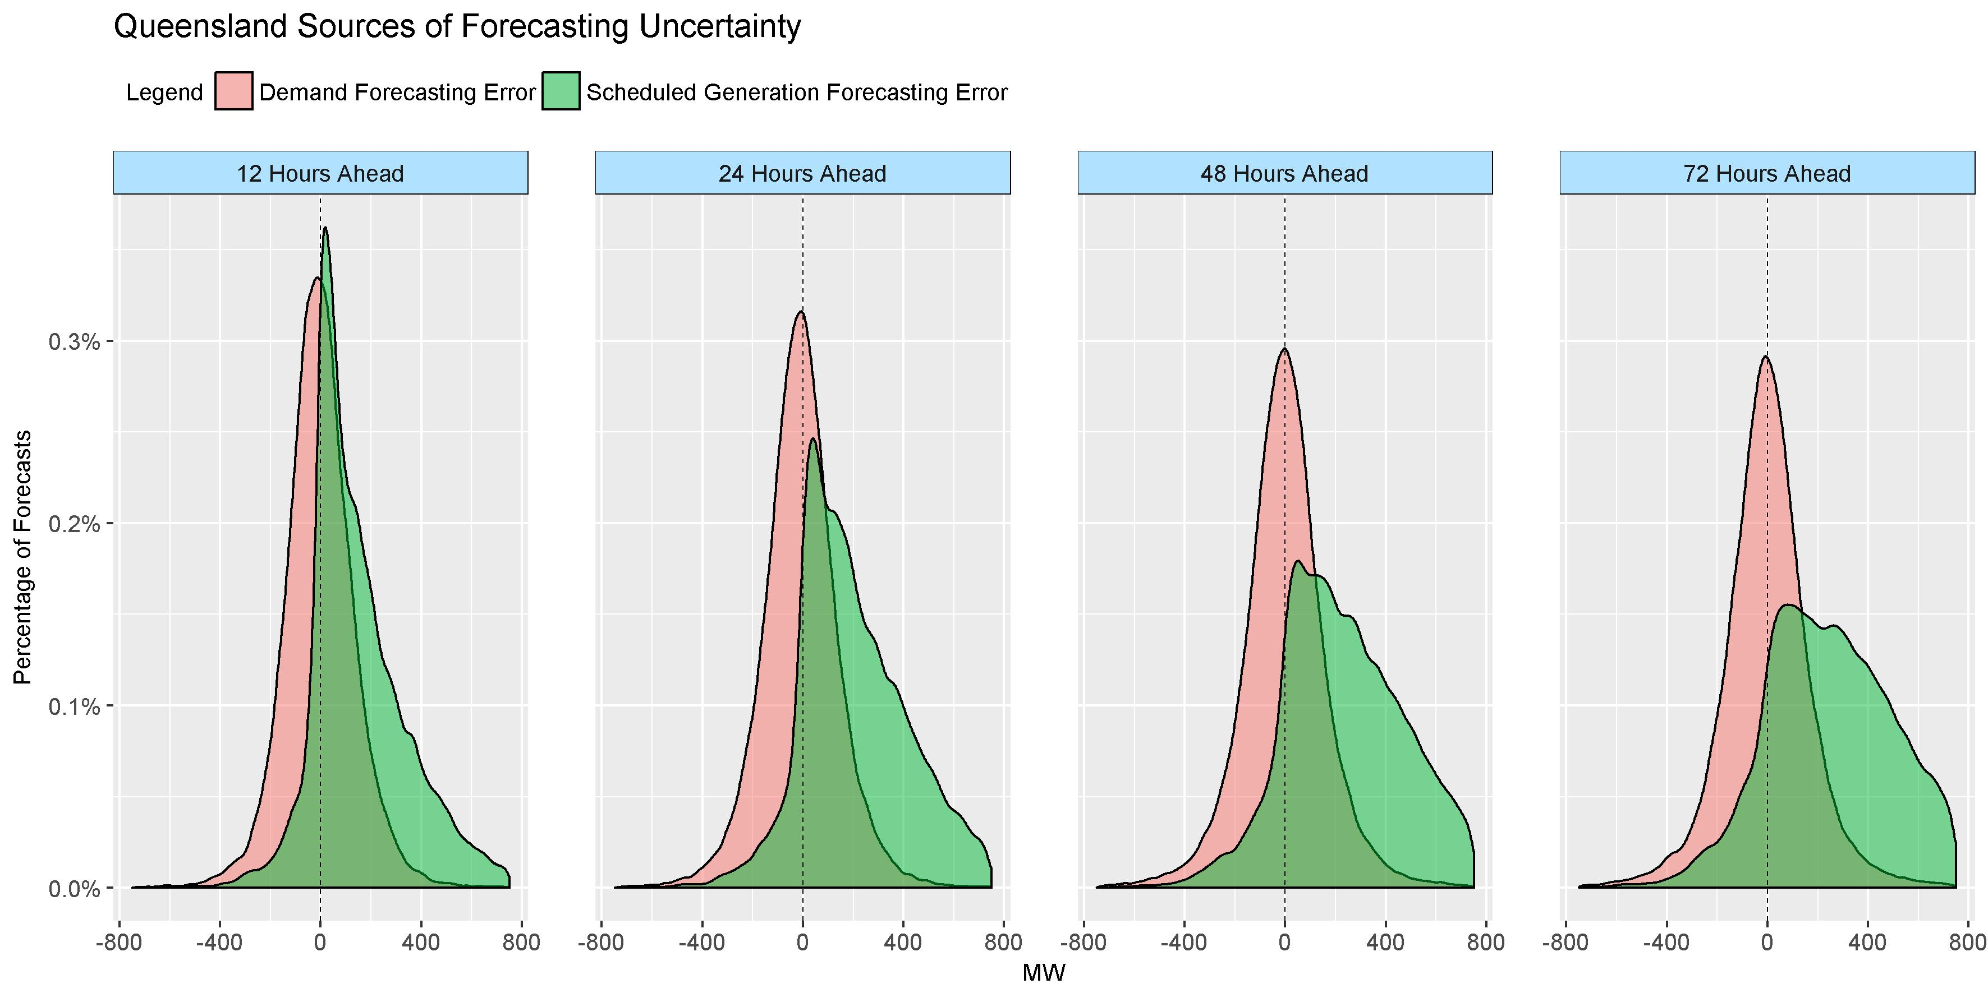

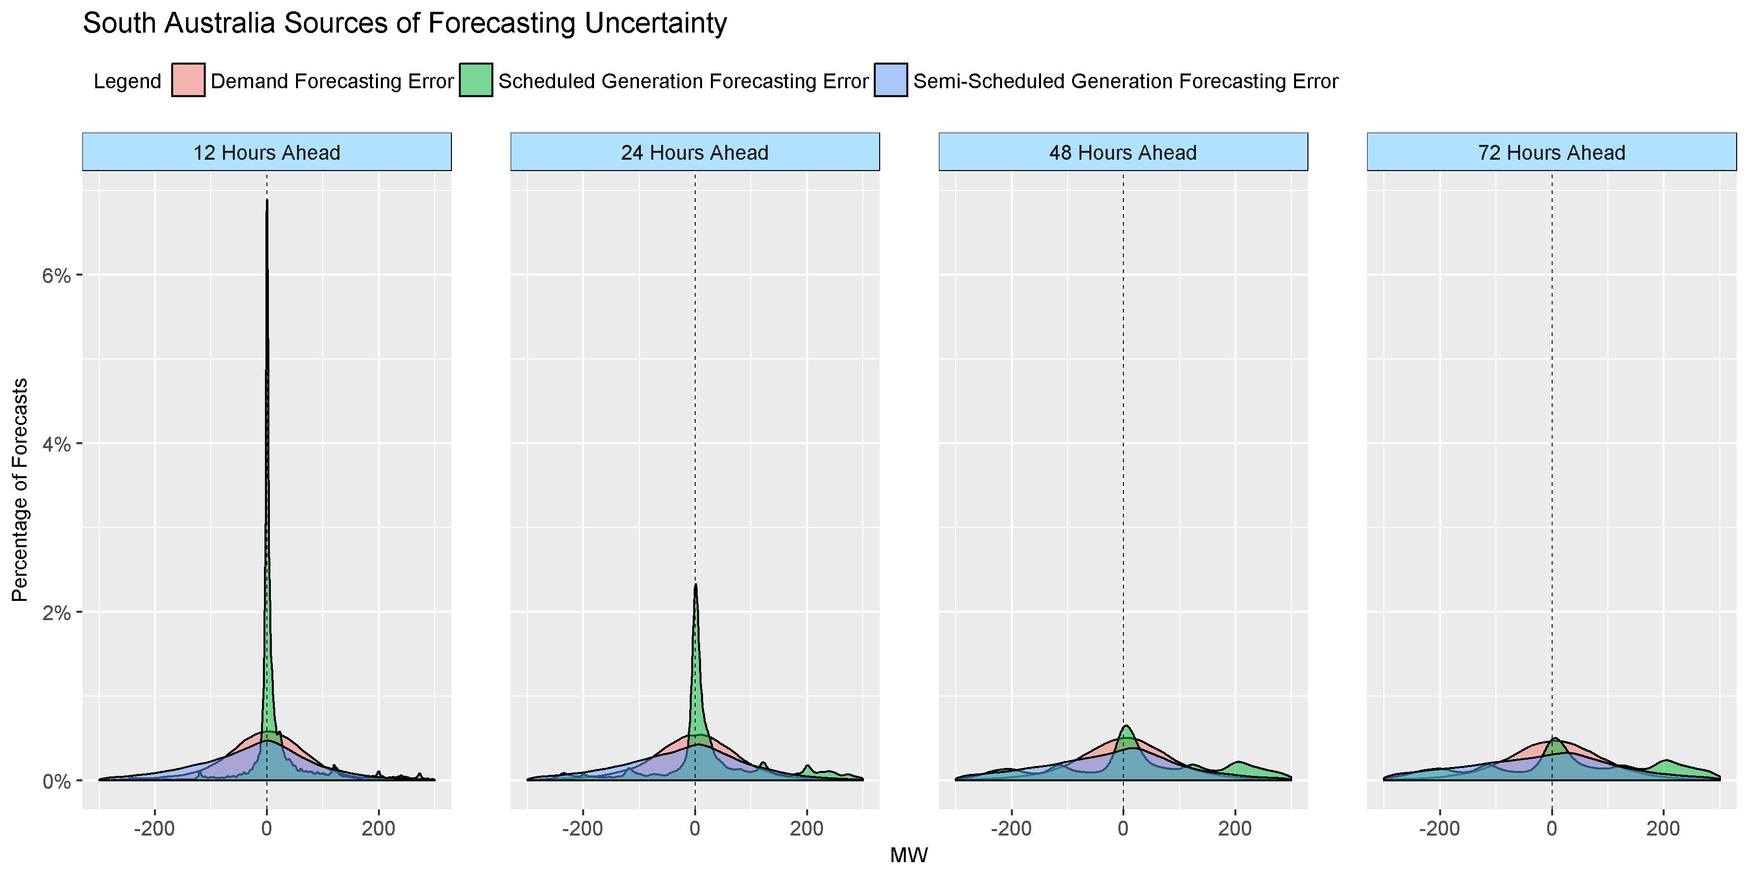

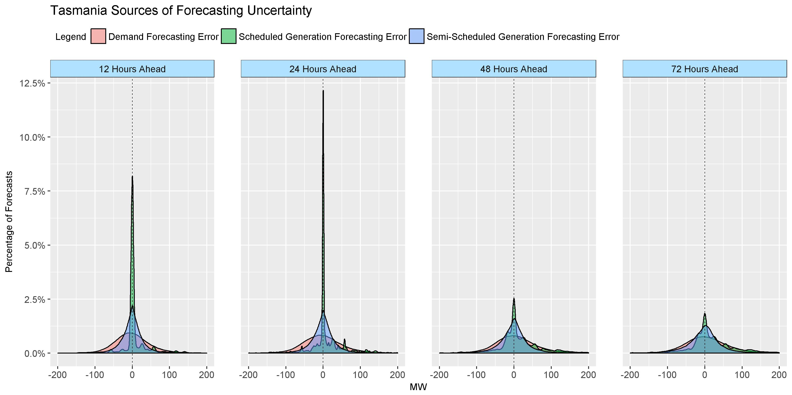

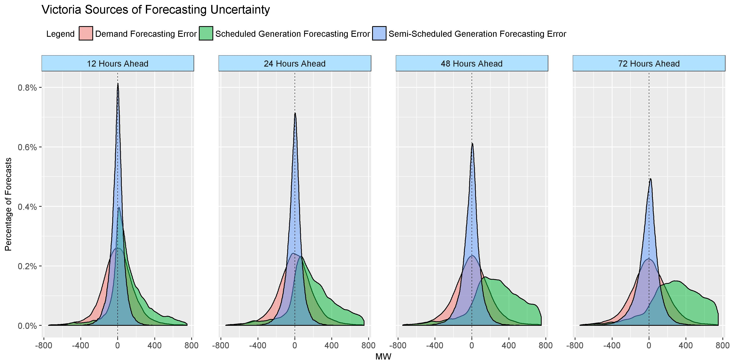

1. Clause 4.8.4(e) inserted by the *National Electricity Amendment (Declaration of lack of reserve conditions) Rule 2017*, effective 16 January 2018.
2. Closing date for submissions was extended from 14 November to 20 November 2017.
3. At this stage AEMO intends to commence the first review in April 2018, and will consider a second review before summer 2018–19.
4. Such as an unusual combination of generating unit and network outages.