


Consultation Paper –
SAS Institute Response

AEMO and ENA - Open Energy Networks Initiative

Jak Dyer
Senior Account Executive
10th August 2018
Contents
1. Open Energy Networks – Transition to a two-way Grid 2
2. Recommendations for the transition to a two-way grid 4
3. Rationale 5
4. In Summary 10
Appendix A. 11

- Open Energy Networks – Transition to a two-way Grid
The SAS Institute thanks the Australian Energy Market Operator, (AEMO), and Energy Networks Australia, (ENA), for its work on the Open Energy Network (OEN) consultation paper. We have attended the OEN national workshops and provided feedback during the sessions in Melbourne, Sydney and Perth. The purpose of this submission is to highlight additional areas of focus while offering our ability to partner with the Australian Government to make a two-way energy grid reality. This can only happen by putting customers at the centre of any proposed reforms while sharing the substantial benefits from rapid technological breakthroughs and more efficient markets.
The OEN consultation paper provides a useful summary of the technological disruption to the grid from Distributed Energy Resources (DER’s), and the options for system integration. As Australia is a leader in the decentralisation of generation, AEMO and ENA have the opportunity to become global leaders in grid management and market structure. Over the next decade, the National Electricity Market can either become an example of true energy sustainability for the rest of the world, or a cautionary tale of what happens when regulation and market structure lag technology.

The Power of Data & Analytics
Data and analytics has always had a critical place in the energy market. Thomas Edison in the 1880’s needed to forecast increases in annual generation based on counting street lamps and estimating next year’s energy growth. The introduction of SCADA systems in the 1960’s enabled more data and different types of information to be analysed. Advanced Metering Infrastructure (AMI), IoT devices and smart grids have emerged as a reality since the start of 2000. Now the rapid growth in DER and the beginning of a decentralised energy system is gaining momentum.
Initially the lowest common denominator of data has been price or cost, a simplification or aggregation of the many data types involved in the industry. Understandably for much of the energy industry’s life we have been restricted by analogue technologies and minimal computer resources, whether being in processing power or data storage. These are no-longer constraints, which is timely as the industry cannot afford such limitations and must embrace multiple new challenges. This includes the management of new data types, (ie. carbon emissions), greater data volumes, (ie. the transition to 5 minute energy trading), greater visibility, (ie. the spread of IoT enabling controllability and observability of our networks), greater distributed generation, (ie. DER’s and electric vehicles), the increase in battery storage (ie. especially important for individual PV, large scale solar and wind farms), and other challenges highlighted in the consultation report.
SAS has helped guiding the global energy and utilities market for over 40 years as the leading advanced analytics software company. We have 560 energy customers worldwide and of the Global Fortune 500 utility companies 80% are SAS customers. We also proudly remain the world’s largest privately held software company allowing us to provide cutting edge technology by investing 26% of revenues on Research & Development, nearly double the average of other software companies. SAS has made significant investments in Australia with offices in all major capital cities, approximately 300 local data and analytics professionals with access to a global team of 14,000+ people.
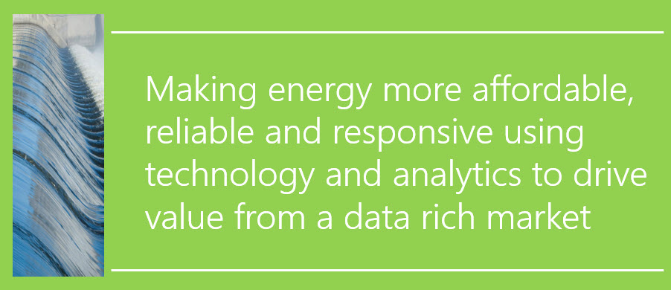
- Recommendations for the transition to a two-way grid
The needs of the customer and the operation of the new grid will be determined more than ever before by the data that can be collected, processed and distributed to those currently in the market. This will clearly benefit organisations wishing to enter the energy market with new innovative products and services. At the same time, it must be remembered that all citizens, consumers and businesses will benefit from the sharing of real-time data as it will help transform and optimise the system. Just as the ready access to map data and instant payment systems made Uber possible, so too will access to local energy load and production data help all consumers with better services, greater options, more competition and lower prices for electricity.
To make this happen the combined power of Ministers’ at the COAG Energy Council must consider an approach that examines and aligns incentives for the customer, the DER owners and the needs of the grid. In addition to some of the key features outlined in the consultation paper we recommend any plan must include:
- Open access to real-time data – AEMO, the DNSP’s and energy retailers need to work together to provide open access to grid data in real-time. This data sharing is fundamental to empowering customers, aggregators, and retailers to make informed decisions. Greater data sharing needs to be facilitated through legislation that could be fast-tracked by following the Green Button My Data Initiative in the US.
- Accurate Integrated Forecasting – There is an important role for government in providing an analytics framework capable of pulling in different types of energy data (ie. planned outages, power quality, etc.). This needs to be combined with external data like weather patterns for potential impacts on wind and solar, third party Electric Vehicle stations, mapping and spatial data to produce truly accurate forecasts for demand, load and renewables.
- Market based congestion and nodal pricing – The current structure of a single energy price per state provides the wrong incentives for customers, DNSP’s and DER owners. Increasingly DER is causing congestion problems across the grid. By providing market-based congestion pricing at each substation, DER owners and customers can respond to incentives aligned to the needs of the grid.

- Rationale
Open Access to Real time data
Increasing the visibility and transparency of data in the electricity system was the most commonly referenced issue in the OEN stakeholder workshops. We acknowledge the challenges of setting up an open data program though there are already lessons from other jurisdictions that have taken great steps along this path. A number of organisations like Green Tech Media and Advanced Energy Perspectives publish the top utility regulation trends in the US, highlighting the need for better sharing of progress and data. For instance, in October 2017 the New York State Electric & Gas Corporation and other utilities filed status reports with details:
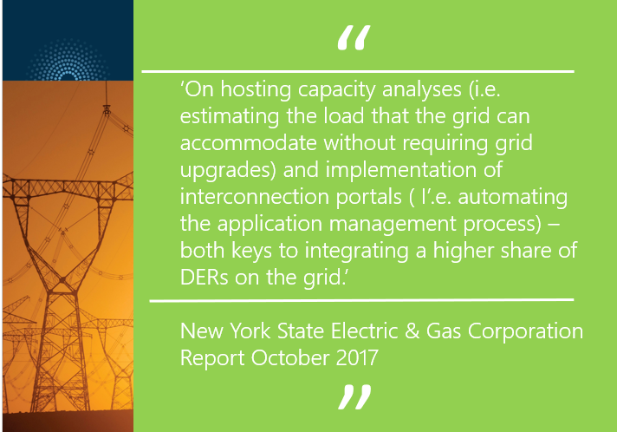

Similarly, the main Connecticut utilities:
‘submitted DER integration pilot plans that include hosting capacity analysis maps to provide customers and third parties more transparency into their distribution systems. They also both included DER and load forecasting to inform distribution system planning, and a DER portal and management system to facilitate the two-way sharing of information between customers and the utility.’
The Australian Government needs to design information sharing structures, a DER portal and management systems to enable the two-way sharing of information. The SAS Institute is keen to help the government from a data and analytics perspective to identify the steps required for open access to real time energy data and how it can be used most effectively. We strongly believe in the Green Button initiative in the US where industry led the response to a White House call-to-action to provide electricity customers with easy access to energy usage data in a consumer-friendly and computer-friendly format. To enable this the Green Button Alliance (GBA) was formed in 2015 to foster the development, compliance, and widespread adoption of the global Green Button electricity data standard. The SAS Institute is looking for partners in bringing this important initiative to Australia to help with the transition to a two-way grid.

Accurate Integrated Forecasting
The link between customers, data and a better pricing mechanism is largely tied to forecasting and planning. If energy producers, including DER investors, can rely on accurate forecasts then they can plan better where and when to invest which will bring down prices for customers. SAS explored the significant advantages to distribution system planners and operators from better forecasting in its joint report with Ameren titled: ‘Distribution circuit load forecasting using advanced metering infrastructure data’, see Appendix. One of the conclusions from the report was: ‘these forecasts generate significant value to utilities by helping avoid customer interruptions, reducing the duration of interruptions, improving long-term planning, and offering a foundation for Integrated Distribution Planning.’
The promotion of system and external data as a lever to address emerging business models and business problems will be critical to transforming the network. The following scenarios outline some examples of how important accurate forecasting is becoming:
AMI data scenario 1: the need to anticipate overloading of devices, substation transformers, and conductors when circuits are in their normal configurations. By forecasting potential overloads with sufficient lead times, system operators can initiate relief actions to prevent system degradation and unplanned customer interruptions. In this case, sufficient lead times can vary from very short-term, (day-ahead), to very long-term, (decades-ahead).
AMI data scenario 2: predicting future loads of circuit sections whenever a change of circuit state is anticipated. For example, if a circuit section requires de-energization for maintenance, then customers behind the sectionalizing device could be transferred to an available alternate supply provided that the transferred customers do not overload the alternate supply during the period that maintenance is being performed on the primary supply. This overload assessment would be accomplished with very short-term load forecasts for the sectionalized circuit. It also highlights the benefits of having a more decentralised energy system.
Analytics scenario 1: analytics for dispatch optimization of all moving parts including rooftop PV, home batteries, grid batteries, demand response, and possibly EV batteries. Large wind and solar are complications that define to an extent how the others are treated.
Forecasting scenario 1: energy forecasting at the total system level, and more critical, forecasts for the distribution system by phase. There is typically little instrumentation on the distribution system beyond the substation. Forecasts are the only way to predict an overload condition at some point beyond.





Market based congestion and nodal pricing
The current zonal market fails to signal to generators where the correct places to generate are, where the best place to build generation is, and all the resulting costs of this are borne by the end user who must pay both for energy and the compensation costs for an inefficient system. A nodal market seeks to make structural changes by simply representing the true value of power at different locations within the market. If there is a limit on transmission between two locations then the market will lower the price in the sending location, discouraging generation there, while raising the price in the receiving region, encouraging more generation there. As each generator sells at its local price, and each consumer buys at its local price with more accurate forecasts then the need for compensation is avoided.
A nodal model aligns the energy scheduled in the market to be much closer to energy flows in reality, and pays participants accordingly. New blockchain technology now makes the payment and auditing of energy usage and production possible at a large scale. The greater accuracy of a nodal pricing system avoids the issue with the zonal market whereby a generator could be scheduled and paid in the market but does not actually deliver the power. Under the zonal market generators could locate at a poor location with respect to the available transmission or the demand to be served, but would get compensated for this, compensation funded by the end user.
Reliability is driven in part by having fast responding generators available to make up the lost supply when generators or transmission lines experience equipment failure and become unavailable. A new nodal market would provide an improved market for the provision of these fast responses – and allows demand to participate – maintaining reliability in a least cost fashion, reducing the cost to the end consumer.
Prices that vary with location mean that different people pay different prices – you may ask whether this will create issues for policy and law makers? The market includes instruments available to all participants in the market that allow them to hedge the price differences between locations. In practice this means that participants who hedge the price of energy production and the price of transmitting that power across the grid effectively see a known price for their purchases. They are only exposed to the nodal price signal if they vary from their hedged quantities. This means that participants can achieve price certainty for the vast bulk of their energy needs, while the power system still provides them with the correct incentives for behaviour to work around constraints when they take more or less power than expected.

The significant benefits of a nodal market for electricity consumers was assessed in the cost-benefit analysis for the transition to a nodal market by the Public Utility Commission of Texas. In 2008, Charles River Associates estimated real economic efficiencies from the transition to a nodal market would be $520 million dollars for the period 2011-2020. The benefits from improved generation dispatch would be $339 million with the benefits from improved generation siting worth $181 million. Charles River Associates estimated that the reduction in need for compensation for inefficient market scheduling of generators would produce a net present value saving to consumers of $5.6 billion over the first ten years of operation, more than twenty times the projected cost. Even more interesting, as the OEN paper highlights, the potential benefits of optimising and coordinating DER at the distribution level could provide a cumulative value of $158 billion by 2027. This means the substantial investments and foresight required to create an operational two-way grid relying on greater DER energy production does have the potential for enormous financial rewards that must be dispersed as fairly as possible throughout the economy.
- In Summary
We are witnessing a once in a lifetime restructuring of the electricity industry, the lifeblood of our modern digital civilisation. The great leaps in technology enabling rapid growth in cheaper DER investments are occurring whilst the costs for baseload power is rising dramatically, alerting us to the urgent need to transform regulatory, governance and commercial structures in the energy industry. Our recommendations for open access to real-time data, accurate integrated forecasting and a system for market-based congestion and nodal pricing need to be key aspects of any reform package. We are confident the public will embrace the transformation needed if the financial benefits and governance structures are clearly articulated. With data now an asset more valuable than gold, we need to be conscious of who should own those assets and who is entitled to profit from the insights they provide. SAS is pleased to be invited into this debate and happy to provide any more insights related to data and analytics as progress is made with this important initiative.

CRA International, 2008 ‘Update on the ERCOT Nodal Market Cost-Benefit Analysis’, Prepared for the Public Utility Commission of Texas.

Shil, P., Anderson T., Konya M., 2018 ‘Distribution circuit load forecasting using advanced metering infrastructure data’, https://www.sas.com/content/dam/SAS/support/en/sas-global.../2722-2018.pdf

Girouard, C., 2017, ‘Top 10 Utility Regulation Trends of 2017’, https://blog.aee.net/top-10-utility-regulation-trends-of-2017

Girouard, C., 2018, ‘Top 10 Utility Regulation Trends of 2018 – So Far’ https://www.greentechmedia.com/articles/read/top-10-utility-regulation-trends-of-2018-so-far#gs.VE8k3Hg

Case Study 1
Transition to a Smart Grid
Getting full utility out of smart grid data
As these examples demonstrate, smart grid analytics plays a role in several different parts of the utility business, and a single analytical technique can answer very different questions. For example, you can use predictive modeling to anticipate asset failure and predict which customers will adopt a new service offering. You can use forecasting to plan for the aftermath of a storm or plan for staffing needs and fuel costs.

A utility company that capitalizes on smart grid analytics will soon find itself managing a wide portfolio of analytical models. These models should be treated as company assets, which calls for cross-functional governance to ensure consistency, repeatability, sharing and reuse. Managing models is just one piece of maximizing the return on smart grid analytics. Utilities also need a systematic way to track progress on analytics projects, measure their impact, manage models across their life cycles, and provide access to the right data and technology.

Many utilities – especially those with more than a million meters – have adopted a center of excellence approach to provide this enterprise-level oversight. An analytics center of excellence (ACE) typically coordinates:
• Data governance.
• Technology.
• Skills development and resources.
• Alignment with mobile strategy.
• Use of standard analytics solutions.
After several years of trial and error, most utilities have established both centralized and decentralized analytics resources that are tied to an ACE in a hub-and-spoke model. Tools and processes are centralized, while model development remains close to domain experts in the lines of business.

Smart grid analytics is proving its value
From optimizing asset management to forecasting weather and storm response, analytics is becoming a core part of today’s utility business. And it’s changing how utilities will do business in the future.
“The analytics movement is really taking hold for us,” said Jason Handley, PE, Director of Smart Grid Emerging Technology and Operations for Duke Energy. “About five years ago we had only six data scientists at Duke Energy. Today we have 41. We’re continuing to see an upswing, because we’re seeing more and more value out of these roles.”

In most geographies, load growth is flat while competitive pressure from new market entrants and alternative energy sources is up. Insights generated from smart grid analytics will be critical for delivering safe and reliable power, and providing value-added services in the most cost-effective manner. The direct financial benefits are already quantified for many areas of application. Now, the real question becomes: Can utilities afford not to invest in smart grid analytics?
Case Study 2
Forecasting optimizes energy production
RWE Poland predicts customers' electricity needs, streamlines operations, reduces costs
The core challenge for utility company RWE Poland was balancing its customers' likely next-day demands for electricity with its ability to generate or purchase power on the day-ahead market. RWE Poland was unable to go to intra-day markets for spot purchases, so making good next-day calculations were imperative to its profit and loss operations.

Improving forecasts to reduce "balancing costs" is a complex exercise that's complicated by seemingly infinite variables. How many customers will be using electricity at each moment in time? How will they be using it? How will hot or cold weather affect their demand? How will the economic environment increase or decrease usage? How many unique customers are we serving throughout the day?

RWE Poland was attempting to answer all those questions using the homegrown rule-of-thumb estimations that often reside within each separate department. The challenge was that each small digression from actual facts creates ever-larger matching and coordination problems, especially for the day-ahead contracting this utility needed. In addition, it had some data from smart meters to use for forecasting load, but other data that had to be fit in the forecast to get a holistic picture of energy demand.

Closing the forecast gap
To solve its knowledge needs, RWE Poland began to look for more statistically-defensible approaches that provide portfolio analysis to calculate standard load profiles with higher degrees of confidence. An increase in accuracy would reduce balancing costs – positively impacting the bottom line.

To accomplish this goal, RWE Poland quickly discovered that it also needed to clean, manage and structure its customer data to be useful. By first understanding its customers, the utility could get a better grasp of the variables affecting them and their use of electricity and incorporate that dynamic into its planning. Unfortunately, the data in RWE Poland's customer information systems was in bad shape and continued to degrade in quality as new, large volumes of usage data was incorporated by smart meters and automated metering infrastructure.

Data and forecasting go hand-in-hand

To do a better job of combining these inputs, RWE Poland realized that it needed a holistic approach to collecting data from these internal and external data sources and converting it into useful knowledge. Now, an analytical data repository built in SAS is a centralized source of intelligence for the organization. The repository is widely adopted throughout the organization because it was led by the business, with support from IT.

Next came the implementation of SAS Demand-Driven Forecasting. During this phase of the project, RWE Poland used the flexible SAS Data Integration tools to aggregate and integrate different types of data coming from multiple lines of business in order to achieve a more comprehensive vision of overall business management.

SAS Demand-Driven Forecasting provides the utility with consensus forecasting in conjunction with the sales and operations planning processes. The solution worked by providing hierarchical forecasting for hundreds of thousands of data series and also synchronizing and allocating forecasts from any level within the hierarchy.

Of special relevance to every utility's minute-by-minute demand profile, the forecasting method included time series methods such single exponential smoothing, Holt's/Brown's two parameter exponential smoothing, and Winter's three parameter exponential smoothing.

The variables involved in utility forecasts are handled by causal methods such as ARIMAX (ARIMA with intervention and causal variables), lagged variables/transfer functions, dynamic multiple regression, and the Unobserved Components Model.

Using these statistical analyses, SAS provided the forecasts that reflected the contingencies of RWE Poland's business, improving its planning accuracy. The solution offered additional value because it went a step further, automatically generating reports that indicated the gaps between the financial plan and all individual, departmental and statistical baseline forecasts, with notes indicating reasons. These reports can be reviewed, changed and written back to the data model and offered a compelling ongoing corrective loop for the ever-changing dynamics involved in electricity demand and supply.
Additional benefits
In addition to achieving more accurate short, mid and long-term forecasts, RWE Poland was inspired by the possibilities created by its customer data cleansing effort. The utility quickly envisioned how it could use this improved data set to identify technical losses that may have been occurring in the distribution system.

Technical losses occur because of the add-on engineering processes of expanding utility systems, in this case in a fast-growing economy. The savings that could be achieved in modeling and planning to correct technical losses could be used to optimize generation operations and reduce investments needed for additional generation capacities. Non-technical losses occurring due to theft of services could also be detected as a result of the clean-up for the forecasting exercise.

The combination of improved market balancing costs through better forecasts with the ability to detect technical losses allowed RWE Poland to gain a better sense of how it could invest in replacements to its aging infrastructure assets.

Girouard, C., 2017, ‘Top 10 Utility Regulation Trends of 2017’, https://blog.aee.net/top-10-utility-regulation-trends-of-2017, pp.2-6
Girouard, C., 2017, ‘Top 10 Utility Regulation Trends of 2017’, https://blog.aee.net/top-10-utility-regulation-trends-of-2017, p.2
CRA International, 2008 ‘Update on the ERCOT Nodal Market Cost-Benefit Analysis’, Prepared for the Public Utility Commission of Texas, p. 6-7.

