3G LCM
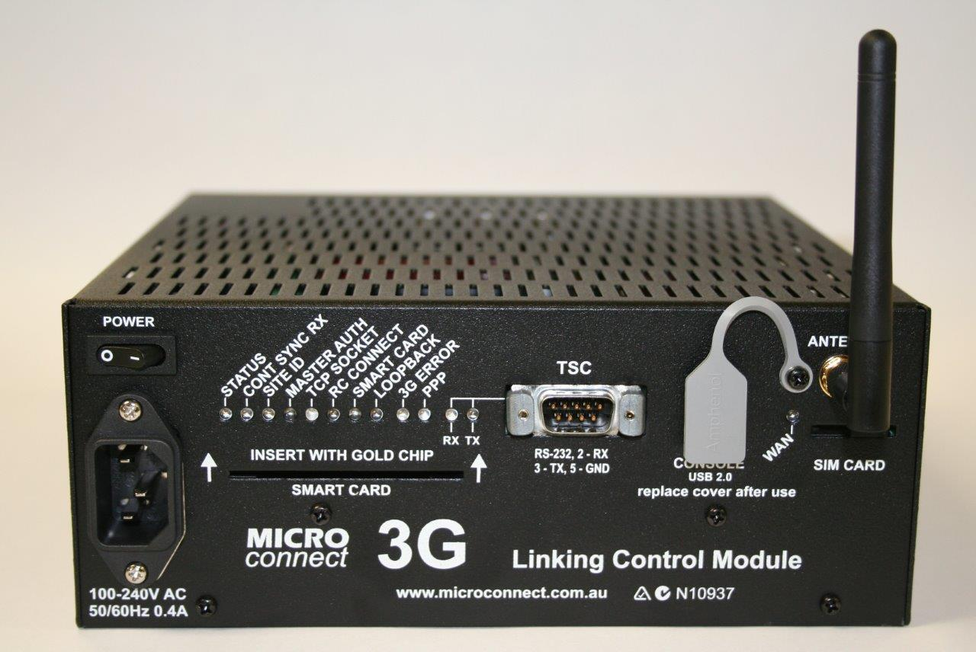
 |  | Smart card for quick and easy field changeover | Supercap UPS with power failure alarms | Powered AUX serial port for Bluetooth Travel time
 |  |  | 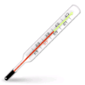
 |  | Designed and tested with the latest SCATS® software | High temperature operation

Description
The 3G LCM connects a SCATS® traffic controller (using RS232) to the SCATS® traffic system using a Mobile 3G connection. The 3G LCM is fully automatic, easily installed and is ideal for:
- Remote locations where standard cable is too expensive to install
- Backup for critical sites
- New sites awaiting cable to be installed but need to be linked prior to commissioning
- Features
- 3G Quad Band 850/900/1800/1900 MHz
- High temperature operation
- Advanced diagnostics
- USB Console port
- Complete status display on the LED front panel
- Smartcard for easy in field replacement
- Quick connect cables
- Full logging of events including SCATS® connection issues (Redundant Syslog sending)
- Internal low voltage UPS allows mains failure event logging
- Syslog logging
- 100-240VAC, 50/60Hz

Accessories
Configuration Smart Card
Universal PSC- TSC/4 cable
Older Controller cables, Delta 3/5 - PTF
Vertical mounting bracket
IEC power cable (country specific)
Manuals etc are available via our secure customer portal site for registered customers only. Please contact us if you require more information
®SCATS is a registered trademark of RMS in NSW

