aseXML Schema Change Request
PREPARED BY: Pius kurian
DOCUMENT REF: CR 57
VERSION: 1.7.2
DATE: 12 february 2014
Draft/FINAL FINAL
Version Release History
Version | Date | By | Changes
1.0 | 10/09/2014 | Pius Kurian | Initial Draft
1.1 | 03/12/2014 | Pius Kurian | Modified in accordance wth the feedback from working group
1.2 | 13/1/2015 | Pius Kurian | Major modification to several types in the schema mailnly in the Gas_34.xsd
1.3 | 23/1/2015 | Pius Kurian | Minor modification after consulting major stakeholders
1.4 | 29/1/2015 | Pius Kurian | Removed ERFT and IAIT prefixes from report names
1.5 | 02/02/2015 | Pius Kurian | Minor Edits
1.6 | 03/02/2015 | Pius Kurian | Versioned Types to R34 such as GasStandingData, GasMeterNotification that have been impacted and Enumerations file to v7 to include market report names
1.7 | 10/02/2015 | Pius Kurian | Modified section 2.1.3 and diagrams.
1.7.1 | 12/02/2015 | Pius Kurian | Modified JobEnquiryCode
1.7.2 | 12/02/2015 | Pius Kurian | Changed GasServiceOrderDetails diagram

Glossary
Abbreviation | Description
NARGP | NSW-ACT Retail Gas Project

Contents
1 Change Proposal 4
1.1 Description of the proposed change 4
1.2 Reason for Change 6
1.3 Supplied Documents 6
1.3.1 Other 6
1.4 Baseline Schema 6
2 Approval Proposal 7
2.1 Proposed Change #1 7
2.1.1 Draft schema 7
2.1.2 Change log 7
2.1.3 Schema change description 9
2.1.4 Impact Summary 60
2.1.5 Developer Test 62
3 Proposal Assessment 65
3.1 Test 65
3.1.1 Test Platforms 65
3.1.2 Test Cases 65
3.1.3 Test Results 65
3.2 Conformance Report 65
4 Issue Register 66
4.1 Status of Issues 66
5 Resolution 66
5.1 ASWG Endorsement 66

Change Proposal
In February 2014 Jemena Gas Networks (JGN), the largest gas network provider in NSW, announced the replacement of their retail gas systems. JGN’s system replacement provides an opportunity for industry to reassess the feasibility of introducing Business to Business (B2B) and Business to Market (B2M) arrangements in NSW and ACT. JGN requested AEMO consider progressing the alignment of the NSW and ACT B2B and B2M arrangements with other retail gas markets (Queensland, Victoria and South Australia).

AEMO formed a working group (consisting of AEMO, JGN, AGL, Origin Energy, Energy Australia, Lumo Energy and APA / Envestra) to determine the industry appetite for harmonisation together with the intended scope and approach. To inform a decision to proceed with the project, the working group agreed to complete the following by July 2014:
- Project scope and market design;
- Updated cost/benefit assessment;
- Implementation Plan.
Intended benefits of the project were identified to be the establishment of consistent B2B and B2M market arrangements in NSW and ACT which will lower the barriers to entry and facilitate increased competition

The AEMO working group completed the high-level design in the form of eight separate scoping documents for NSW and ACT retail gas transactions in June 2014. The key features are as follows:
- The proposed design is based on the current arrangements in Victoria with consideration of specific jurisdictional allowances for NSW and ACT. The main allowances made for NSW and ACT include the contestability of hot water, differing market transaction types (i.e. no retrospective customer transfers), retaining the bulk transfer processes and the ability to transfer customers on estimated meter reads; and
- The technology architecture (system, network and infrastructure) will be based on the architecture design for the planned retail gas Hub Upgrade Project. The retail gas hub is a technology platform operated by AEMO that facilitates retail gas transactions (B2B and B2M) and is used by participants in the Queensland, Victoria, South Australia and Western Australia retail gas markets. The retail gas hub is currently not used in the NSW and ACT gas retail markets. This project will deliver the technology platform required to manage the expected increase in the NSW and ACT market transaction volumes.
In late July 2014, after an industry cost Benefit Analysis, AEMO Board has made a decision to proceed with the NSW & ACT Retail Gas Project (NARGP) with an implementation date of April 2016.

Description of the proposed change
The proposed changes are listed in the following table.
Item# | Change Description | Change Type
1 | New Complex Types  BaseMultiMeterReadDataType  BaseServiceOrderGasMeterData  DailyImbalanceNotification  EstimationResultsDataType  EstimationResultsRpt  ExpiredImbalanceTradeRpt  GasBasicMultiMeterStandingData  GasMeterVerifyRequestWithMSNData  GasMeterVerifyResponseWithMSNData  GasMultiMeterMasterStandingDataType  GasMultiMeterReadDataType  GasMultiMeterStandingData  GasMultiMeterStandingDataType  GasMultiMeterStandingDataUpdate  HWMultiMeterReadDataType  ImbalanceTradeRequest  LinepackAndUnaccountedForGasNotification  MarketReport  MatchedAllocationsDataNotification  MatchedImbalanceTradeRpt  MRBlockParameterType  MRMissingBlockParameters  MultiMeterSiteAccessDetails  ParticipantCLPandUAGNotification  ParticipantImbalanceAmountRequest  ParticipantImbalanceAmountRpt  RevisedImbalanceRpt  ServiceOrderMultiMeterData  TotalGasInjectedNotification  Modified Complex Types  GasMeterFixCertification  GasMeterNotification  GasServiceOrderDetails  NetworkDUoSBillingNotification  ServiceOrderGasCompletionData  ServiceOrderGasMeterData  ServiceOrderRequestData  Transaction  New Simple Types  ApportionmentPercentage  BillingMethodType  CommonFactorType  ConsumptionFactorType  ConsumptionLitresType  Description  DistanceType  GasConnectionType  GasInstallationType  KPAValueType  MeterInstallationType  MeterMeasurementUnitType  MeterMultiplierType  MeterReadingFrequencyType  MeterReadingFrequencyTypeBase  MeterType  NetworkID  NetworkReceiptPointID  NetworkTariffCodeType  PipelineID  QuantityOfGasMJ  ReportType  SupplyPointID  TradeType  Modified Simple types:  EnergyMarket  GasJobCompletionCode3  GasMeterReadFrequency  IndexInvestigationCode  MarketReportNamesType  MarketReportNamesType  MIRNStatus  TransactionGroup | New
Table 1-1, Proposed Changes

Reason for Change
As mentioned in section 1, Jemena’s announcement to replace their retail gas systems provided with an opportunity to move towards a common schema.
The proposed design is based on the current arrangements in Victoria with consideration of specific jurisdictional allowances for NSW and ACT.

Supplied Documents

Other
aseXML_r34.zip

Baseline Schema
The schema used as a basis for this proposal aseXML_r33.zip

Approval Proposal

Proposed Change #1

Draft schema
Please refer to the draft schema mentioned above attached to this change request. The base schema is aseXML_r33 and the files as detailed in the next section have been changed.

Change log
The following changes have been implemented in this draft:
Chg # | Item # | Description of change | Filename
1 | 1 | Modified the following Complex types:  Transaction | Transactions_r34.xsd
2 | 1 | Added the following Complex Types:  DailyImbalanceNotification  ImbalanceTradeRequest  LinepackAndUnaccountedForGasNotification  MatchedAllocationsDataNotification  ParticipantCLPandUAGNotification  ParticipantImbalanceAmountRequest  TotalGasInjectedNotification  Added the following Simple types:  ApportionmentPercentage  Description  MeterReadingFrequencyType  MeterReadingFrequencyTypeBase  NetworkReceiptPointID  QuantityOfGasMJ  TradeType | GasMarketWholesale_r34.xsd
3 | 1 | Added the following Complex Types:  EstimationResultsDataType  EstimationResultsRpt  ExpiredImbalanceTradeRpt  MarketReport  MatchedImbalanceTradeRpt  MRBlockParameterType  MRMissingBlockParameters  ParticipantImbalanceAmountRpt  RevisedImbalanceRpt  Added the following Simple types:  PipelineID  ReportType | Reports_r34.xsd
4 | 1 | Updated schema namespace to urn:aseXML:r34, new include to refer to the file added, and changed the version numbers of modified files. | aseXML_r34.xsd
5 | 1 | Add new type r34 for new schema version | Events_r34.xsd
6 | 1 | Modified the following Simple types:  EnergyMarket  TransactionGroup | Header_r34.xsd
7 | 1 | Added the following Complex Types:  BaseMultiMeterReadDataType  BaseServiceOrderGasMeterData  GasBasicMultiMeterStandingData  GasMeterVerifyRequestWithMSNData  GasMeterVerifyResponseWithMSNData  GasMultiMeterMasterStandingDataType  GasMultiMeterReadDataType  GasMultiMeterStandingData  GasMultiMeterStandingDataType  GasMultiMeterStandingDataUpdate  HWMultiMeterReadDataType  ServiceOrderMultiMeterData  Modified the following Complex types:  GasMeterFixCertification  GasMeterNotification  GasServiceOrderDetails  ServiceOrderGasCompletionData  ServiceOrderGasMeterData  ServiceOrderRequestData  Added the following Simple types:  BillingMethodType  CommonFactorType  ConsumptionFactorType  ConsumptionLitresType  DistanceType  GasConnectionType  GasInstallationType  KPAValueType  MeterInstallationType  MeterMeasurementUnitType  MeterMultiplierType  MeterType  NetworkTariffCodeType  SupplyPointID  Modified the following Simple types:  GasJobCompletionCode3  GasMeterReadFrequency  MIRNStatus | Gas_r34.xsd
8 | 1 | Added the following Simple types:  NetworkID  Modified the following Simple types:  IndexInvestigationCode | Common_r34.xsd
11 | 1 | Added the following Complex Types:  MultiMeterSiteAccessDetails | CustomerDetails_r34
12 | 1 | Modified the following Simple types:  MarketReportNamesType | Enumerations.xsd
13 | 1 | Added the following Complex Types:  NetworkDUoSBillingNotification | NetworkBilling_r34.xsd
Table 2-2 Change Log

Schema change description
… changed portions have been marked in bold in the Text View…

Schema File Transactions.xsd

Text View
… unmodified text removed for brevity …

<xsd:complexType name="Transaction">
<xsd:annotation>
<xsd:documentation>
Purpose - Common container for all transactions
Detail - All transactions within aseXML are carried within this container. The transactionID and transactionDate are provided for all transactions. The initiatingTransactionID is only provided on response transactions and represents the transactionID of the initiating transaction.
</xsd:documentation>
</xsd:annotation>
<xsd:choice>
<xsd:element name="ReplicationRequest" type="ReplicationRequest"/>
<xsd:element name="ReplicationNotification" type="ReplicationNotification"/>
<xsd:element name="ReportRequest" type="ReportRequest"/>
<xsd:element name="ReportResponse" type="ReportResponse"/>
<xsd:element name="MeterDataNotification" type="MeterDataNotification"/>
<xsd:element name="MeterDataResponse" type="MeterDataResponse"/>
<xsd:element name="SettlementDataNotification" type="SettlementDataNotification"/>
<xsd:element name="NMIDiscoveryRequest" type="NMIDiscoveryRequest"/>
<xsd:element name="NMIDiscoveryResponse" type="NMIDiscoveryResponse"/>
<xsd:element name="NMIStandingDataRequest" type="NMIStandingDataRequest"/>
<xsd:element name="NMIStandingDataResponse" type="NMIStandingDataResponse"/>
<xsd:element name="CATSChangeRequest" type="CATSChangeRequest"/>
<xsd:element name="CATSChangeResponse" type="CATSChangeResponse"/>
<xsd:element name="CATSChangeWithdrawal" type="CATSChangeWithdrawal"/>
<xsd:element name="CATSObjectionRequest" type="CATSObjectionRequest"/>
<xsd:element name="CATSObjectionResponse" type="CATSObjectionResponse"/>
<xsd:element name="CATSObjectionWithdrawal" type="CATSObjectionWithdrawal"/>
<xsd:element name="CATSNotification" type="CATSNotification"/>
<xsd:element name="CATSDataRequest" type="CATSDataRequest"/>
<xsd:element name="CATSChangeAlert" type="CATSChangeAlert"/>
<xsd:element name="ServiceOrderRequest" type="ServiceOrderRequest"/>
<xsd:element name="ServiceOrderResponse" type="ServiceOrderResponse"/>
<xsd:element name="FieldWorkNotification" type="FieldWorkNotification"/>
<xsd:element name="NetworkInvoiceNotification" type="NetworkInvoiceNotification"/>
<xsd:element name="DisputeNotification" type="DisputeNotification"/>
<xsd:element name="RemittanceNotification" type="RemittanceNotification"/>
<xsd:element name="DisputeResponse" type="DisputeResponse"/>
<xsd:element name="CreditNotification" type="CreditNotification"/>
<xsd:element name="FaultInformationRequest" type="FaultInformationRequest"/>
<xsd:element name="FaultNotification" type="FaultNotification"/>
<xsd:element name="FaultOutageAdvice" type="FaultOutageAdvice"/>
<xsd:element name="CustomerDetailsRequest" type="CustomerDetailsRequest"/>
<xsd:element name="CustomerDetailsNotification" type="CustomerDetailsNotification"/>
<xsd:element name="AmendMeterRouteDetails" type="AmendMeterRouteDetails"/>
<xsd:element name="AccountCreationNotification" type="AccountCreationNotification"/>
<xsd:element name="NetworkDUoSBillingNotification" type="NetworkDUoSBillingNotification"/>
<xsd:element name="MeterReadInputNotification" type="MeterReadInputNotification"/>
<xsd:element name="MeterDataVerifyRequest" type="MeterDataVerifyRequest"/>
<xsd:element name="MeterDataVerifyResponse" type="MeterDataVerifyResponse"/>
<xsd:element name="MeterDataHistoryRequest" type="MeterDataHistoryRequest"/>
<xsd:element name="MeterDataHistoryResponse" type="MeterDataHistoryResponse"/>
<xsd:element name="SpecialReadRequest" type="ServiceOrderRequest"/>
<xsd:element name="SpecialReadResponse" type="ServiceOrderResponse"/>
<xsd:element name="MeterDataMissingNotification" type="MeterDataMissingNotification"/>
<xsd:element name="CurrentRetailerConfirmationRequest" type="CurrentRetailerConfirmationRequest"/>
<xsd:element name="CurrentRetailerConfirmationResponse" type="CurrentRetailerConfirmationResponse"/>
<xsd:element name="NMIStandingDataUpdateNotification" type="NMIStandingDataUpdateNotification"/>
<xsd:element name="NMIStandingDataUpdateResponse" type="MeterDataResponse"/>
<xsd:element name="GasMeterNotification" type="GasMeterNotification"/>
<xsd:element name="MeteredSupplyPointsCountUpdate" type="MeteredSupplyPointsCountUpdate"/>
<xsd:element name="CATSBulkDataRequest" type="CATSBulkDataRequest"/>
<xsd:element name="CATSBulkDataResponse" type="CATSBulkDataResponse"/>
<xsd:element name="NOSBookingSubmission" type="NOSBookingSubmission">
<xsd:unique name="uniqueBooking">
<xsd:selector xpath=".//Booking"/>
<xsd:field xpath="CompanyBookingId"/>
</xsd:unique>
</xsd:element>
<xsd:element name="NOSBookingResponse" type="NOSBookingResponse"/>
<xsd:element name="NOSBookingInfoRequest" type="NOSBookingInfoRequest"/>
<xsd:element name="NOSEquipmentSubmission" type="NOSEquipmentSubmission">
<xsd:unique name="equipmentKey">
<xsd:selector xpath=".//NOSEquipment"/>
<xsd:field xpath="CompanyElementId"/>
</xsd:unique>
</xsd:element>
<xsd:element name="NOSEquipmentResponse" type="NOSEquipmentResponse"/>
<xsd:element name="NOSEquipmentInfoRequest" type="NOSEquipmentInfoRequest"/>
<xsd:element name="NOSInfoResponse" type="NOSInfoResponse"/>
<xsd:element name="AllocationNotification" type="AllocationNotification"/>
<xsd:element name="ReconciliationNotification" type="ReconciliationNotification"/>
<xsd:element name="SwingServiceNotification" type="SwingServiceNotification"/>
<xsd:element name="MeterReadingReferenceDataRequest" type="MeterReadingReferenceDataRequest"/>
<xsd:element name="MeterReadingReferenceDataResponse" type="MeterReadingReferenceDataResponse"/>
<xsd:element name="WholesaleRetrieveRequest" type="WholesaleRetrieveRequest"/>
<xsd:element name="WholesaleRetrieveResponse" type="WholesaleRetrieveResponse"/>
<xsd:element name="WholesaleSearchRequest" type="WholesaleSearchRequest"/>
<xsd:element name="WholesaleSearchResponse" type="WholesaleSearchResponse"/>
<xsd:element name="WholesaleSubmitRequest" type="WholesaleSubmitRequest"/>
<xsd:element name="WholesaleSubmitResponse" type="WholesaleSubmitResponse"/>
<xsd:element name="WholesaleInformationRequest" type="WholesaleInformationRequest"/>
<xsd:element name="WholesaleInformationResponse" type="WholesaleInformationResponse"/>
<xsd:element name="HSMMonitorsRequest" type="HSMMonitorsRequest"/>
<xsd:element name="HSMMonitorsResponse" type="HSMMonitorsResponse"/>
<xsd:element name="HSMMonitorDataRequest" type="HSMMonitorDataRequest"/>
<xsd:element name="HSMMonitorDataResponse" type="HSMMonitorDataResponse"/>
<xsd:element name="HSMDataInventoryRequest" type="HSMDataInventoryRequest"/>
<xsd:element name="HSMDataInventoryResponse" type="HSMDataInventoryResponse"/>
<xsd:element name="HSMTriggersRequest" type="HSMTriggersRequest"/>
<xsd:element name="HSMTriggersResponse" type="HSMTriggersResponse"/>
<xsd:element name="OneWayNotification" type="OneWayNotification"/>
<xsd:element name="MMSIntermittentGenAvailabilityRequest" type="MMSIntermittentGenAvailabilityRequest"/>
<xsd:element name="MarketReport" type="MarketReport"/>
<xsd:element name="ParticipantImbalanceAmountRequest" type="ParticipantImbalanceAmountRequest"/>
<xsd:element name="ImbalanceTradeRequest" type="ImbalanceTradeRequest"/>
<xsd:element name="TotalGasInjectedNotification" type="TotalGasInjectedNotification"/>
<xsd:element name="LinepackAndUnaccountedForGasNotification" type="LinepackAndUnaccountedForGasNotification"/>
<xsd:element name="ParticipantCLPandUAGNotification" type="ParticipantCLPandUAGNotification"/>
<xsd:element name="MatchedAllocationsDataNotification" type="MatchedAllocationsDataNotification"/>
<xsd:element name="DailyImbalanceNotification" type="DailyImbalanceNotification"/>
<xsd:element name="ForecastWithdrawalNotification" type="ForecastWithdrawalNotification"/>
<xsd:element name="EstimationResultsToNWONotification" type="EstimationResultsToNWONotification"/>
<xsd:element name="RevisedEstimationResultsToNWONotification" type="EstimationResultsToNWONotification"/>
</xsd:choice>
<xsd:attribute name="transactionID" type="TransactionIdentifier" use="required"/>
<xsd:attribute name="transactionDate" type="xsd:dateTime" use="required"/>
<xsd:attribute name="initiatingTransactionID" type="TransactionIdentifier" use="optional"/>
</xsd:complexType>
… unmodified text removed for brevity …

Schema File GasMarketWholesale_r34.xsd
This file contains the new definitions for NSW-ACT Gas Wholesale Market Transactions.
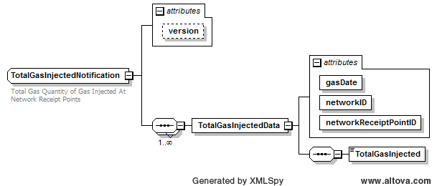
Figure 2-1 TotalGasInjectedNotification

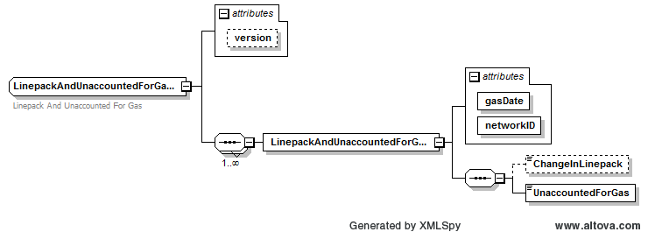
Figure 2-2 LinepackAndUnaccountedForGasNotification

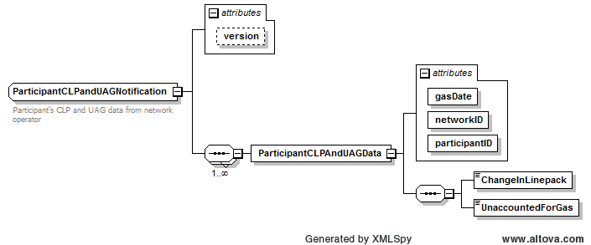
Figure 2-3 ParticipantCLPandUAGNotification

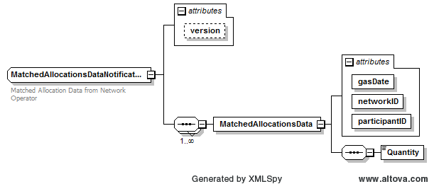
Figure 2-4 MatchedAllocationsDataNotification

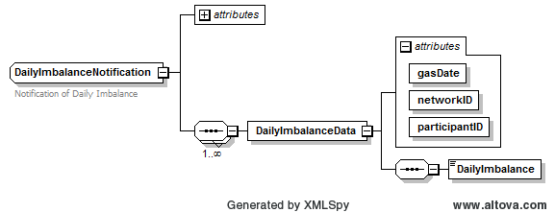
Figure 2-5 DailyImbalanceNotification

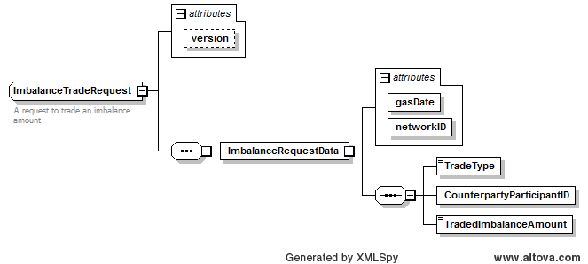
Figure 2-6 ImbalanceTradeRequest
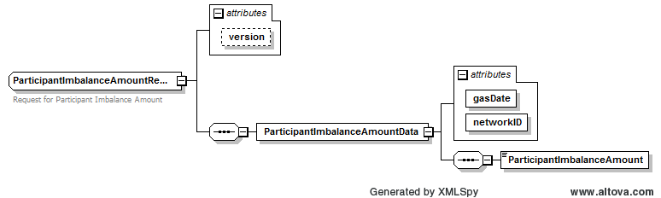
Figure 2-7 ParticipantImbalanceAmountRequest

Text View
… unmodified text removed for brevity …

<!-- ================================================================= -->
<!-- NSWGAS Specific Simple and Complex Sub-Types -->
<!-- ================================================================= -->
<xsd:simpleType name="NetworkReceiptPointID">
<xsd:annotation>
<xsd:documentation>NetworkReceiptPointID has been included in several reports and as a part of meter standing data</xsd:documentation>
</xsd:annotation>
<xsd:restriction base="xsd:string">
<xsd:maxLength value="15"/>
<xsd:minLength value="2"/>
</xsd:restriction>
</xsd:simpleType>
<xsd:simpleType name="MeterReadingTypeBase">
<xsd:annotation>
<xsd:documentation>The Type of Meter Reading</xsd:documentation>
</xsd:annotation>
<xsd:restriction base="xsd:string">
<xsd:length value="1"/>
<xsd:enumeration value="A"/>
<xsd:enumeration value="S"/>
<xsd:enumeration value="E"/>
<xsd:enumeration value="X"/>
</xsd:restriction>
</xsd:simpleType>
<xsd:complexType name="MeterReadingType">
<xsd:annotation>
<xsd:documentation>The Type of Meter Reading</xsd:documentation>
</xsd:annotation>
<xsd:sequence>
<xsd:element name="MeterReadingTypeCode" type="MeterReadingTypeBase"/>
<xsd:element name="Description" type="Description" minOccurs="0"/>
</xsd:sequence>
</xsd:complexType>
<xsd:simpleType name="MeterReadingFrequencyBase">
<xsd:annotation>
<xsd:documentation>The frequency at which a meter is read.</xsd:documentation>
</xsd:annotation>
<xsd:restriction base="xsd:string">
<xsd:length value="1"/>
<xsd:enumeration value="D"/>
<xsd:enumeration value="M"/>
<xsd:enumeration value="B"/>
<xsd:enumeration value="Q"/>
</xsd:restriction>
</xsd:simpleType>
<xsd:complexType name="MeterReadingFrequency">
<xsd:annotation>
<xsd:documentation>The frequency at which a meter is read.</xsd:documentation>
</xsd:annotation>
<xsd:sequence>
<xsd:element name="MeterReadingFrequencyCode" type="MeterReadingFrequencyBase"/>
<xsd:element name="Description" type="Description" minOccurs="0"/>
</xsd:sequence>
</xsd:complexType>
<xsd:simpleType name="MeterReadingFrequencyTypeBase">
<xsd:annotation>
<xsd:documentation>Identifies a Delivery Point Reading Frequency as Daily or Non Daily</xsd:documentation>
</xsd:annotation>
<xsd:restriction base="xsd:string">
<xsd:length value="1"/>
<xsd:enumeration value="D"/>
<xsd:enumeration value="N"/>
</xsd:restriction>
</xsd:simpleType>
<xsd:complexType name="MeterReadingFrequencyType">
<xsd:annotation>
<xsd:documentation>Identifies a Delivery Point Reading Frequency as Daily or Non Daily</xsd:documentation>
</xsd:annotation>
<xsd:sequence>
<xsd:element name="MeterReadingFrequencyTypeCode" type="MeterReadingFrequencyTypeBase"/>
<xsd:element name="Description" type="Description" minOccurs="0"/>
</xsd:sequence>
</xsd:complexType>
<!--Simple Types-->
<xsd:simpleType name="ApportionmentPercentage">
<xsd:annotation>
<xsd:documentation>The Percentage of Net Section Load attributable to consumption by a User's customers.</xsd:documentation>
</xsd:annotation>
<xsd:restriction base="xsd:decimal">
<xsd:totalDigits value="10"/>
<xsd:fractionDigits value="7"/>
<xsd:maxExclusive value="1000"/>
<xsd:minInclusive value="0"/>
</xsd:restriction>
</xsd:simpleType>
<xsd:simpleType name="PercentageAccuracy">
<xsd:annotation>
<xsd:documentation>Forecasting entity’s confidence level for the forecast network section load for a given gas day expressed as a percentage</xsd:documentation>
</xsd:annotation>
<xsd:restriction base="xsd:decimal">
<xsd:minInclusive value="0"/>
<xsd:maxExclusive value="10000"/>
<xsd:totalDigits value="6"/>
<xsd:fractionDigits value="2"/>
</xsd:restriction>
</xsd:simpleType>
<xsd:simpleType name="TradeType">
<xsd:annotation>
<xsd:documentation>The type of an imbalance trade.</xsd:documentation>
</xsd:annotation>
<xsd:restriction base="xsd:string">
<xsd:length value="1"/>
<xsd:enumeration value="B"/>
<xsd:enumeration value="S"/>
</xsd:restriction>
</xsd:simpleType>
<xsd:simpleType name="QuantityOfGasMJ">
<xsd:annotation>
<xsd:documentation>A quantity of Gas measured in Megajoules.</xsd:documentation>
</xsd:annotation>
<xsd:restriction base="xsd:integer">
<xsd:minInclusive value="-99999999999"/>
<xsd:maxInclusive value="99999999999"/>
</xsd:restriction>
</xsd:simpleType>
<xsd:simpleType name="Description">
<xsd:annotation>
<xsd:documentation>Generic Type for descriptions</xsd:documentation>
</xsd:annotation>
<xsd:restriction base="xsd:string">
<xsd:maxLength value="100"/>
</xsd:restriction>
</xsd:simpleType>
<xsd:simpleType name="MoveInMeterReadingTypeCode">
<xsd:annotation>
<xsd:documentation>Identifies a type of meter reading required for a move in change of user transaction</xsd:documentation>
</xsd:annotation>
<xsd:restriction base="xsd:string">
<xsd:enumeration value="A"/>
<xsd:enumeration value="E"/>
</xsd:restriction>
</xsd:simpleType>
</xsd:schema>

Schema File Reports_r34.xsd
This file contains the new definitions for NSW-ACT Gas Wholesale Market Reports.
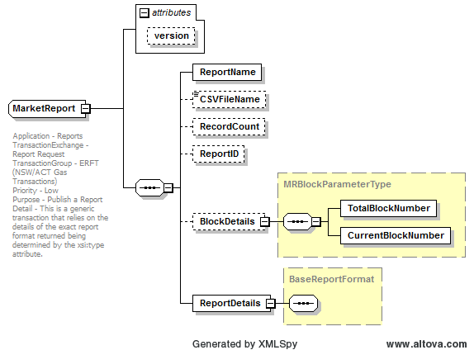
Figure 2-8 MarketReport
Please note that MarketReport is a generic type used for the following CSV reports as well as the XML types defined below:
- ReconciliationResultsRpt
- BasicConsumptionRpt
- MeterReadingToUserRpt
- MeterReadingToUserNonSTTMRpt
- ChangeOfStandingDataRpt
- CustomerChurnRpt
- ReconciliationResultsRpt
- ForecastingDataRpt
- ApportionmentPercentageRpt
- TotalGasInjectedRpt
- DailyNSLRpt
- DailyToSTTMRpt
- WeeklyToSTTMRpt
- WeeklyToUserRpt
- MonthlyToSTTMRpt
- PreMonthlyToSTTMRpt
- FinMonthlyToSTTMRpt
- RevMonthlyToSTTMRpt
- MonthlyToUserRpt
- EstimationResultsToNWORpt
- EstimationResultsToUserRpt
- RevisedEstimationResultsToNWORpt
- RevisedEstimationResultsToUserRpt
- MatchedImbalanceTradeRpt
- ExpiredImbalanceTradeRpt
- ParticipantImbalanceAmountRpt
- RevisedImbalanceRpt
- STTMPipelineAllocationDataRpt
- T298NewStreetListingRpt
- T299CompleteMIRNListingRpt
- T900CustomerSiteDetailsMonthlyRpt
- T2125AncillaryChargeListingRpt
- T2130HeatingValueDailyRpt
- T2131PublishedHeatingValueDailyRpt
- T2145HaulageRightsRpt
- T2270TotalCLPRpt
- T2275TotalCLPRpt
- T2305EffectiveDegreeDayRpt
- T2420QuotationStatusRpt
- T2421QuotationSubmissionRpt
- T2422QuotationNotificationRpt
- T2423QuotationAcceptedRpt
- T2424QuotationAvailableRpt

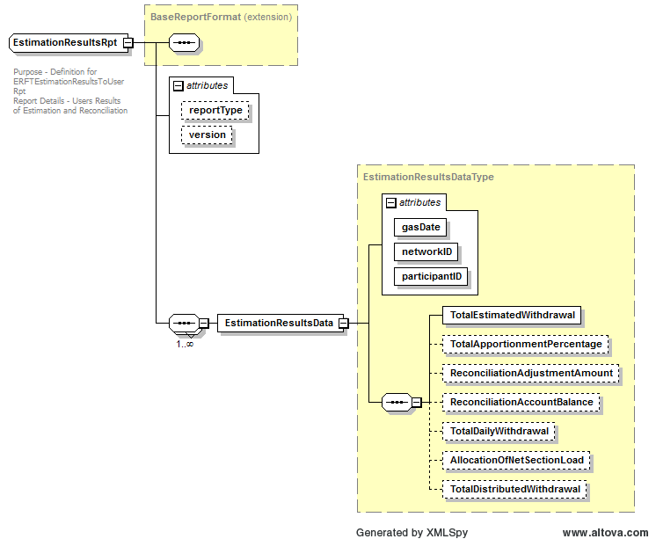
Figure 2-9 EstimationResultsRpt

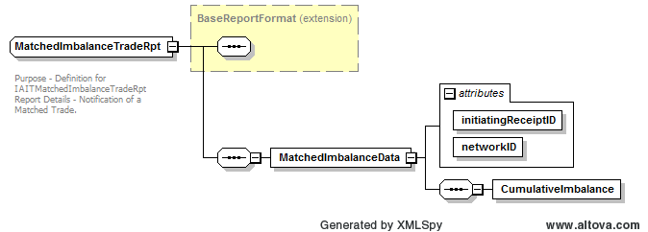

Figure 2-10 MatchedImbalanceTradeRpt

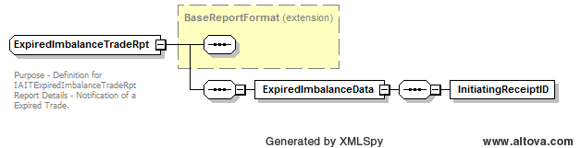

Figure 2-11 ExpiredImbalanceTradeRpt

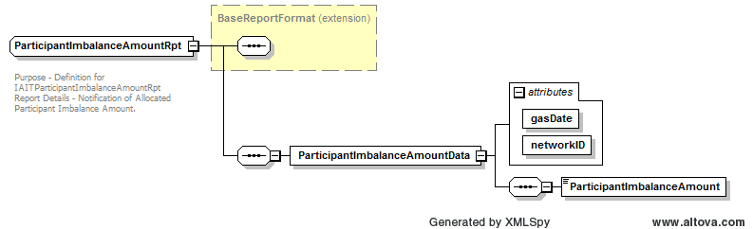

Figure 2-12 ParticipantImbalanceAmountRpt
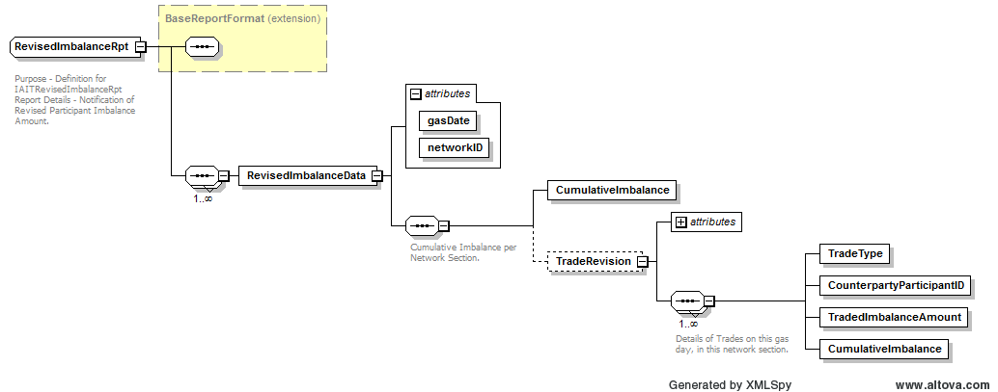

Figure 2-13 RevisedImbalanceRpt

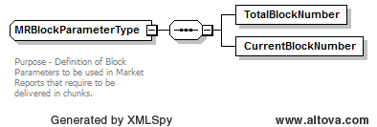

Figure 2-14 - MRBlockParameterType

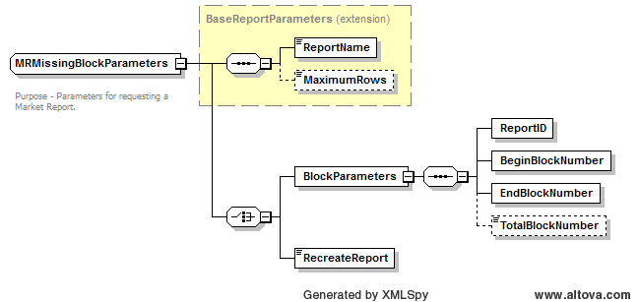

Figure 2-15 - MRMissingBlockParameters

Text View
<?xml version="1.0" encoding="UTF-8"?>
<!-- edited with XMLSpy v2014 rel. 2 sp1 (x64) (http://www.altova.com) by ﻿Australian Energy Market Operator (Australian Energy Market Operator) -->
<xsd:schema xmlns:xsd="http://www.w3.org/2001/XMLSchema" elementFormDefault="unqualified" attributeFormDefault="unqualified">
<xsd:annotation>
<xsd:documentation>This schema file is part of the aseXML schema set, and is subject to the terms and conditions that are detailed in the aseXML_r*.xsd schema file with which this file is used</xsd:documentation>
</xsd:annotation>
<xsd:annotation>
<xsd:documentation>
Purpose - Provide the transaction exchanges needed by reports within each application
Detail - Reports are a common feature of most applications. However, the parameters to and format of each report are likely to vary widely. Thus, the transactions defined in this schema are defined using abstract types for report parameters and formats. Each new application that wishes to use the transactions defines, where necessary, its own derived types for report parameters and formats. Instances of report requests or reponses then use the xsi:type attribute to indicate the specific report details required.
The "Report" transaction exchange allows the request of a report and the return of the results. It consists of a ReportRequest and a ReportResult.
</xsd:documentation>
</xsd:annotation>
<!-- Support Types -->
<xsd:simpleType name="ReportName">
<xsd:annotation>
<xsd:documentation>
Purpose - Identifies the required report
</xsd:documentation>
</xsd:annotation>
<xsd:restriction base="xsd:string">
<xsd:maxLength value="80"/>
</xsd:restriction>
</xsd:simpleType>
<xsd:simpleType name="ReportType">
<xsd:annotation>
<xsd:documentation>The type reports.
PRE- Preliminary
REV-Revision
FIN-Final
</xsd:documentation>
</xsd:annotation>
<xsd:restriction base="xsd:string">
<xsd:length value="3"/>
<xsd:enumeration value="PRE"/>
<xsd:enumeration value="REV"/>
<xsd:enumeration value="FIN"/>
</xsd:restriction>
</xsd:simpleType>
<xsd:simpleType name="PipelineID">
<xsd:annotation>
<xsd:documentation>A unique identifier for a Pipeline</xsd:documentation>
</xsd:annotation>
<xsd:restriction base="xsd:string">
<xsd:minLength value="1"/>
<xsd:maxLength value="12"/>
</xsd:restriction>
</xsd:simpleType>
<!-- Base Report Types -->
<xsd:complexType name="BaseReportParameters" abstract="true">
<xsd:annotation>
<xsd:documentation>
Purpose - base type from which all report parameter definitions derive.
Detail - The minimum parameters required for a report is a report name
</xsd:documentation>
</xsd:annotation>
<xsd:sequence>
<xsd:element name="ReportName" type="ReportName"/>
<xsd:element name="MaximumRows" type="xsd:nonNegativeInteger" minOccurs="0"/>
</xsd:sequence>
</xsd:complexType>
<xsd:complexType name="BaseReportFormat" abstract="true">
<xsd:annotation>
<xsd:documentation>
Purpose - base types from which all report format definitions derive
Detail - The only limitation made by this definition is that the content will be complex.
</xsd:documentation>
</xsd:annotation>
<xsd:sequence/>
</xsd:complexType>
<!--Generic Report Parameters-->
<xsd:complexType name="ReportParameterType" abstract="true">
<xsd:annotation>
<xsd:documentation>
Purpose - Identify a genericParameterType </xsd:documentation>
</xsd:annotation>
<xsd:sequence>
<xsd:element name="Name" type="NonZeroLengthString"/>
</xsd:sequence>
</xsd:complexType>
<xsd:complexType name="MRBlockParameterType">
<xsd:annotation>
<xsd:documentation>
Purpose - Definition of Block Parameters to be used in Market Reports that are required to be delivered in chunks.</xsd:documentation>
</xsd:annotation>
<xsd:sequence>
<xsd:element name="TotalBlockNumber" type="ReplicationSequenceNumber"/>
<xsd:element name="CurrentBlockNumber" type="ReplicationSequenceNumber"/>
</xsd:sequence>
</xsd:complexType>
<xsd:complexType name="StringParameter">
<xsd:annotation>
<xsd:documentation>
Purpose - Identify a genericParameterType </xsd:documentation>
</xsd:annotation>
<xsd:complexContent>
<xsd:extension base="ReportParameterType">
<xsd:sequence>
<xsd:element name="Value" type="NonZeroLengthString" nillable="true"/>
<xsd:element name="Description" minOccurs="0"/>
</xsd:sequence>
</xsd:extension>
</xsd:complexContent>
</xsd:complexType>
<xsd:complexType name="DateParameter">
<xsd:annotation>
<xsd:documentation>
Purpose - Identify a genericParameterType </xsd:documentation>
</xsd:annotation>
<xsd:complexContent>
<xsd:extension base="ReportParameterType">
<xsd:sequence>
<xsd:element name="Value" type="xsd:date" nillable="true"/>
<xsd:element name="Description" type="NonZeroLengthString" minOccurs="0"/>
</xsd:sequence>
</xsd:extension>
</xsd:complexContent>
</xsd:complexType>
<xsd:complexType name="DateTimeParameter">
<xsd:annotation>
<xsd:documentation>
Purpose - Identify a genericParameterType </xsd:documentation>
</xsd:annotation>
<xsd:complexContent>
<xsd:extension base="ReportParameterType">
<xsd:sequence>
<xsd:element name="Value" type="xsd:dateTime" nillable="true"/>
<xsd:element name="Description" minOccurs="0"/>
</xsd:sequence>
</xsd:extension>
</xsd:complexContent>
</xsd:complexType>
<xsd:complexType name="IntegerParameter">
<xsd:annotation>
<xsd:documentation>
Purpose - Identify a genericParameterType </xsd:documentation>
</xsd:annotation>
<xsd:complexContent>
<xsd:extension base="ReportParameterType">
<xsd:sequence>
<xsd:element name="Value" type="xsd:integer" nillable="true"/>
<xsd:element name="Description" type="NonZeroLengthString" minOccurs="0"/>
</xsd:sequence>
</xsd:extension>
</xsd:complexContent>
</xsd:complexType>
<xsd:complexType name="BooleanParameter">
<xsd:annotation>
<xsd:documentation>
Purpose - Identify a genericParameterType </xsd:documentation>
</xsd:annotation>
<xsd:complexContent>
<xsd:extension base="ReportParameterType">
<xsd:sequence>
<xsd:element name="Value" type="xsd:boolean" nillable="true"/>
<xsd:element name="Description" type="NonZeroLengthString" minOccurs="0"/>
</xsd:sequence>
</xsd:extension>
</xsd:complexContent>
</xsd:complexType>
<xsd:complexType name="DecimalParameter">
<xsd:annotation>
<xsd:documentation>
Purpose - Identify a genericParameterType </xsd:documentation>
</xsd:annotation>
<xsd:complexContent>
<xsd:extension base="ReportParameterType">
<xsd:sequence>
<xsd:element name="Value" type="xsd:decimal" nillable="true"/>
<xsd:element name="Description" type="NonZeroLengthString" minOccurs="0"/>
</xsd:sequence>
</xsd:extension>
</xsd:complexContent>
</xsd:complexType>
<xsd:complexType name="TimeParameter">
<xsd:annotation>
<xsd:documentation>
Purpose - Identify a genericParameterType </xsd:documentation>
</xsd:annotation>
<xsd:complexContent>
<xsd:extension base="ReportParameterType">
<xsd:sequence>
<xsd:element name="Value" type="xsd:time" nillable="true"/>
<xsd:element name="Description" type="NonZeroLengthString" minOccurs="0"/>
</xsd:sequence>
</xsd:extension>
</xsd:complexContent>
</xsd:complexType>
<xsd:complexType name="ReportParametersType">
<xsd:annotation>
<xsd:documentation>
Purpose - container for list of generic parameters
</xsd:documentation>
</xsd:annotation>
<xsd:sequence maxOccurs="unbounded">
<xsd:element name="Parameter" type="ReportParameterType"/>
</xsd:sequence>
</xsd:complexType>
<!-- Generic Report Format Types -->
<xsd:complexType name="CSVReportFormat">
<xsd:annotation>
<xsd:documentation>
Purpose - container for a CSV formatted report
Detail - Where the report is using CSV as the output format, this generic container may be used to return the results.
</xsd:documentation>
</xsd:annotation>
<xsd:complexContent>
<xsd:extension base="BaseReportFormat">
<xsd:sequence>
<xsd:element name="CSVData" type="xsd:string"/>
</xsd:sequence>
</xsd:extension>
</xsd:complexContent>
</xsd:complexType>
<xsd:complexType name="ReplicationReportFormat">
<xsd:annotation>
<xsd:documentation>
Purpose - container for a report having the same structure as used by the table replication transactions
Detail - Where a report returns a related set of table contents, a standard container may be used, since the structure of the replication block will impose structure on the report in terms of format.
</xsd:documentation>
</xsd:annotation>
<xsd:complexContent>
<xsd:extension base="BaseReportFormat">
<xsd:sequence>
<xsd:element name="ReplicationBlock" type="ReplicationBlock" maxOccurs="unbounded"/>
</xsd:sequence>
</xsd:extension>
</xsd:complexContent>
</xsd:complexType>
<xsd:complexType name="GenericReportParameters">
<xsd:annotation>
<xsd:documentation>
Purpose - Generic Report Parameters for a MDMT and CATS Reports
Report Name -
MSATS Report -
</xsd:documentation>
</xsd:annotation>
<xsd:complexContent>
<xsd:extension base="BaseReportParameters">
<xsd:sequence>
<xsd:element name="Parameters" type="ReportParametersType" minOccurs="0"/>
</xsd:sequence>
<xsd:attribute name="version" type="r22" use="optional" default="r22"/>
</xsd:extension>
</xsd:complexContent>
</xsd:complexType>
<xsd:complexType name="MRMissingBlockParameters">
<xsd:annotation>
<xsd:documentation>
Purpose - Parameters for requesting a Market Report. Provide the ReportID which will be the same for all chunks.
For example if chunk 6 is required out of a report sent as 10 chunks populate BeginBlockNumber and EndBlockNumber as 6
and TotalBlockNumber as 10.
</xsd:documentation>
</xsd:annotation>
<xsd:complexContent>
<xsd:extension base="BaseReportParameters">
<xsd:choice>
<xsd:element name="BlockParameters">
<xsd:complexType>
<xsd:sequence>
<xsd:element name="ReportID" type="UniqueIdentifier"/>
<xsd:element name="BeginBlockNumber" type="ReplicationSequenceNumber"/>
<xsd:element name="EndBlockNumber" type="ReplicationSequenceNumber"/>
<xsd:element name="TotalBlockNumber" minOccurs="0"/>
</xsd:sequence>
</xsd:complexType>
</xsd:element>
<xsd:element name="RecreateReport" type="xsd:boolean"/>
</xsd:choice>
</xsd:extension>
</xsd:complexContent>
</xsd:complexType>
<!-- Transaction Types -->
<xsd:complexType name="ReportRequest">
<xsd:annotation>
<xsd:documentation>
Application - Reports
TransactionExchange - Report Request
TransactionGroup - Multiple
Priority - Low
Purpose - Request a report
Detail - This is a generic transaction that relies on the details of the exact report required being determined by the xsi:type attribute provided by the sender on the ReportParameters element.
</xsd:documentation>
</xsd:annotation>
<xsd:sequence>
<xsd:element name="ReportParameters" type="BaseReportParameters"/>
</xsd:sequence>
<xsd:attribute name="version" type="r10" use="optional" default="r10"/>
</xsd:complexType>
<xsd:complexType name="ReportResponse">
<xsd:annotation>
<xsd:documentation>
Application - Reports
TransactionExchange - Report Request
TransactionGroup - CATS for CATSReportRequest, MDMT for MDMReportRequest
Priority - Low
Purpose - Return the results of a report
Detail - This is a generic transaction that relies on the details of the exact report format returned being determined by the xsi:type attribute provided by the sender on the ReportParameters and ReportResults elements. At least one Event element must be present in the response to indicate the success or otherwise of the report.
</xsd:documentation>
</xsd:annotation>
<xsd:sequence>
<xsd:element name="ReportParameters" type="BaseReportParameters"/>
<xsd:element name="ReportResults" type="BaseReportFormat" minOccurs="0"/>
<xsd:element name="Event" type="Event" maxOccurs="unbounded"/>
</xsd:sequence>
<xsd:attribute name="version" type="r10" use="optional" default="r10"/>
</xsd:complexType>
<!--NSW-ACT Specific Reports-->
<xsd:complexType name="MarketReport">
<xsd:annotation>
<xsd:documentation>
Application - Reports
TransactionExchange - Report Request
TransactionGroup - (NSW/ACT Gas Transactions)
Priority - Low
Purpose - Publish a Report
Detail - This is a generic transaction that relies on the details of the exact report format returned being determined by the xsi:type attribute.
</xsd:documentation>
</xsd:annotation>
<xsd:sequence>
<xsd:element name="ReportName" type="MarketReportNamesType"/>
<xsd:element name="CSVFileName" type="xsd:string" minOccurs="0"/>
<xsd:element name="RecordCount" type="RecordCount" minOccurs="0"/>
<xsd:element name="ReportID" type="UniqueIdentifier" minOccurs="0"/>
<xsd:element name="BlockDetails" type="MRBlockParameterType" minOccurs="0"/>
<xsd:element name="ReportDetails" type="BaseReportFormat"/>
</xsd:sequence>
<xsd:attribute name="version" type="r34" use="optional" default="r34"/>
</xsd:complexType>
<xsd:complexType name="EstimationResultsRpt">
<xsd:annotation>
<xsd:documentation>
Purpose - Definition for ERFTEstimationResultsToUserRpt
Report Details - Users Results of Estimation and Reconciliation
</xsd:documentation>
</xsd:annotation>
<xsd:complexContent>
<xsd:extension base="BaseReportFormat">
<xsd:sequence maxOccurs="unbounded">
<xsd:element name="EstimationResultsData" type="EstimationResultsDataType"/>
</xsd:sequence>
<xsd:attribute name="reportType" type="ReportType" use="optional"/>
<xsd:attribute name="version" type="r34" use="optional" default="r34"/>
</xsd:extension>
</xsd:complexContent>
</xsd:complexType>
<xsd:complexType name="MatchedImbalanceTradeRpt">
<xsd:annotation>
<xsd:documentation>
Purpose - Definition for IAITMatchedImbalanceTradeRpt
Report Details - Notification of a Matched Trade.
</xsd:documentation>
</xsd:annotation>
<xsd:complexContent>
<xsd:extension base="BaseReportFormat">
<xsd:sequence>
<xsd:element name="MatchedImbalanceData">
<xsd:complexType>
<xsd:sequence>
<xsd:element name="CumulativeImbalance" type="QuantityOfGasMJ"/>
</xsd:sequence>
<xsd:attribute name="initiatingReceiptID" type="ReceiptIdentifier" use="required"/>
<xsd:attribute name="networkID" type="NetworkID" use="required"/>
</xsd:complexType>
</xsd:element>
</xsd:sequence>
</xsd:extension>
</xsd:complexContent>
</xsd:complexType>
<xsd:complexType name="ExpiredImbalanceTradeRpt">
<xsd:annotation>
<xsd:documentation>
Purpose - Definition for IAITExpiredImbalanceTradeRpt
Report Details - Notification of a Expired Trade.
</xsd:documentation>
</xsd:annotation>
<xsd:complexContent>
<xsd:extension base="BaseReportFormat">
<xsd:sequence>
<xsd:element name="ExpiredImbalanceData">
<xsd:complexType>
<xsd:sequence>
<xsd:element name="InitiatingReceiptID" type="ReceiptIdentifier"/>
</xsd:sequence>
</xsd:complexType>
</xsd:element>
</xsd:sequence>
</xsd:extension>
</xsd:complexContent>
</xsd:complexType>
<xsd:complexType name="ParticipantImbalanceAmountRpt">
<xsd:annotation>
<xsd:documentation>
Purpose - Definition for IAITParticipantImbalanceAmountRpt
Report Details - Notification of Allocated Participant Imbalance Amount.
</xsd:documentation>
</xsd:annotation>
<xsd:complexContent>
<xsd:extension base="BaseReportFormat">
<xsd:sequence>
<xsd:element name="ParticipantImbalanceAmountData">
<xsd:complexType>
<xsd:sequence>
<xsd:element name="ParticipantImbalanceAmount"/>
</xsd:sequence>
<xsd:attribute name="gasDate" use="required"/>
<xsd:attribute name="networkID" use="required"/>
</xsd:complexType>
</xsd:element>
</xsd:sequence>
</xsd:extension>
</xsd:complexContent>
</xsd:complexType>
<xsd:complexType name="RevisedImbalanceRpt">
<xsd:annotation>
<xsd:documentation>
Purpose - Definition for IAITRevisedImbalanceRpt
Report Details - Notification of Revised Participant Imbalance Amount.
</xsd:documentation>
</xsd:annotation>
<xsd:complexContent>
<xsd:extension base="BaseReportFormat">
<xsd:sequence maxOccurs="unbounded">
<xsd:element name="RevisedImbalanceData">
<xsd:complexType>
<xsd:sequence>
<xsd:annotation>
<xsd:documentation>Cumulative Imbalance per Network Section.</xsd:documentation>
</xsd:annotation>
<xsd:element name="CumulativeImbalance" type="QuantityOfGasMJ"/>
<xsd:element name="TradeRevision" minOccurs="0">
<xsd:complexType>
<xsd:sequence maxOccurs="unbounded">
<xsd:annotation>
<xsd:documentation>Details of Trades on this gas day, in this network section.</xsd:documentation>
</xsd:annotation>
<xsd:element name="TradeType" type="TradeType"/>
<xsd:element name="CounterpartyParticipantID" type="PartyIdentifier"/>
<xsd:element name="TradedImbalanceAmount" type="QuantityOfGasMJ"/>
<xsd:element name="CumulativeImbalance" type="QuantityOfGasMJ"/>
</xsd:sequence>
<xsd:attribute name="initiatingReceiptID" use="required"/>
</xsd:complexType>
</xsd:element>
</xsd:sequence>
<xsd:attribute name="gasDate" type="xsd:date" use="required"/>
<xsd:attribute name="networkID" type="NetworkID" use="required"/>
</xsd:complexType>
</xsd:element>
</xsd:sequence>
</xsd:extension>
</xsd:complexContent>
</xsd:complexType>
<xsd:complexType name="EstimationResultsDataType">
<xsd:annotation>
<xsd:documentation>
Purpose - Definition for ERFTRevisedEstimationResultsData
Details - Results of Estimation and Reconciliation to User (Sent as a Notification Transaction)
</xsd:documentation>
</xsd:annotation>
<xsd:sequence>
<xsd:element name="TotalEstimatedWithdrawal" type="QuantityOfGasMJ"/>
<xsd:element name="TotalApportionmentPercentage" type="ApportionmentPercentage" minOccurs="0"/>
<xsd:element name="ReconciliationAdjustmentAmount" type="QuantityOfGasMJ" minOccurs="0"/>
<xsd:element name="ReconciliationAccountBalance" type="QuantityOfGasMJ" minOccurs="0"/>
<xsd:element name="TotalDailyWithdrawal" type="QuantityOfGasMJ" minOccurs="0"/>
<xsd:element name="AllocationOfNetSectionLoad" type="QuantityOfGasMJ" minOccurs="0"/>
<xsd:element name="TotalDistributedWithdrawal" type="QuantityOfGasMJ" minOccurs="0"/>
</xsd:sequence>
<xsd:attribute name="gasDate" type="xsd:date" use="required"/>
<xsd:attribute name="networkID" type="NetworkID" use="required"/>
<xsd:attribute name="participantID" type="xsd:string" use="required"/>
</xsd:complexType>
</xsd:schema>

Schema File aseXml_r34.xsd

Text View
<?xml version=”1.0” encoding=”UTF-8”?>
<xsd:schema xmlns=”urn:aseXML:r34” xmlns:xsd=”http://www.w3.org/2001/XMLSchema” targetNamespace=”urn:aseXML:r34”>
<xsd:annotation>
<xsd:documentation>
Purpose — Top level aseXML schema

… unmodified text removed for brevity …

</xsd:documentation>
</xsd:annotation>
<xsd:include schemaLocation=”Events_r33.xsd”>
<xsd:include schemaLocation=”Events_r34.xsd”>
<xsd:annotation>
<xsd:documentation>
Purpose — Include data types for status reporting
</xsd:documentation>
</xsd:annotation>
</xsd:include>

… unmodified text removed for brevity …
<xsd:include schemaLocation="Common_r33.xsd">
<xsd:include schemaLocation="Common_r34.xsd">
<xsd:annotation>
<xsd:documentation>
Purpose - Include data types for carrying transactions within aseXML
</xsd:documentation>
</xsd:annotation>
</xsd:include>
… unmodified text removed for brevity …

<xsd:include schemaLocation="Reports_r33.xsd">
<xsd:include schemaLocation="Reports_r34.xsd">
<xsd:annotation>
<xsd:documentation>
Purpose - Include data types for carrying transactions within aseXML
</xsd:documentation>
</xsd:annotation>
</xsd:include>

… unmodified text removed for brevity …

<xsd:include schemaLocation="Header_r28.xsd">
<xsd:include schemaLocation="Header_r34.xsd">
<xsd:annotation>
<xsd:documentation>
Purpose - Include data types for carrying transactions within aseXML
</xsd:documentation>
</xsd:annotation>
</xsd:include>

… unmodified text removed for brevity …
<xsd:include schemaLocation="CustomerDetails_r33.xsd">
<xsd:include schemaLocation="CustomerDetails_r34.xsd">
<xsd:annotation>
<xsd:documentation>
Purpose - Include data types for carrying transactions within aseXML
</xsd:documentation>
</xsd:annotation>
</xsd:include>

<xsd:include schemaLocation="NetworkBilling_r33.xsd">
<xsd:include schemaLocation="NetworkBilling_r34.xsd">
<xsd:annotation>
<xsd:documentation>
Purpose - Include data types for carrying transactions within aseXML
</xsd:documentation>
</xsd:annotation>
</xsd:include>

… unmodified text removed for brevity …

<xsd:include schemaLocation="Gas_r33.xsd">
<xsd:include schemaLocation="Gas_r34.xsd">
<xsd:annotation>
<xsd:documentation>
Purpose - Include data types for carrying transactions within aseXML
</xsd:documentation>
</xsd:annotation>
</xsd:include>

… unmodified text removed for brevity …

<xsd:include schemaLocation="GasMarketWholesale_r31.xsd">
<xsd:include schemaLocation="GsWholesaleMarket_r34.xsd">
<xsd:annotation>
<xsd:documentation>
Purpose - Include data types for Electricity MMS transactions
</xsd:documentation>
</xsd:annotation>
</xsd:include
Purpose - Include data types for gas market wholesale functionality.
… unmodified text removed for brevity …

<xsd:include schemaLocation="Transactions_r33.xsd">
<xsd:include schemaLocation="Transactions_r34.xsd">
<xsd:annotation>
<xsd:documentation>
Purpose - Include data types for carrying transactions within aseXML
</xsd:documentation>
</xsd:annotation>
</xsd:include>
… unmodified text removed for brevity …

Schema File Events_r34.xsd

Text View
Text added is given in bold:
… unmodified text removed for brevity …
<xsd:simpleType name="r34">
<xsd:annotation>
<xsd:documentation>Purpose - Release r34 identifier. This release adds AMDQ Transactions to Gas Wholesale Market to support Web Exchanger Web Services</xsd:documentation>
</xsd:annotation>
<xsd:restriction base="ReleaseIdentifier">
<xsd:enumeration value="r34"/>
</xsd:restriction>
</xsd:simpleType>

Schema File Header_r34.xsd

Text View
… unmodified text removed for brevity …

<xsd:enumeration value="ERFT"/>
<xsd:enumeration value="IAIT"/>

… unmodified text removed for brevity …
<xsd:enumeration value="NTGAS"/>
<xsd:enumeration value="QLDGAS"/>
<xsd:enumeration value="SAGAS"/>
<xsd:enumeration value="TASGAS"/>
<xsd:enumeration value="VICGAS"/>
<xsd:enumeration value="WAGAS"/>
<xsd:enumeration value="NSWACTGAS"/>

Schema File Common_r34.xsd

Text View
… unmodified text removed for brevity …

<xsd:enumeration value="UP"/>
<xsd:enumeration value="UR"/>
<xsd:enumeration value="US"/>
<xsd:enumeration value="WH"/>
</xsd:restriction>
</xsd:simpleType>
<xsd:simpleType name="NetworkID">
<xsd:annotation>
<xsd:documentation>Network ID has been included in several reports and as a part of meter standing data</xsd:documentation>
</xsd:annotation>
<xsd:restriction base="xsd:string">
<xsd:maxLength value="15"/>
<xsd:minLength value="2"/>
</xsd:restriction>
</xsd:simpleType>
<xsd:simpleType name="IndexInvestigationCode">
<xsd:annotation>
<xsd:documentation>Schema - Gas</xsd:documentation>
</xsd:annotation>
<xsd:restriction base="xsd:string">
<xsd:enumeration value="Confirm Reading For Vacant Site"/>
<xsd:enumeration value="Confirm Zero Consumption"/>
<xsd:enumeration value="Incomplete Data"/>
<xsd:enumeration value="Invalid MDFF Data"/>
<xsd:enumeration value="Invalid Standing Data"/>
<xsd:enumeration value="Missing Datastream"/>
<xsd:enumeration value="Require Actual Reading or Substitute"/>
<xsd:enumeration value="Require Final Substitute"/>
<xsd:enumeration value="Require Latest Version"/>
<xsd:enumeration value="Scheduled Reading Required"/>
<xsd:enumeration value="Service Order Reading Required"/>
<xsd:enumeration value="Verify High Reading"/>
<xsd:enumeration value="Verify Low Reading"/>
<xsd:enumeration value="Customer Away"/>
<xsd:enumeration value="Customer Query"/>
<xsd:enumeration value="Customer Read"/>
<xsd:enumeration value="High Account"/>
<xsd:enumeration value="Zero Consumption"/>
<xsd:enumeration value="Recipient Not Responsible For The NMI"/>
<xsd:enumeration value="Other"/>
<xsd:enumeration value="Cross Meter"/>
<xsd:enumeration value="MDL Out of Alignment"/>
</xsd:restriction>
</xsd:simpleType>
… unmodified text removed for brevity …

Schema File CustomerDetails_r34.xsd
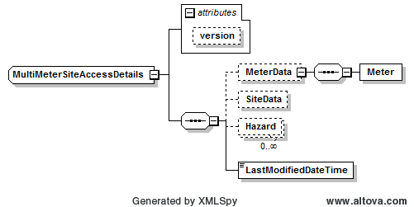
Figure 2-16 MultiMeterSiteAccessDetails

Text View
… unmodified text removed for brevity …
<xsd:complexType name="MultiMeterSiteAccessDetails">
<xsd:annotation>
<xsd:documentation> </xsd:documentation>
</xsd:annotation>
<xsd:complexContent>
<xsd:extension base="NMIStandingData">
<xsd:sequence>
<xsd:element name="MeterData" minOccurs="0">
<xsd:complexType>
<xsd:sequence>
<xsd:element name="Meter" type="GasMultiMeterStandingDataType"/>
</xsd:sequence>
</xsd:complexType>
</xsd:element>
<xsd:element name="SiteData" type="ServicePoint" minOccurs="0"/>
<xsd:element name="Hazard" type="SiteHazard" minOccurs="0" maxOccurs="unbounded"/>
<xsd:element name="LastModifiedDateTime" type="xsd:dateTime"/>
</xsd:sequence>
<xsd:attribute name="version" type="r34" use="optional" default="r34"/>
</xsd:extension>
</xsd:complexContent>
</xsd:complexType>
… unmodified text removed for brevity …

Schema File Enumerations.xsd

Text View
… unmodified text removed for brevity …
</xsd:annotation>
<xsd:annotation>
<xsd:documentation>File version 7.0

Enumerations file containing the enumerations that can be added to at short notice and can be released outside of the standard aseXML change cycle.

Guidelines for use of this file:
- The included types and enumerated values should be controlled by bodies outside of participating industries (ie. councils, etc)
- The included types should be unlikely to ever be involved in back end decision making processing
- Only additions are allowed outside of the standard aseXML Change Process cycle
- Deletions and modifications should be discouraged, but, if necessary, must be made through the aseXML Rapid Change

… unmodified text removed for brevity …

<!--NSW Report Names-->
<xsd:simpleType name="MarketReportNamesType">
<xsd:annotation>
<xsd:documentation>
Purpose - Define the Name of any report that accepts CSV Report in the generic CSVReport format.
Element MarketReportNames has been restricted to 80 characters.

Version 7.0 additions
Added MarketReportNamesType for defining Market Report Names

</xsd:documentation>
</xsd:annotation>
<xsd:restriction base="xsd:string">
<xsd:maxLength value="80"/>
<xsd:enumeration value="DPRExtractRpt"/>
<xsd:enumeration value="BasicConsumptionRpt"/>
<xsd:enumeration value="MeterReadingToUserRpt"/>
<xsd:enumeration value="MeterReadingToUserNonSTTMRpt"/>
<xsd:enumeration value="ChangeOfStandingDataRpt"/>
<xsd:enumeration value="CustomerChurnRpt"/>
<xsd:enumeration value="EstimationResultsToUserRpt"/>
<xsd:enumeration value="RevisedEstimationResultsToUserRpt"/>
<xsd:enumeration value="ReconciliationResultsRpt"/>
<xsd:enumeration value="ForecastingDataRpt"/>
<xsd:enumeration value="ApportionmentPercentageRpt"/>
<xsd:enumeration value="DailyNSLRpt"/>
<xsd:enumeration value="STTMPipelineAllocationDataRpt"/>
<xsd:enumeration value="DailyToSTTMRpt"/>
<xsd:enumeration value="DailyToUserRpt"/>
<xsd:enumeration value="WeeklyToSTTMRpt"/>
<xsd:enumeration value="MonthlyToSTTMRpt"/>
<xsd:enumeration value="PreMonthlyToSTTMRpt"/>
<xsd:enumeration value="FinMonthlyToSTTMRpt"/>
<xsd:enumeration value="RevMonthlyToSTTMRpt"/>
<xsd:enumeration value="MonthlyToUserRpt"/>
<xsd:enumeration value="TotalGasInjectedRpt"/>
<xsd:enumeration value="WeeklyToUserRpt"/>
<xsd:enumeration value="EstimationResultsToNWORpt"/>
<xsd:enumeration value="RevisedEstimationResultsToNWORpt"/>
<xsd:enumeration value="MatchedImbalanceTradeRpt"/>
<xsd:enumeration value="ExpiredImbalanceTradeRpt"/>
<xsd:enumeration value="ParticipantImbalanceAmountRpt"/>
<xsd:enumeration value="RevisedImbalanceRpt"/>
<xsd:enumeration value="T298NewStreetListingRpt"/>
<xsd:enumeration value="T299CompleteMIRNListingRpt"/>
<xsd:enumeration value="T900CustomerSiteDetailsMonthlyRpt"/>
<xsd:enumeration value="T2125AncillaryChargeListingRpt"/>
<xsd:enumeration value="T2130HeatingValueDailyRpt"/>
<xsd:enumeration value="T2131PublishedHeatingValueDailyRpt"/>
<xsd:enumeration value="T2145HaulageRightsRpt"/>
<xsd:enumeration value="T2270TotalCLPRpt"/>
<xsd:enumeration value="T2275TotalCLPRpt"/>
<xsd:enumeration value="T2305EffectiveDegreeDayRpt"/>
<xsd:enumeration value="T2420QuotationStatusRpt"/>
<xsd:enumeration value="T2421QuotationSubmissionRpt"/>
<xsd:enumeration value="T2422QuotationNotificationRpt"/>
<xsd:enumeration value="T2423QuotationAcceptedRpt"/>
<xsd:enumeration value="T2424QuotationAvailableRpt"/>
</xsd:restriction>
</xsd:simpleType>
… unmodified text removed for brevity …

Schema File Gas_r34.xsd

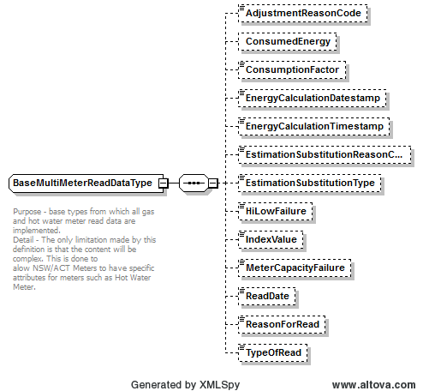

Figure 2-17 BaseMultiMeterReadDataType

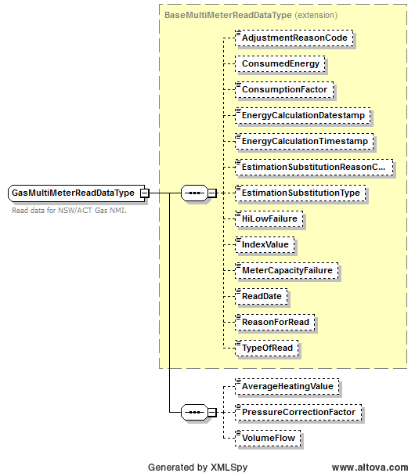

Figure 2-18 GasMultiMeterReadDataType

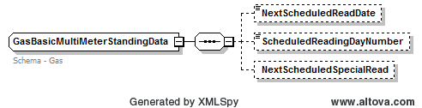

Figure 2-19 GasBasicMultiMeterReadDataType
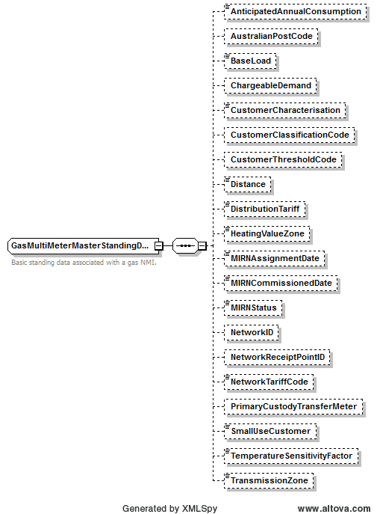

Figure 2-20 GasMultiMeterMasterStandingDataType

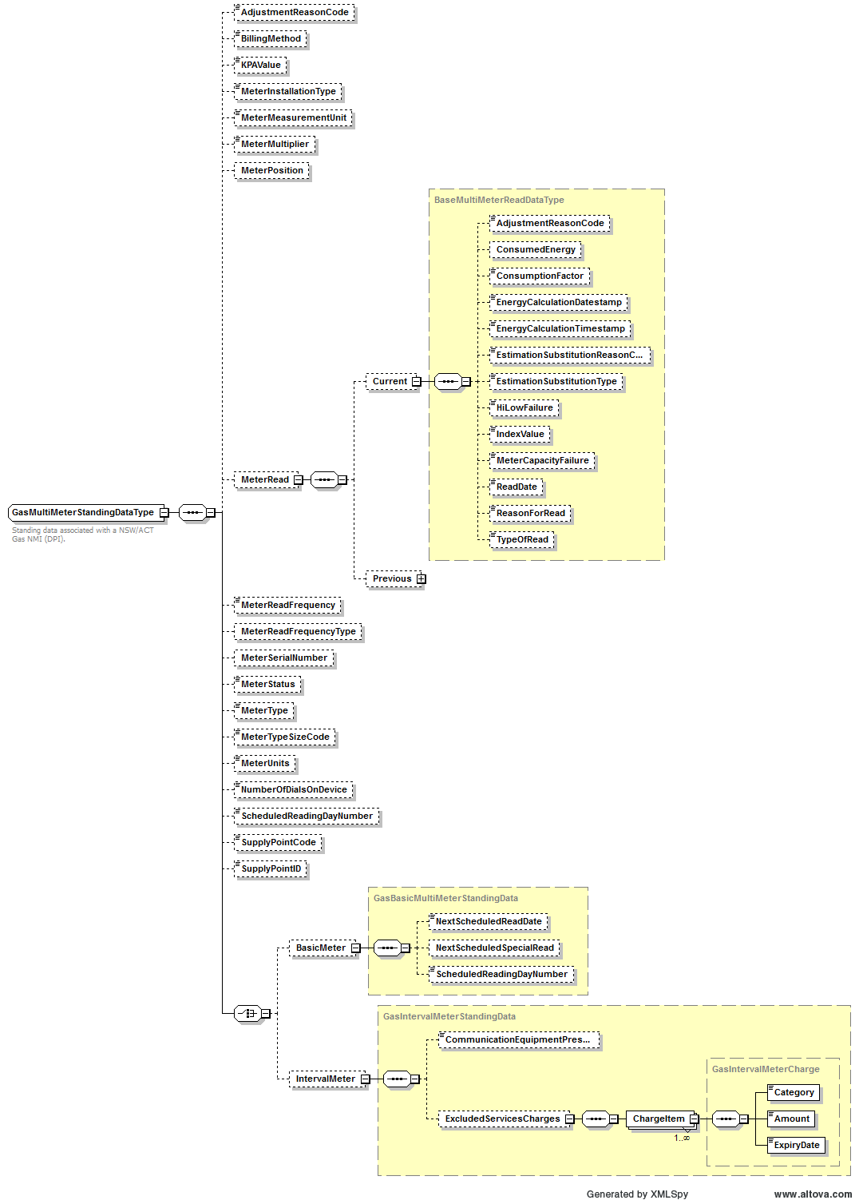

Figure 2-21 GasMultiMeterStandingDataType
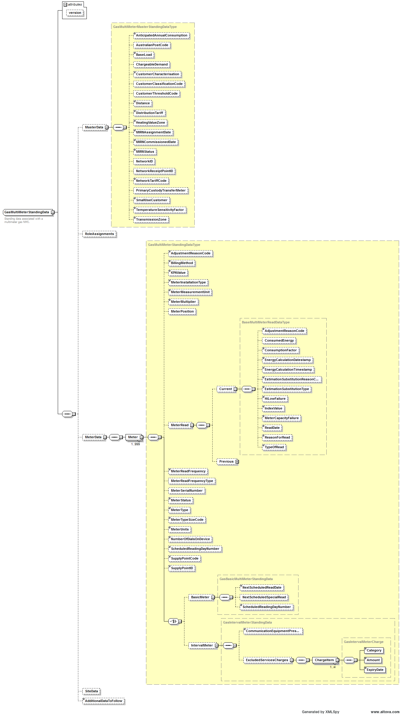

Figure 2-22 GasMultiMeterStandingData

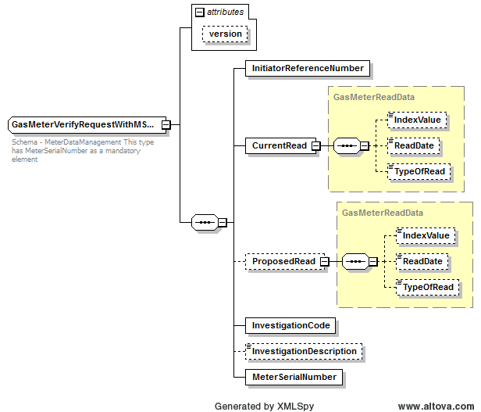

Figure 2-23 GasMeterVerifyRequestWithMSNData

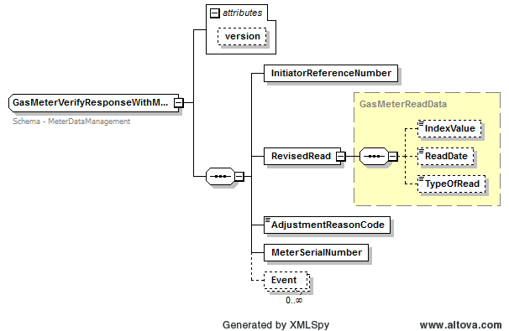

Figure 2-24 GasMeterVerifyResponseWithMSNData

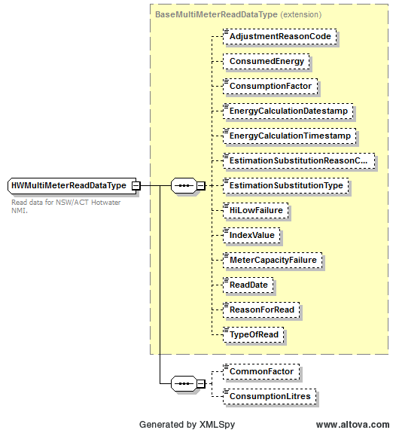

Figure 2-25 HWMultiMeterReadDataType
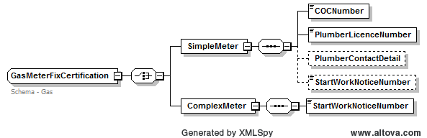

Figure 2-26 GasMeterFixCertification

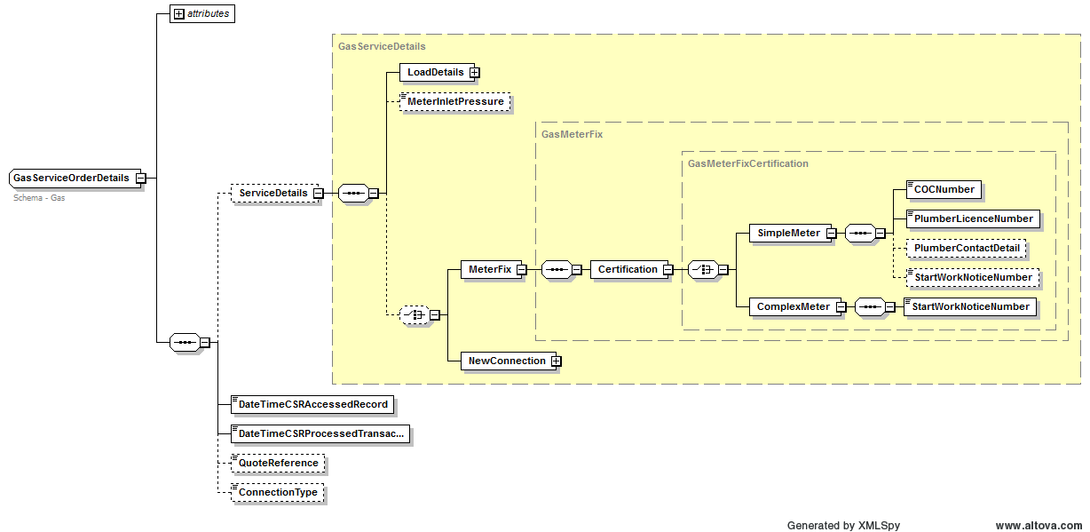

Figure 2-27 GasServiceOrderDetails

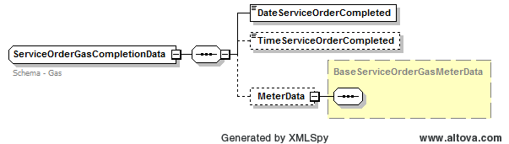

Figure 2-28 ServiceOrderGasCompletionData
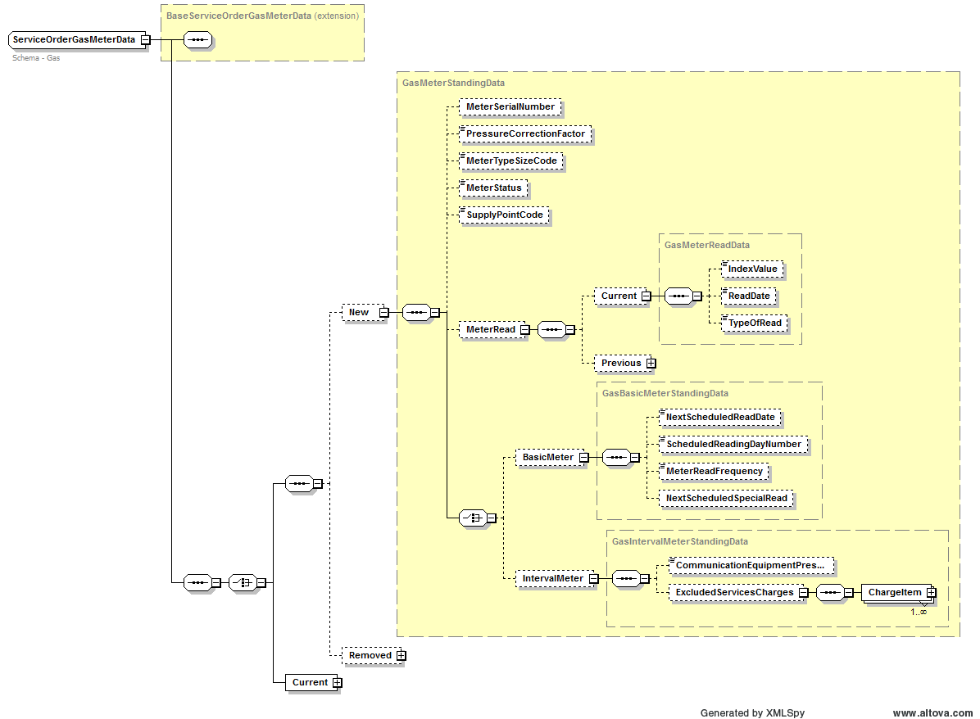

Figure 2-29 ServiceOrderGasMeterData
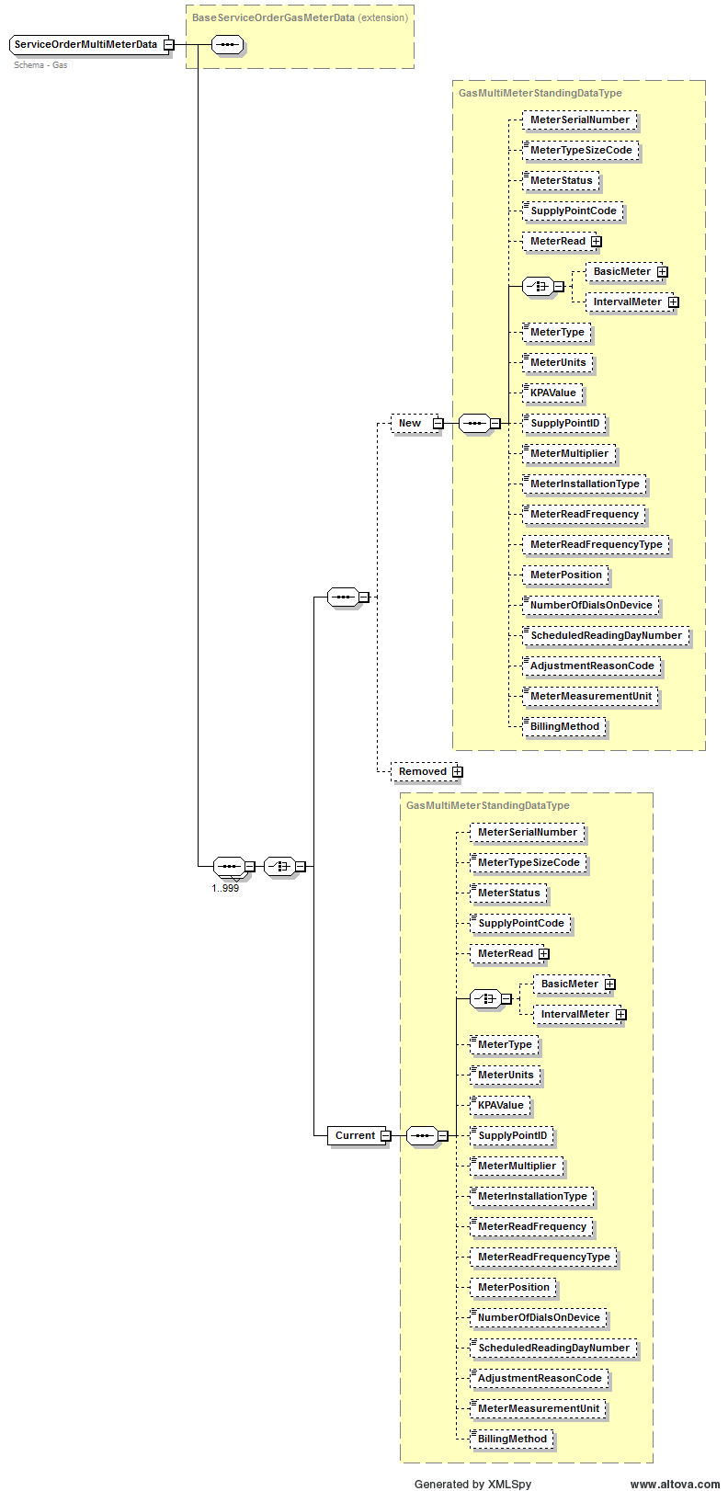
Figure 2-30 ServiceOrderMultiMeterData

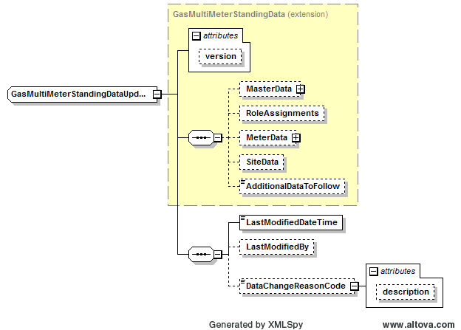
Figure 2-31 GasMultiMeterStandingDataUpdate

Text View
… unmodified text removed for brevity …
<?xml version="1.0" encoding="UTF-8"?>
<!-- edited with XMLSpy v2014 rel. 2 sp1 (x64) (http://www.altova.com) by ﻿Australian Energy Market Operator (Australian Energy Market Operator) -->
<xsd:schema xmlns:xsd="http://www.w3.org/2001/XMLSchema">
<xsd:annotation>
<xsd:documentation>This schema file is part of the aseXML schema set, and is subject to the terms and conditions that are detailed in the aseXML_r*.xsd schema file with which this file is used</xsd:documentation>
</xsd:annotation>
<xsd:annotation>
<xsd:documentation>
Purpose - Define gas specific types and the standing data structure used for gas.
</xsd:documentation>
</xsd:annotation>
<!-- Basic Types -->
<xsd:simpleType name="AnticipatedAnnualConsumption">
<xsd:annotation>
<xsd:documentation>Schema - Gas</xsd:documentation>
</xsd:annotation>
<xsd:restriction base="xsd:integer">
<xsd:totalDigits value="13"/>
</xsd:restriction>
</xsd:simpleType>
<xsd:simpleType name="BaseLoad">
<xsd:annotation>
<xsd:documentation>Schema - Gas</xsd:documentation>
</xsd:annotation>
<xsd:restriction base="xsd:decimal">
<xsd:totalDigits value="9"/>
<xsd:fractionDigits value="1"/>
</xsd:restriction>
</xsd:simpleType>
<xsd:simpleType name="CustomerCharacterisation">
<xsd:annotation>
<xsd:documentation>Schema - Gas</xsd:documentation>
</xsd:annotation>
<xsd:restriction base="xsd:string">
<xsd:enumeration value="Metropolitan Business"/>
<xsd:enumeration value="Metropolitan Residential"/>
<xsd:enumeration value="Non Metropolitan Business"/>
<xsd:enumeration value="Non Metropolitan Residential"/>
</xsd:restriction>
</xsd:simpleType>
<xsd:simpleType name="DistributionTariff">
<xsd:annotation>
<xsd:documentation>Schema - Gas</xsd:documentation>
</xsd:annotation>
<xsd:restriction base="xsd:string">
<xsd:enumeration value="Demand"/>
<xsd:enumeration value="Volume"/>
<xsd:enumeration value="1A1R"/>
<xsd:enumeration value="1A2R"/>
<xsd:enumeration value="1B1R"/>
<xsd:enumeration value="1B2R"/>
<xsd:enumeration value="1B3R"/>
<xsd:enumeration value="1A1N"/>
<xsd:enumeration value="1A2N"/>
<xsd:enumeration value="1B1N"/>
<xsd:enumeration value="1B2N"/>
<xsd:enumeration value="1B3N"/>
<xsd:enumeration value="1D1R"/>
<xsd:enumeration value="1D2R"/>
<xsd:enumeration value="1D3R"/>
<xsd:enumeration value="1D1N"/>
<xsd:enumeration value="1D2N"/>
<xsd:enumeration value="1D3N"/>
<xsd:enumeration value="1K1R"/>
<xsd:enumeration value="1K2R"/>
<xsd:enumeration value="1K3R"/>
<xsd:enumeration value="1K1N"/>
<xsd:enumeration value="1K2N"/>
<xsd:enumeration value="1K3N"/>
<xsd:enumeration value="1V1R"/>
<xsd:enumeration value="1V2R"/>
<xsd:enumeration value="1V3R"/>
<xsd:enumeration value="1V1N"/>
<xsd:enumeration value="1V2N"/>
<xsd:enumeration value="1V3N"/>
<xsd:enumeration value="1Demand"/>
<xsd:enumeration value="2Demand"/>
<xsd:enumeration value="3Demand"/>
<xsd:enumeration value="4Demand"/>
<xsd:enumeration value="5Demand"/>
<xsd:enumeration value="6Demand"/>
<xsd:enumeration value="7Demand"/>
<xsd:enumeration value="8Demand"/>
<xsd:enumeration value="9Demand"/>
<xsd:enumeration value="0Demand"/>
<xsd:enumeration value="Commercial"/>
<xsd:enumeration value="Negotiated"/>
<xsd:enumeration value="NegotiatedVolume"/>
</xsd:restriction>
</xsd:simpleType>
<xsd:simpleType name="GasJobCompletionCode1">
<xsd:annotation>
<xsd:documentation>Schema - Gas</xsd:documentation>
</xsd:annotation>
<xsd:restriction base="xsd:string">
<xsd:enumeration value="10"/>
<xsd:enumeration value="14"/>
<xsd:enumeration value="15"/>
<xsd:enumeration value="21"/>
<xsd:enumeration value="22"/>
<xsd:enumeration value="28"/>
<xsd:enumeration value="48"/>
<xsd:enumeration value="60"/>
<xsd:enumeration value="70"/>
<xsd:enumeration value="74"/>
</xsd:restriction>
</xsd:simpleType>
<xsd:simpleType name="GasJobCompletionCode2">
<xsd:annotation>
<xsd:documentation>Schema - Gas</xsd:documentation>
</xsd:annotation>
<xsd:restriction base="xsd:string">
<xsd:enumeration value="02"/>
<xsd:enumeration value="03"/>
<xsd:enumeration value="04"/>
<xsd:enumeration value="06"/>
<xsd:enumeration value="10"/>
<xsd:enumeration value="11"/>
<xsd:enumeration value="12"/>
<xsd:enumeration value="13"/>
<xsd:enumeration value="15"/>
<xsd:enumeration value="16"/>
<xsd:enumeration value="17"/>
<xsd:enumeration value="18"/>
<xsd:enumeration value="22"/>
<xsd:enumeration value="23"/>
<xsd:enumeration value="24"/>
<xsd:enumeration value="30"/>
<xsd:enumeration value="37"/>
<xsd:enumeration value="40"/>
<xsd:enumeration value="42"/>
<xsd:enumeration value="46"/>
<xsd:enumeration value="55"/>
<xsd:enumeration value="60"/>
<xsd:enumeration value="64"/>
<xsd:enumeration value="70"/>
<xsd:enumeration value="78"/>
<xsd:enumeration value="79"/>
<xsd:enumeration value="86"/>
<xsd:enumeration value="98"/>
</xsd:restriction>
</xsd:simpleType>
<xsd:simpleType name="GasJobCompletionCode3">
<xsd:annotation>
<xsd:documentation>Schema - Gas</xsd:documentation>
</xsd:annotation>
<xsd:restriction base="xsd:string">
<xsd:enumeration value="31"/>
<xsd:enumeration value="33"/>
<xsd:enumeration value="34"/>
<xsd:enumeration value="37"/>
<xsd:enumeration value="42"/>
<xsd:enumeration value="44"/>
<xsd:enumeration value="45"/>
<xsd:enumeration value="47"/>
<xsd:enumeration value="51"/>
<xsd:enumeration value="52"/>
<xsd:enumeration value="53"/>
<xsd:enumeration value="55"/>
<xsd:enumeration value="58"/>
<xsd:enumeration value="59"/>
<xsd:enumeration value="63"/>
<xsd:enumeration value="72"/>
<xsd:enumeration value="99"/>
</xsd:restriction>
</xsd:simpleType>
<xsd:simpleType name="GasMeterIndexValue">
<xsd:annotation>
<xsd:documentation>Schema - Gas</xsd:documentation>
</xsd:annotation>
<xsd:restriction base="xsd:integer">
<xsd:totalDigits value="7"/>
</xsd:restriction>
</xsd:simpleType>
<xsd:simpleType name="GasMeterTypeSizeCode">
<xsd:annotation>
<xsd:documentation>Schema - Gas</xsd:documentation>
</xsd:annotation>
<xsd:restriction base="xsd:string">
<xsd:maxLength value="3"/>
<xsd:minLength value="1"/>
</xsd:restriction>
</xsd:simpleType>
<xsd:simpleType name="DataChangeReasonCode">
<xsd:annotation>
<xsd:documentation>Schema - Gas</xsd:documentation>
</xsd:annotation>
<xsd:restriction base="xsd:string">
<xsd:maxLength value="6"/>
<xsd:enumeration value="DCR001"/>
<xsd:enumeration value="DCR002"/>
<xsd:enumeration value="DCR003"/>
<xsd:enumeration value="DCR004"/>
<xsd:enumeration value="DCR005"/>
<xsd:enumeration value="DCR006"/>
<xsd:enumeration value="DCR007"/>
<xsd:enumeration value="DCR008"/>
</xsd:restriction>
</xsd:simpleType>
<xsd:simpleType name="KPAValueType">
<xsd:restriction base="xsd:decimal">
<xsd:totalDigits value="9"/>
<xsd:fractionDigits value="4"/>
</xsd:restriction>
</xsd:simpleType>
<xsd:simpleType name="MeterInstallationType">
<xsd:annotation>
<xsd:documentation>
NSW/ACT Meter Installation Types
O - Ordinary
M - Master Meter
S - Sub-meter linked to a master meter
</xsd:documentation>
</xsd:annotation>
<xsd:restriction base="xsd:string">
<xsd:length value="1"/>
<xsd:enumeration value="O"/>
<xsd:enumeration value="M"/>
<xsd:enumeration value="S"/>
</xsd:restriction>
</xsd:simpleType>
<xsd:simpleType name="MeterMeasurementUnitType">
<xsd:annotation>
<xsd:documentation>
NSW/ACT Meter Measurement Unit Types
M - Metric
I - Imperial
</xsd:documentation>
</xsd:annotation>
<xsd:restriction base="xsd:string">
<xsd:length value="1"/>
<xsd:enumeration value="M"/>
<xsd:enumeration value="I"/>
</xsd:restriction>
</xsd:simpleType>
<xsd:simpleType name="BillingMethodType">
<xsd:annotation>
<xsd:documentation>
NSW/ACT Meter Billing Method Types
O - Ordinary billing
C - Central hot water system billing
D - Deduct meter billing
</xsd:documentation>
</xsd:annotation>
<xsd:restriction base="xsd:string">
<xsd:length value="1"/>
<xsd:enumeration value="O"/>
<xsd:enumeration value="C"/>
<xsd:enumeration value="D"/>
</xsd:restriction>
</xsd:simpleType>
<xsd:simpleType name="DistanceType">
<xsd:restriction base="xsd:decimal">
<xsd:totalDigits value="4"/>
<xsd:fractionDigits value="1"/>
</xsd:restriction>
</xsd:simpleType>
<xsd:simpleType name="MeterMultiplierType">
<xsd:restriction base="xsd:decimal">
<xsd:totalDigits value="5"/>
<xsd:fractionDigits value="2"/>
</xsd:restriction>
</xsd:simpleType>
<xsd:simpleType name="ConsumptionLitresType">
<xsd:restriction base="xsd:decimal">
<xsd:totalDigits value="24"/>
<xsd:fractionDigits value="2"/>
</xsd:restriction>
</xsd:simpleType>
<xsd:simpleType name="ConsumptionFactorType">
<xsd:annotation>
<xsd:documentation>
A factor based on the calculation of HV * Volume Correction Factor
</xsd:documentation>
</xsd:annotation>
<xsd:restriction base="xsd:decimal">
<xsd:totalDigits value="11"/>
<xsd:fractionDigits value="6"/>
</xsd:restriction>
</xsd:simpleType>
<xsd:simpleType name="CommonFactorType">
<xsd:annotation>
<xsd:documentation>
A factor applicable to hot water meter installations – Energy/Total Litres Heated
</xsd:documentation>
</xsd:annotation>
<xsd:restriction base="xsd:decimal">
<xsd:totalDigits value="11"/>
<xsd:fractionDigits value="6"/>
</xsd:restriction>
</xsd:simpleType>
<xsd:simpleType name="GasMeterReadFrequency">
<xsd:annotation>
<xsd:documentation>Schema - Gas</xsd:documentation>
</xsd:annotation>
<xsd:restriction base="xsd:string">
<xsd:enumeration value="Bi Monthly"/>
<xsd:enumeration value="Monthly"/>
<xsd:enumeration value="Quarterly"/>
<xsd:enumeration value="Daily"/>
</xsd:restriction>
</xsd:simpleType>
<xsd:simpleType name="HeatingValueZone">
<xsd:annotation>
<xsd:documentation>Schema - Gas</xsd:documentation>
</xsd:annotation>
<xsd:restriction base="xsd:string">
<xsd:maxLength value="3"/>
</xsd:restriction>
</xsd:simpleType>
<xsd:simpleType name="IndexAdjustmentReasonCode">
<xsd:annotation>
<xsd:documentation>Schema - Gas</xsd:documentation>
</xsd:annotation>
<xsd:restriction base="xsd:string">
<xsd:enumeration value="Over Read"/>
<xsd:enumeration value="Under Read"/>
<xsd:enumeration value="Over Estimate"/>
<xsd:enumeration value="Under Estimate"/>
<xsd:enumeration value="No Change"/>
</xsd:restriction>
</xsd:simpleType>
<xsd:simpleType name="IntervalMeterCharge">
<xsd:annotation>
<xsd:documentation>Schema - Gas</xsd:documentation>
</xsd:annotation>
<xsd:restriction base="xsd:decimal">
<xsd:totalDigits value="9"/>
<xsd:fractionDigits value="2"/>
</xsd:restriction>
</xsd:simpleType>
<xsd:simpleType name="JobEnquiryCode">
<xsd:annotation>
<xsd:documentation>Schema - Gas</xsd:documentation>
</xsd:annotation>
<xsd:restriction base="xsd:string">
<xsd:enumeration value="AML"/>
<xsd:enumeration value="CSL"/>
<xsd:enumeration value="CLT"/>
<xsd:enumeration value="DFC"/>
<xsd:enumeration value="DSD"/>
<xsd:enumeration value="EBD"/>
<xsd:enumeration value="EBS"/>
<xsd:enumeration value="ECO"/>
<xsd:enumeration value="EFB"/>
<xsd:enumeration value="EMG"/>
<xsd:enumeration value="EMT"/>
<xsd:enumeration value="EOT"/>
<xsd:enumeration value="ESE"/>
<xsd:enumeration value="EST"/>
<xsd:enumeration value="EXP"/>
<xsd:enumeration value="FAP"/>
<xsd:enumeration value="FAT"/>
<xsd:enumeration value="FHS"/>
<xsd:enumeration value="FMN"/>
<xsd:enumeration value="FMT"/>
<xsd:enumeration value="FSV"/>
<xsd:enumeration value="MAP"/>
<xsd:enumeration value="MBO"/>
<xsd:enumeration value="MCH"/>
<xsd:enumeration value="MDM"/>
<xsd:enumeration value="MDO"/>
<xsd:enumeration value="MFX"/>
<xsd:enumeration value="MFXA"/>
<xsd:enumeration value="MHA"/>
<xsd:enumeration value="MRC"/>
<xsd:enumeration value="MRF"/>
<xsd:enumeration value="MRG"/>
<xsd:enumeration value="MRM"/>
<xsd:enumeration value="MRR"/>
<xsd:enumeration value="MRT"/>
<xsd:enumeration value="MST"/>
<xsd:enumeration value="MTE"/>
<xsd:enumeration value="MTJ"/>
<xsd:enumeration value="MTN"/>
<xsd:enumeration value="OTH"/>
<xsd:enumeration value="RML"/>
<xsd:enumeration value="RSD"/>
<xsd:enumeration value="RSR"/>
<xsd:enumeration value="SBS"/>
<xsd:enumeration value="SCR"/>
<xsd:enumeration value="SDR"/>
<xsd:enumeration value="SNG"/>
<xsd:enumeration value="SPN"/>
<xsd:enumeration value="UEF"/>
<xsd:enumeration value="UMS"/>
<xsd:enumeration value="USR"/>
</xsd:restriction>
</xsd:simpleType>
<xsd:simpleType name="MeterType">
<xsd:annotation>
<xsd:documentation>
NSW/ACT Meter Types
G - Gas
W - Hot Water
</xsd:documentation>
</xsd:annotation>
<xsd:restriction base="xsd:string">
<xsd:enumeration value="G"/>
<xsd:enumeration value="W"/>
</xsd:restriction>
</xsd:simpleType>
<xsd:simpleType name="GasConnectionType">
<xsd:annotation>
<xsd:documentation>
NSW/ACT Connection Types
N - New Home
E - Existing Home
H - Hot Water Breakdown
</xsd:documentation>
</xsd:annotation>
<xsd:restriction base="xsd:string">
<xsd:enumeration value="N"/>
<xsd:enumeration value="E"/>
<xsd:enumeration value="H"/>
</xsd:restriction>
</xsd:simpleType>
<xsd:simpleType name="SupplyPointID">
<xsd:annotation>
<xsd:documentation>A unique identifier for a Supply Point</xsd:documentation>
</xsd:annotation>
<xsd:restriction base="xsd:string">
<xsd:minLength value="1"/>
<xsd:maxLength value="13"/>
</xsd:restriction>
</xsd:simpleType>
<xsd:simpleType name="NetworkTariffCodeType">
<xsd:annotation>
<xsd:documentation>A unique identifier for Network Tariff Code</xsd:documentation>
</xsd:annotation>
<xsd:restriction base="xsd:string">
<xsd:minLength value="1"/>
<xsd:maxLength value="10"/>
</xsd:restriction>
</xsd:simpleType>
<xsd:simpleType name="LoadDetailsPerAnnum">
<xsd:annotation>
<xsd:documentation>Schema - Gas</xsd:documentation>
</xsd:annotation>
<xsd:restriction base="xsd:integer">
<xsd:totalDigits value="10"/>
</xsd:restriction>
</xsd:simpleType>
<xsd:simpleType name="LoadDetailsPerHour">
<xsd:annotation>
<xsd:documentation>Schema - Gas</xsd:documentation>
</xsd:annotation>
<xsd:restriction base="xsd:integer">
<xsd:totalDigits value="6"/>
</xsd:restriction>
</xsd:simpleType>
<xsd:simpleType name="PressureCorrectionFactor">
<xsd:annotation>
<xsd:documentation>Schema - Gas</xsd:documentation>
</xsd:annotation>
<xsd:restriction base="xsd:decimal">
<xsd:totalDigits value="6"/>
<xsd:fractionDigits value="4"/>
</xsd:restriction>
</xsd:simpleType>
<xsd:simpleType name="ReasonForNoAccess">
<xsd:annotation>
<xsd:documentation>Schema - Common</xsd:documentation>
</xsd:annotation>
<xsd:restriction base="xsd:string">
<xsd:enumeration value="Access Overgrown"/>
<xsd:enumeration value="Can't Locate Meter"/>
<xsd:enumeration value="Damaged Meter"/>
<xsd:enumeration value="Dial Out of Alignment"/>
<xsd:enumeration value="Dirty Dial"/>
<xsd:enumeration value="Gate Locked"/>
<xsd:enumeration value="Key Required"/>
<xsd:enumeration value="Locked and No Answer"/>
<xsd:enumeration value="Meter Changed"/>
<xsd:enumeration value="Meter Obstructed"/>
<xsd:enumeration value="Meter Removed"/>
<xsd:enumeration value="Other"/>
<xsd:enumeration value="Refused Access"/>
<xsd:enumeration value="Savage Dog"/>
</xsd:restriction>
</xsd:simpleType>
<!-- NSW Gas InstallationType-->
<xsd:simpleType name="GasInstallationType">
<xsd:annotation>
<xsd:documentation>
NSW Gas InstallationType. This is different to the Electricity Installation Type.
</xsd:documentation>
</xsd:annotation>
<xsd:restriction base="xsd:string">
<xsd:maxLength value="4"/>
<xsd:minLength value="4"/>
<xsd:whiteSpace value="collapse"/>
</xsd:restriction>
</xsd:simpleType>
<xsd:simpleType name="MeterReadingDayNumber">
<xsd:annotation>
<xsd:documentation>Schema - Gas</xsd:documentation>
</xsd:annotation>
<xsd:restriction base="xsd:string">
<xsd:maxLength value="2"/>
</xsd:restriction>
</xsd:simpleType>
<xsd:simpleType name="SupplyPointCode">
<xsd:annotation>
<xsd:documentation>Schema - Gas</xsd:documentation>
</xsd:annotation>
<xsd:restriction base="xsd:string">
<xsd:enumeration value="Basic"/>
<xsd:enumeration value="Interval"/>
<xsd:enumeration value="Transmission"/>
</xsd:restriction>
</xsd:simpleType>
<xsd:simpleType name="TemperatureSensitivityFactor">
<xsd:annotation>
<xsd:documentation>Schema - Gas</xsd:documentation>
</xsd:annotation>
<xsd:restriction base="xsd:decimal">
<xsd:totalDigits value="9"/>
<xsd:fractionDigits value="2"/>
</xsd:restriction>
</xsd:simpleType>
<xsd:simpleType name="TransmissionZone">
<xsd:annotation>
<xsd:documentation>Schema - Gas</xsd:documentation>
</xsd:annotation>
<xsd:restriction base="xsd:integer">
<xsd:totalDigits value="2"/>
</xsd:restriction>
</xsd:simpleType>
<xsd:simpleType name="TypeOfRead">
<xsd:annotation>
<xsd:documentation>Schema - Gas</xsd:documentation>
</xsd:annotation>
<xsd:restriction base="xsd:string">
<xsd:enumeration value="Actual"/>
<xsd:enumeration value="Estimated"/>
<xsd:enumeration value="Substituted"/>
<xsd:enumeration value="Customer Own Read"/>
<xsd:enumeration value="Deemed"/>
</xsd:restriction>
</xsd:simpleType>
<xsd:simpleType name="MIRNStatus">
<xsd:restriction base="xsd:string">
<xsd:enumeration value="Commissioned"/>
<xsd:enumeration value="Decommissioned"/>
<xsd:enumeration value="Deregistered"/>
<xsd:enumeration value="Registered"/>
<xsd:enumeration value="Unclaimed"/>
</xsd:restriction>
</xsd:simpleType>
<xsd:simpleType name="GasMeterStatus">
<xsd:restriction base="xsd:string">
<xsd:enumeration value="No meter"/>
<xsd:enumeration value="Turned on"/>
<xsd:enumeration value="Turned off"/>
<xsd:enumeration value="Plugged"/>
</xsd:restriction>
</xsd:simpleType>
<xsd:simpleType name="ExcludedServicesCategory">
<xsd:restriction base="xsd:string">
<xsd:maxLength value="20"/>
<xsd:enumeration value="Logger"/>
<xsd:enumeration value="Mains"/>
<xsd:enumeration value="Meter"/>
<xsd:enumeration value="O+M"/>
<xsd:enumeration value="Other"/>
<xsd:enumeration value="Service"/>
</xsd:restriction>
</xsd:simpleType>
<!--Service Order Types-->
<xsd:complexType name="GasMeterFixCertification">
<xsd:annotation>
<xsd:documentation>Schema - Gas</xsd:documentation>
</xsd:annotation>
<xsd:choice>
<xsd:element name="SimpleMeter">
<xsd:complexType>
<xsd:sequence>
<xsd:element name="COCNumber">
<xsd:simpleType>
<xsd:restriction base="xsd:string">
<xsd:maxLength value="8"/>
</xsd:restriction>
</xsd:simpleType>
</xsd:element>
<xsd:element name="PlumberLicenceNumber">
<xsd:simpleType>
<xsd:restriction base="xsd:string">
<xsd:maxLength value="30"/>
</xsd:restriction>
</xsd:simpleType>
</xsd:element>
<xsd:element name="PlumberContactDetail" type="CustomerDetail" minOccurs="0"/>
<xsd:element name="StartWorkNoticeNumber" type="StartWorkNoticeNumberType" minOccurs="0"/>
</xsd:sequence>
</xsd:complexType>
</xsd:element>
<xsd:element name="ComplexMeter">
<xsd:complexType>
<xsd:sequence>
<xsd:element name="StartWorkNoticeNumber" type="StartWorkNoticeNumberType"/>
</xsd:sequence>
</xsd:complexType>
</xsd:element>
</xsd:choice>
</xsd:complexType>
<xsd:complexType name="GasMeterFix">
<xsd:sequence>
<xsd:element name="Certification" type="GasMeterFixCertification"/>
</xsd:sequence>
</xsd:complexType>
<xsd:complexType name="GasNewConnection">
<xsd:sequence>
<xsd:element name="CustomerCharacterisation" type="CustomerCharacterisation"/>
</xsd:sequence>
</xsd:complexType>
<xsd:complexType name="LoadDetails">
<xsd:sequence>
<xsd:element name="PerHour" type="LoadDetailsPerHour"/>
<xsd:element name="PerAnnum" type="LoadDetailsPerAnnum" minOccurs="0"/>
</xsd:sequence>
</xsd:complexType>
<xsd:complexType name="GasSpecialReadNoAccess">
<xsd:annotation>
<xsd:documentation>Schema - Gas</xsd:documentation>
</xsd:annotation>
<xsd:sequence>
<xsd:element name="ReasonForNoAccess" type="ReasonForNoAccess"/>
<xsd:element name="NextAvailableReadDate" type="xsd:date"/>
</xsd:sequence>
</xsd:complexType>
<xsd:complexType name="GasServiceDetails">
<xsd:sequence>
<xsd:element name="LoadDetails" type="LoadDetails"/>
<xsd:element name="MeterInletPressure" default="1.1" minOccurs="0">
<xsd:simpleType>
<xsd:restriction base="xsd:decimal">
<xsd:totalDigits value="6"/>
<xsd:fractionDigits value="2"/>
</xsd:restriction>
</xsd:simpleType>
</xsd:element>
<xsd:choice minOccurs="0">
<xsd:element name="MeterFix" type="GasMeterFix"/>
<xsd:element name="NewConnection" type="GasNewConnection"/>
</xsd:choice>
</xsd:sequence>
</xsd:complexType>
<xsd:complexType name="ServiceOrderGasJobCompletionCodes">
<xsd:annotation>
<xsd:documentation>Schema - Gas</xsd:documentation>
</xsd:annotation>
<xsd:sequence>
<xsd:element name="JobCompletionCode1" type="GasJobCompletionCode1"/>
<xsd:element name="JobCompletionCode2" type="GasJobCompletionCode2"/>
<xsd:element name="JobCompletionCode3" type="GasJobCompletionCode3" minOccurs="0"/>
</xsd:sequence>
</xsd:complexType>
<xsd:complexType name="ServiceOrderGasNoAccessData">
<xsd:annotation>
<xsd:documentation>Schema - Gas</xsd:documentation>
</xsd:annotation>
<xsd:choice>
<xsd:element name="SpecialReadNoAccess" type="GasSpecialReadNoAccess"/>
<xsd:element name="DateOfAttemptedAccess" type="xsd:date"/>
</xsd:choice>
</xsd:complexType>
<!-- Base type created for multimeter service order type -->
<xsd:complexType name="BaseServiceOrderGasMeterData" abstract="true">
<xsd:annotation>
<xsd:documentation>
Purpose - base types from which all gas meter data for service order transactions are implemented.
Detail - The only limitation made by this definition is that the content will be complex.
</xsd:documentation>
</xsd:annotation>
<xsd:sequence/>
</xsd:complexType>
<xsd:complexType name="BaseMultiMeterReadDataType" abstract="true">
<xsd:annotation>
<xsd:documentation>
Purpose - base types from which all gas and hot water meter read data are implemented.
Detail - The only limitation made by this definition is that the content will be complex. This is done to
alow NSW/ACT Meters to have specific attributes for meters such as Hot Water Meter.
</xsd:documentation>
</xsd:annotation>
<xsd:sequence>
<xsd:element name="AdjustmentReasonCode" type="xsd:string" minOccurs="0"/>
<xsd:element name="ConsumedEnergy" type="QuantityOfGasMJ" minOccurs="0"/>
<xsd:element name="ConsumptionFactor" type="ConsumptionFactorType" minOccurs="0"/>
<xsd:element name="EnergyCalculationDatestamp" type="xsd:date" minOccurs="0"/>
<xsd:element name="EnergyCalculationTimestamp" type="xsd:dateTime" minOccurs="0"/>
<xsd:element name="EstimationSubstitutionReasonCode" type="xsd:string" minOccurs="0"/>
<xsd:element name="EstimationSubstitutionType" type="xsd:string" minOccurs="0"/>
<xsd:element name="HiLowFailure" type="xsd:string" minOccurs="0"/>
<xsd:element name="IndexValue" type="GasMeterIndexValue" nillable="true" minOccurs="0"/>
<xsd:element name="MeterCapacityFailure" type="xsd:string" minOccurs="0"/>
<xsd:element name="ReadDate" type="xsd:date" nillable="true" minOccurs="0"/>
<xsd:element name="ReasonForRead" type="xsd:string" minOccurs="0"/>
<xsd:element name="TypeOfRead" type="TypeOfRead" nillable="true" minOccurs="0"/>
</xsd:sequence>
</xsd:complexType>
<xsd:complexType name="ServiceOrderGasMeterData">
<xsd:annotation>
<xsd:documentation>Schema - Gas</xsd:documentation>
</xsd:annotation>
<xsd:complexContent>
<xsd:extension base="BaseServiceOrderGasMeterData">
<xsd:sequence>
<xsd:choice>
<xsd:sequence>
<xsd:element name="New" type="GasMeterStandingData" minOccurs="0"/>
<xsd:element name="Removed" type="GasMeterStandingData" minOccurs="0"/>
</xsd:sequence>
<xsd:element name="Current" type="GasMeterStandingData"/>
</xsd:choice>
</xsd:sequence>
</xsd:extension>
</xsd:complexContent>
</xsd:complexType>
<xsd:complexType name="ServiceOrderMultiMeterData">
<xsd:annotation>
<xsd:documentation>Schema - Gas</xsd:documentation>
</xsd:annotation>
<xsd:complexContent>
<xsd:extension base="BaseServiceOrderGasMeterData">
<xsd:sequence maxOccurs="999">
<xsd:choice>
<xsd:sequence>
<xsd:element name="New" type="GasMultiMeterStandingDataType" minOccurs="0"/>
<xsd:element name="Removed" type="GasMultiMeterStandingDataType" minOccurs="0"/>
</xsd:sequence>
<xsd:element name="Current" type="GasMultiMeterStandingDataType"/>
</xsd:choice>
</xsd:sequence>
</xsd:extension>
</xsd:complexContent>
</xsd:complexType>
<xsd:complexType name="GasServiceOrderType">
<xsd:complexContent>
<xsd:extension base="ServiceOrderTypeBase">
<xsd:choice>
<xsd:element name="JobEnquiryCode" type="JobEnquiryCode"/>
<xsd:sequence>
<xsd:element name="SpecialReadReasonCode" type="SpecialReadReasonCode"/>
<xsd:element name="MeterSerialNumber" type="MeterSerialNumber" minOccurs="0"/>
</xsd:sequence>
</xsd:choice>
<xsd:attribute name="version" type="r13" use="optional" default="r13"/>
</xsd:extension>
</xsd:complexContent>
</xsd:complexType>
<xsd:complexType name="GasServiceOrderDetails">
<xsd:annotation>
<xsd:documentation>Schema - Gas</xsd:documentation>
</xsd:annotation>
<xsd:complexContent>
<xsd:extension base="ServiceOrderRequestData">
<xsd:sequence>
<xsd:element name="ServiceDetails" type="GasServiceDetails" minOccurs="0"/>
<xsd:element name="DateTimeCSRAccessedRecord" type="xsd:dateTime"/>
<xsd:element name="DateTimeCSRProcessedTransaction" type="xsd:dateTime"/>
<xsd:element name="QuoteReference" type="xsd:string" minOccurs="0"/>
<xsd:element name="ConnectionType" type="GasConnectionType" minOccurs="0"/>
</xsd:sequence>
<xsd:attribute name="version" type="r34" use="optional" default="r34"/>
</xsd:extension>
</xsd:complexContent>
</xsd:complexType>
<xsd:complexType name="GasServiceOrderNotificationData">
<xsd:annotation>
<xsd:documentation>Schema - Gas</xsd:documentation>
</xsd:annotation>
<xsd:complexContent>
<xsd:extension base="ServiceOrderNotificationData">
<xsd:sequence>
<xsd:choice>
<xsd:element name="ServiceOrderCompletion" type="ServiceOrderGasCompletionData"/>
<xsd:element name="NoAccess" type="ServiceOrderGasNoAccessData"/>
</xsd:choice>
<xsd:sequence>
<xsd:element name="JobCompletionCodes" type="ServiceOrderGasJobCompletionCodes" minOccurs="0"/>
</xsd:sequence>
</xsd:sequence>
<xsd:attribute name="version" type="r34" use="optional" default="r34"/>
</xsd:extension>
</xsd:complexContent>
</xsd:complexType>
<xsd:complexType name="ServiceOrderGasCompletionData">
<xsd:annotation>
<xsd:documentation>Schema - Gas</xsd:documentation>
</xsd:annotation>
<xsd:sequence>
<xsd:element name="DateServiceOrderCompleted" type="xsd:date"/>
<xsd:element name="TimeServiceOrderCompleted" type="xsd:time" minOccurs="0"/>
<xsd:element name="MeterData" type="BaseServiceOrderGasMeterData" minOccurs="0"/>
</xsd:sequence>
</xsd:complexType>
<!-- Standing Data Types -->
<xsd:complexType name="GasMeterReadData">
<xsd:sequence>
<xsd:element name="IndexValue" type="GasMeterIndexValue" nillable="true" minOccurs="0"/>
<xsd:element name="ReadDate" type="xsd:date" nillable="true" minOccurs="0"/>
<xsd:element name="TypeOfRead" type="TypeOfRead" nillable="true" minOccurs="0"/>
</xsd:sequence>
</xsd:complexType>
<xsd:complexType name="GasMultiMeterReadDataType">
<xsd:annotation>
<xsd:documentation>Read data for NSW/ACT Gas NMI.</xsd:documentation>
</xsd:annotation>
<xsd:complexContent>
<xsd:extension base="BaseMultiMeterReadDataType">
<xsd:sequence>
<xsd:element name="AverageHeatingValue" type="xsd:decimal" minOccurs="0"/>
<xsd:element name="PressureCorrectionFactor" type="PressureCorrectionFactor" minOccurs="0"/>
<xsd:element name="VolumeFlow" type="xsd:decimal" minOccurs="0"/>
</xsd:sequence>
</xsd:extension>
</xsd:complexContent>
</xsd:complexType>
<xsd:complexType name="HWMultiMeterReadDataType">
<xsd:annotation>
<xsd:documentation>Read data for NSW/ACT Hotwater NMI.</xsd:documentation>
</xsd:annotation>
<xsd:complexContent>
<xsd:extension base="BaseMultiMeterReadDataType">
<xsd:sequence>
<xsd:element name="CommonFactor" type="CommonFactorType" minOccurs="0"/>
<xsd:element name="ConsumptionLitres" type="ConsumptionLitresType" minOccurs="0"/>
</xsd:sequence>
</xsd:extension>
</xsd:complexContent>
</xsd:complexType>
<xsd:complexType name="GasMultiMeterMasterStandingDataType">
<xsd:annotation>
<xsd:documentation>Basic standing data associated with a gas NMI.</xsd:documentation>
</xsd:annotation>
<xsd:sequence>
<xsd:element name="AnticipatedAnnualConsumption" type="AnticipatedAnnualConsumption" minOccurs="0"/>
<xsd:element name="AustralianPostCode" type="AustralianPostCode" nillable="true" minOccurs="0"/>
<xsd:element name="BaseLoad" type="BaseLoad" nillable="true" minOccurs="0"/>
<xsd:element name="ChargeableDemand" type="QuantityOfGasMJ" minOccurs="0"/>
<xsd:element name="CustomerCharacterisation" type="CustomerCharacterisation" minOccurs="0"/>
<xsd:element name="CustomerClassificationCode" type="CustomerClassificationCode" nillable="true" minOccurs="0"/>
<xsd:element name="CustomerThresholdCode" type="CustomerThresholdCode" nillable="true" minOccurs="0"/>
<xsd:element name="Distance" type="DistanceType" minOccurs="0"/>
<xsd:element name="DistributionTariff" type="DistributionTariff" minOccurs="0"/>
<xsd:element name="HeatingValueZone" type="HeatingValueZone" minOccurs="0"/>
<xsd:element name="MIRNAssignmentDate" type="xsd:date" nillable="true" minOccurs="0"/>
<xsd:element name="MIRNCommissionedDate" type="xsd:date" minOccurs="0"/>
<xsd:element name="MIRNStatus" type="MIRNStatus" minOccurs="0"/>
<xsd:element name="NetworkID" type="NetworkID" minOccurs="0"/>
<xsd:element name="NetworkReceiptPointID" type="NetworkReceiptPointID" minOccurs="0"/>
<xsd:element name="NetworkTariffCode" type="NetworkTariffCodeType" minOccurs="0"/>
<xsd:element name="PrimaryCustodyTransferMeter" type="NMIWithChecksum" minOccurs="0"/>
<xsd:element name="SmallUseCustomer" type="xsd:boolean" minOccurs="0"/>
<xsd:element name="TemperatureSensitivityFactor" type="TemperatureSensitivityFactor" nillable="true" minOccurs="0"/>
<xsd:element name="TransmissionZone" type="TransmissionZone" minOccurs="0"/>
</xsd:sequence>
</xsd:complexType>
<xsd:complexType name="GasBasicMeterStandingData">
<xsd:annotation>
<xsd:documentation>Schema - Gas</xsd:documentation>
</xsd:annotation>
<xsd:sequence>
<xsd:element name="NextScheduledReadDate" type="xsd:date" minOccurs="0"/>
<xsd:element name="ScheduledReadingDayNumber" type="MeterReadingDayNumber" minOccurs="0"/>
<xsd:element name="MeterReadFrequency" type="GasMeterReadFrequency" minOccurs="0"/>
<xsd:element name="NextScheduledSpecialRead" type="AppointmentDetail" minOccurs="0"/>
</xsd:sequence>
</xsd:complexType>
<xsd:complexType name="GasBasicMultiMeterStandingData">
<xsd:annotation>
<xsd:documentation>Schema - Gas</xsd:documentation>
</xsd:annotation>
<xsd:sequence>
<xsd:element name="NextScheduledReadDate" type="xsd:date" minOccurs="0"/>
<xsd:element name="NextScheduledSpecialRead" type="AppointmentDetail" minOccurs="0"/>
<xsd:element name="ScheduledReadingDayNumber" type="MeterReadingDayNumber" minOccurs="0"/>
</xsd:sequence>
</xsd:complexType>
<xsd:complexType name="GasIntervalMeterStandingData">
<xsd:annotation>
<xsd:documentation>Schema - Gas</xsd:documentation>
</xsd:annotation>
<xsd:sequence>
<xsd:element name="CommunicationEquipmentPresent" type="xsd:boolean" minOccurs="0"/>
<xsd:element name="ExcludedServicesCharges" minOccurs="0">
<xsd:complexType>
<xsd:sequence>
<xsd:element name="ChargeItem" type="GasIntervalMeterCharge" maxOccurs="unbounded"/>
</xsd:sequence>
</xsd:complexType>
</xsd:element>
</xsd:sequence>
</xsd:complexType>
<xsd:complexType name="GasIntervalMeterCharge">
<xsd:annotation>
<xsd:documentation>Schema - Gas</xsd:documentation>
</xsd:annotation>
<xsd:sequence>
<xsd:element name="Category" type="ExcludedServicesCategory"/>
<xsd:element name="Amount" type="IntervalMeterCharge"/>
<xsd:element name="ExpiryDate" type="xsd:date"/>
</xsd:sequence>
</xsd:complexType>
<xsd:complexType name="GasStandingData">
<xsd:annotation>
<xsd:documentation>Standing data associated with an gas NMI.</xsd:documentation>
</xsd:annotation>
<xsd:complexContent>
<xsd:extension base="NMIStandingData">
<xsd:sequence>
<xsd:element name="MasterData" type="GasMasterStandingData" minOccurs="0"/>
<xsd:element name="RoleAssignments" type="RoleAssignments" minOccurs="0"/>
<xsd:element name="MeterData" type="GasMeterStandingData" minOccurs="0"/>
<xsd:element name="SiteData" type="ServicePoint" minOccurs="0"/>
<xsd:element name="AdditionalDataToFollow" type="xsd:boolean" minOccurs="0"/>
<!-- Fields to be determined -->
</xsd:sequence>
<xsd:attribute name="version" type="r34" use="optional" default="r34"/>
</xsd:extension>
</xsd:complexContent>
</xsd:complexType>
<xsd:complexType name="GasMasterStandingData">
<xsd:annotation>
<xsd:documentation>Basic standing data associated with an gas NMI.</xsd:documentation>
</xsd:annotation>
<xsd:sequence>
<xsd:element name="AustralianPostCode" type="AustralianPostCode" nillable="true" minOccurs="0"/>
<xsd:element name="PrimaryCustodyTransferMeter" type="NMIWithChecksum" minOccurs="0"/>
<xsd:element name="BaseLoad" type="BaseLoad" nillable="true" minOccurs="0"/>
<xsd:element name="TemperatureSensitivityFactor" type="TemperatureSensitivityFactor" nillable="true" minOccurs="0"/>
<xsd:element name="DistributionTariff" type="DistributionTariff" minOccurs="0"/>
<xsd:element name="TransmissionZone" type="TransmissionZone" minOccurs="0"/>
<xsd:element name="HeatingValueZone" type="HeatingValueZone" minOccurs="0"/>
<xsd:element name="CustomerCharacterisation" type="CustomerCharacterisation" minOccurs="0"/>
<xsd:element name="CustomerClassificationCode" type="CustomerClassificationCode" nillable="true" minOccurs="0"/>
<xsd:element name="CustomerThresholdCode" type="CustomerThresholdCode" nillable="true" minOccurs="0"/>
<xsd:element name="MIRNAssignmentDate" type="xsd:date" nillable="true" minOccurs="0"/>
<xsd:element name="MIRNStatus" type="MIRNStatus" minOccurs="0"/>
<xsd:element name="AnticipatedAnnualConsumption" type="AnticipatedAnnualConsumption" minOccurs="0"/>
<xsd:element name="MIRNCommissionedDate" type="xsd:date" minOccurs="0"/>
<xsd:element name="SmallUseCustomer" type="xsd:boolean" minOccurs="0"/>
<xsd:element name="NetworkID" type="NetworkID" minOccurs="0"/>
<!-- Fields to be determined -->
</xsd:sequence>
</xsd:complexType>
<xsd:complexType name="GasMeterStandingData">
<xsd:annotation>
<xsd:documentation>Schema - Gas</xsd:documentation>
</xsd:annotation>
<xsd:sequence>
<xsd:element name="MeterSerialNumber" type="MeterSerialNumber" minOccurs="0"/>
<xsd:element name="PressureCorrectionFactor" type="PressureCorrectionFactor" minOccurs="0"/>
<xsd:element name="MeterTypeSizeCode" type="GasMeterTypeSizeCode" minOccurs="0"/>
<xsd:element name="MeterStatus" type="GasMeterStatus" minOccurs="0"/>
<xsd:element name="SupplyPointCode" type="SupplyPointCode" minOccurs="0"/>
<xsd:element name="MeterRead" minOccurs="0">
<xsd:complexType>
<xsd:sequence>
<xsd:element name="Current" type="GasMeterReadData" minOccurs="0"/>
<xsd:element name="Previous" type="GasMeterReadData" minOccurs="0"/>
</xsd:sequence>
</xsd:complexType>
</xsd:element>
<xsd:choice>
<xsd:element name="BasicMeter" type="GasBasicMeterStandingData" minOccurs="0"/>
<xsd:element name="IntervalMeter" type="GasIntervalMeterStandingData" minOccurs="0"/>
</xsd:choice>
</xsd:sequence>
</xsd:complexType>
<!-- NSW Types forGas Meter-->
<xsd:complexType name="GasMultiMeterStandingDataType">
<xsd:annotation>
<xsd:documentation>Standing data associated with a NSW/ACT Gas NMI (DPI).</xsd:documentation>
</xsd:annotation>
<xsd:sequence>
<xsd:element name="AdjustmentReasonCode" type="xsd:string" minOccurs="0"/>
<xsd:element name="BillingMethod" type="BillingMethodType" minOccurs="0"/>
<xsd:element name="KPAValue" type="KPAValueType" minOccurs="0"/>
<xsd:element name="MeterInstallationType" type="MeterInstallationType" minOccurs="0"/>
<xsd:element name="MeterMeasurementUnit" type="MeterMeasurementUnitType" minOccurs="0"/>
<xsd:element name="MeterMultiplier" type="xsd:string" minOccurs="0"/>
<xsd:element name="MeterPosition" type="GasMeterPosition" minOccurs="0"/>
<xsd:element name="MeterRead" minOccurs="0">
<xsd:complexType>
<xsd:sequence>
<xsd:element name="Current" type="BaseMultiMeterReadDataType" minOccurs="0"/>
<xsd:element name="Previous" type="BaseMultiMeterReadDataType" minOccurs="0"/>
</xsd:sequence>
</xsd:complexType>
</xsd:element>
<xsd:element name="MeterReadFrequency" type="GasMeterReadFrequency" minOccurs="0"/>
<xsd:element name="MeterReadFrequencyType" type="MeterReadingFrequencyType" minOccurs="0"/>
<xsd:element name="MeterSerialNumber" type="MeterSerialNumber" minOccurs="0"/>
<xsd:element name="MeterStatus" type="GasMeterStatus" minOccurs="0"/>
<xsd:element name="MeterType" type="MeterType" minOccurs="0"/>
<xsd:element name="MeterTypeSizeCode" type="GasMeterTypeSizeCode" minOccurs="0"/>
<xsd:element name="MeterUnits" type="xsd:string" minOccurs="0"/>
<xsd:element name="NumberOfDialsOnDevice" minOccurs="0">
<xsd:simpleType>
<xsd:restriction base="xsd:int">
<xsd:totalDigits value="2"/>
</xsd:restriction>
</xsd:simpleType>
</xsd:element>
<xsd:element name="ScheduledReadingDayNumber" type="xsd:int" minOccurs="0"/>
<xsd:element name="SupplyPointCode" type="SupplyPointCode" minOccurs="0"/>
<xsd:element name="SupplyPointID" type="SupplyPointID" minOccurs="0"/>
<xsd:choice>
<xsd:element name="BasicMeter" type="GasBasicMultiMeterStandingData" minOccurs="0"/>
<xsd:element name="IntervalMeter" type="GasIntervalMeterStandingData" minOccurs="0"/>
</xsd:choice>
</xsd:sequence>
</xsd:complexType>
<xsd:complexType name="GasMultiMeterStandingData">
<xsd:annotation>
<xsd:documentation>Standing data associated with a multimeter gas NMI.</xsd:documentation>
</xsd:annotation>
<xsd:complexContent>
<xsd:extension base="NMIStandingData">
<xsd:sequence>
<xsd:element name="MasterData" type="GasMultiMeterMasterStandingDataType" minOccurs="0"/>
<xsd:element name="RoleAssignments" type="RoleAssignments" minOccurs="0"/>
<xsd:element name="MeterData" minOccurs="0">
<xsd:complexType>
<xsd:sequence>
<xsd:element name="Meter" type="GasMultiMeterStandingDataType" maxOccurs="999"/>
</xsd:sequence>
</xsd:complexType>
</xsd:element>
<xsd:element name="SiteData" type="ServicePoint" minOccurs="0"/>
<xsd:element name="AdditionalDataToFollow" type="xsd:boolean" minOccurs="0"/>
</xsd:sequence>
<xsd:attribute name="version" type="r34" use="optional" default="r34"/>
</xsd:extension>
</xsd:complexContent>
</xsd:complexType>
<xsd:complexType name="GasStandingDataUpdate">
<xsd:complexContent>
<xsd:extension base="GasStandingData">
<xsd:sequence>
<xsd:element name="LastModifiedDateTime" type="xsd:dateTime"/>
<xsd:element name="LastModifiedBy" type="PartyIdentifier" minOccurs="0"/>
<xsd:simpleType name="StartWorkNoticeNumberType">
<xsd:annotation>
<xsd:documentation>Schema - Gas</xsd:documentation>
</xsd:annotation>
<xsd:restriction base="xsd:string">
<xsd:maxLength value="6"/>
</xsd:restriction>
</xsd:simpleType>
<xsd:element name="DataChangeReasonCode" minOccurs="0">
<xsd:complexType>
<xsd:simpleContent>
<xsd:extension base="DataChangeReasonCode">
<xsd:attribute name="description" type="xsd:string"/>
</xsd:extension>
</xsd:simpleContent>
</xsd:complexType>
</xsd:element>
</xsd:sequence>
</xsd:extension>
</xsd:complexContent>
</xsd:complexType>
<!--GasMultimeterStandingDataUpdate-->
<xsd:complexType name="GasMultiMeterStandingDataUpdate">
<xsd:complexContent>
<xsd:extension base="GasMultiMeterStandingData">
<xsd:sequence>
<xsd:element name="LastModifiedDateTime" type="xsd:dateTime"/>
<xsd:element name="LastModifiedBy" type="PartyIdentifier" minOccurs="0"/>
<xsd:element name="DataChangeReasonCode" minOccurs="0">
<xsd:complexType>
<xsd:simpleContent>
<xsd:extension base="DataChangeReasonCode">
<xsd:attribute name="description" type="xsd:string"/>
</xsd:extension>
</xsd:simpleContent>
</xsd:complexType>
</xsd:element>
</xsd:sequence>
</xsd:extension>
</xsd:complexContent>
</xsd:complexType>
<!--MeterDataManagement Types-->
<xsd:complexType name="GasMeterVerifyRequestData">
<xsd:annotation>
<xsd:documentation>Schema - MeterDataManagement</xsd:documentation>
</xsd:annotation>
<xsd:complexContent>
<xsd:extension base="NMITransactionBase">
<xsd:sequence>
<xsd:element name="InitiatorReferenceNumber" type="UniqueIdentifier"/>
<xsd:element name="CurrentRead" type="GasMeterReadData"/>
<xsd:element name="ProposedRead" type="GasMeterReadData" minOccurs="0"/>
<xsd:element name="InvestigationCode" type="IndexInvestigationCode"/>
<xsd:element name="InvestigationDescription" minOccurs="0">
<xsd:simpleType>
<xsd:restriction base="xsd:string">
<xsd:maxLength value="100"/>
</xsd:restriction>
</xsd:simpleType>
</xsd:element>
</xsd:sequence>
<xsd:attribute name="version" type="r17" use="optional" default="r17"/>
</xsd:extension>
</xsd:complexContent>
</xsd:complexType>
<xsd:complexType name="GasMeterVerifyRequestWithMSNData">
<xsd:annotation>
<xsd:documentation>Schema - MeterDataManagement This type has MeterSerialNumber as a mandatory element</xsd:documentation>
</xsd:annotation>
<xsd:complexContent>
<xsd:extension base="NMITransactionBase">
<xsd:sequence>
<xsd:element name="InitiatorReferenceNumber" type="UniqueIdentifier"/>
<xsd:element name="CurrentRead" type="GasMeterReadData"/>
<xsd:element name="ProposedRead" type="GasMeterReadData" minOccurs="0"/>
<xsd:element name="InvestigationCode" type="IndexInvestigationCode"/>
<xsd:element name="InvestigationDescription" minOccurs="0">
<xsd:simpleType>
<xsd:restriction base="xsd:string">
<xsd:maxLength value="100"/>
</xsd:restriction>
</xsd:simpleType>
</xsd:element>
<xsd:element name="MeterSerialNumber" type="MeterSerialNumber"/>
</xsd:sequence>
<xsd:attribute name="version" type="r34" use="optional" default="r34"/>
</xsd:extension>
</xsd:complexContent>
</xsd:complexType>
<xsd:complexType name="GasMeterVerifyResponseData">
<xsd:annotation>
<xsd:documentation>Schema - MeterDataManagement</xsd:documentation>
</xsd:annotation>
<xsd:complexContent>
<xsd:extension base="NMITransactionBase">
<xsd:sequence>
<xsd:element name="InitiatorReferenceNumber" type="UniqueIdentifier"/>
<xsd:element name="RevisedRead" type="GasMeterReadData"/>
<xsd:element name="AdjustmentReasonCode" type="IndexAdjustmentReasonCode"/>
<xsd:element name="Event" type="Event" minOccurs="0" maxOccurs="unbounded"/>
</xsd:sequence>
<xsd:attribute name="version" type="r13" use="optional" default="r13"/>
</xsd:extension>
</xsd:complexContent>
</xsd:complexType>
<xsd:complexType name="GasMeterVerifyResponseWithMSNData">
<xsd:annotation>
<xsd:documentation>Schema - MeterDataManagement</xsd:documentation>
</xsd:annotation>
<xsd:complexContent>
<xsd:extension base="NMITransactionBase">
<xsd:sequence>
<xsd:element name="InitiatorReferenceNumber" type="UniqueIdentifier"/>
<xsd:element name="RevisedRead" type="GasMeterReadData"/>
<xsd:element name="AdjustmentReasonCode" type="IndexAdjustmentReasonCode"/>
<xsd:element name="MeterSerialNumber" type="MeterSerialNumber"/>
<xsd:element name="Event" type="Event" minOccurs="0" maxOccurs="unbounded"/>
</xsd:sequence>
<xsd:attribute name="version" type="r34" use="optional" default="r34"/>
</xsd:extension>
</xsd:complexContent>
</xsd:complexType>
<xsd:complexType name="GasSingleHistoryRequestData">
<xsd:annotation>
<xsd:documentation>Schema - MeterDataManagement</xsd:documentation>
</xsd:annotation>
<xsd:complexContent>
<xsd:extension base="NMITransactionBase">
<xsd:sequence>
<xsd:element name="RequestPeriod" type="Period"/>
<xsd:element name="FullHistoryRequired" type="xsd:boolean"/>
</xsd:sequence>
<xsd:attribute name="version" type="r9" use="optional" default="r9"/>
</xsd:extension>
</xsd:complexContent>
</xsd:complexType>
<!--Transaction Types-->
<xsd:complexType name="GasMeterNotification">
<xsd:sequence>
<xsd:choice>
<xsd:element name="MeterFix" type="NMIStandingData"/>
<xsd:element name="MIRNStatusUpdate" type="NMIStandingData"/>
</xsd:choice>
<xsd:element name="DateServiceOrderCompleted" type="xsd:date"/>
</xsd:sequence>
<xsd:attribute name="version" type="r34" use="optional" default="r34"/>
</xsd:complexType>
<xsd:complexType name="MeteredSupplyPointsCountUpdate">
<xsd:sequence>
<xsd:element name="Count" type="xsd:integer"/>
<xsd:element name="CountDate" type="xsd:date"/>
</xsd:sequence>
<xsd:attribute name="version" type="r9" use="optional" default="r9"/>
</xsd:complexType>
</xsd:schema>

Schema File NetworkBilling_r34.xsd

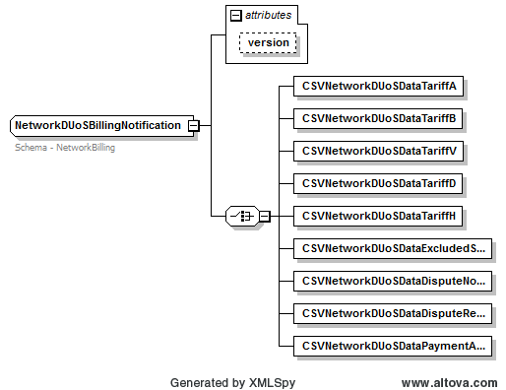

Figure 2-32 NetworkDUoSBillingNotification

Text View

… unmodified text removed for brevity …

<xsd:element name="OutstandingInvoice" type="OustandingInvoiceDetail" maxOccurs="unbounded"/>
<xsd:element name="CreditBalance" type="CreditBalanceDetail" maxOccurs="unbounded"/>
</xsd:choice>
</xsd:complexType>
</xsd:element>
<xsd:element name="Summary" type="ChargeFooter"/>
</xsd:sequence>
</xsd:complexType>
<!-- Transaction Types -->
<xsd:complexType name="NetworkDUoSBillingNotification">
<xsd:annotation>
<xsd:documentation>Schema - NetworkBilling</xsd:documentation>
</xsd:annotation>
<xsd:choice>
<xsd:element name="CSVNetworkDUoSDataTariffA" type="CSVRequestFormat"/>
<xsd:element name="CSVNetworkDUoSDataTariffB" type="CSVRequestFormat"/>
<xsd:element name="CSVNetworkDUoSDataTariffV" type="CSVRequestFormat"/>
<xsd:element name="CSVNetworkDUoSDataTariffD" type="CSVRequestFormat"/>
<xsd:element name="CSVNetworkDUoSDataTariffH" type="CSVRequestFormat"/>
<xsd:element name="CSVNetworkDUoSDataExcludedServices" type="CSVRequestFormat"/>
<xsd:element name="CSVNetworkDUoSDataDisputeNotification" type="CSVRequestFormat"/>
<xsd:element name="CSVNetworkDUoSDataDisputeResolution" type="CSVRequestFormat"/>
<xsd:element name="CSVNetworkDUoSDataPaymentAdvice" type="CSVRequestFormat"/>
</xsd:choice>
<xsd:attribute name="version" type="r34" use="optional" default="r34"/>
</xsd:complexType>
<xsd:complexType name="NetworkInvoiceNotification">
<xsd:annotation>
<xsd:documentation>
Application –

… unmodified text removed for brevity …

Impact Summary

The change for NSW-ACT Retail Gas Project is addition of new Transactions and reports to support market functionalities. However, the change will have no impact as the existing Transaction is not in active use by participant or AEMO systems.

Modified types | Derived types | Versioned types affected | Transactions potentially affected | Schema files affected
GasMasterStandingData (due to networkID and possibility of being used in backwards compatible mode. Originally it was only expected to be forwards compatable!) |  | GasStandingData | MeterReadInputNotification  NMIStandingDataUpdateNotification  AccountCreationNotification  AmendMeterRouteDetails  CATSChangeRequest  CATSDataRequest  CATSNotification  NMIDiscoveryResponse  NMIStandingDataResponse  ServiceOrderResponse | Gas_r34.xsd
GasMeterFixCertification |  | GasServiceOrderDetails | ServiceOrderRequest | Gas_r34.xsd
GasMeterNotification |  | GasMeterNotification | GasMeterNotification | Gas_r34.xsd
GasServiceOrderDetails |  | GasServiceOrderDetails | ServiceOrderRequest | Gas_r34.xsd
ServiceOrderGasCompletionData |  | GasServiceOrderNotificationData | ServiceOrderResponse | Gas_r34.xsd
ServiceOrderGasMeterData |  | GasServiceOrderNotificationData | ServiceOrderResponse | Gas_r34.xsd
NetworkDUoSBillingNotification |  | NetworkDUoSBillingNotification | NetworkDUoSBillingNotification | NetworkBilling_r34.xsd
NetworkID |  | GasStandingData | AccountCreationNotification  AmendMeterRouteDetails  CATSChangeRequest  CATSDataRequest  CATSNotificatio  MeterReadInputNotification  NMIDiscoveryResponse  NMIStandingDataRequest  NMIStandingDataResponse  NMIStandingDataUpdateNotification  ServiceOrderRequest  ServiceOrderResponse | Common_r34.xsd
Transaction |  |  | All Transactions | Transaction_r34.xsd

Developer Test

Test Platforms
The new schema has been tested using the following platforms as advised by ASWG:
- XMLSpy 2011
- MSXML4 SP1
- Xerces 2.9.1 and 2.2.1

Test Cases
Valid Files
NSWGAS_AccountCreationNotification_r34.xml
- Valid Transaction
NSWGAS_AmendMeterRouteDetails_r34.xml
- Valid Transaction
NSWGAS_CATSChangeRequest_r34.xml
- Valid transaction
NSWGAS_CATSNotification_MeterReadType_r34.xml
- Valid transaction
NSWGAS_CATSNotification_r34.xml
- Valid transaction
NSWGAS_CATSObjectionNotification_r34.xml
- Valid transaction
NSWGAS_CATSObjectionRequest_r34.xml
- Valid transaction
NSWGAS_CATSObjectionResponse_r34.xml
- Valid transaction
NSWGAS_CATSObjectionWithdrawal_r34.xml
- Valid transaction
NSWGAS_CompleteMirnListing_r34.xml
- Valid transaction
NSWGAS_ERFTApportionmentPercentageRpt_r34.xml
- Valid transaction
NSWGAS_ERFTBasicConsumptionRpt_r34.xml
- Valid transaction
NSWGAS_ERFTChangeOfStandingDataRpt_r34.xml
- Valid transaction
NSWGAS_ERFTCustomerChurnRpt_r34.xml
- Valid transaction
NSWGAS_ERFTDailyNSLRpt_r34.xml
- Valid transaction
NSWGAS_ERFTDailyToSTTMRpt_r34.xml
- Valid transaction
NSWGAS_ERFTEstimationResultsToNWORpt_xml_r34.xml
- Valid transaction
NSWGAS_ERFTEstimationResultsToUserRpt_r34.xml
- Valid transaction
NSWGAS_ERFTLinepackAndUnaccountedForGasNotification_r34.xml
- Valid transaction
NSWGAS_ERFTReconciliationResultsRpt_r34.xml
- Valid transaction
NSWGAS_ERFTRevisedEstimationResultsToNWORpt-asXML.xml
- Valid transaction
NSWGAS_ERFTRevisedEstimationResultsToUserRpt_r34.xml
- Valid transaction
NSWGAS_ERFTTotalGasInjectedNotification_r34.xml
- Valid transaction
NSWGAS_ERFTTotalGasInjectedRpt_r34.xml
- Valid transaction
NSWGAS_IAITDailyImbalanceNotification_r34.xml
- Valid transaction
NSWGAS_IAITExpiredImbalanceTradeRpt_r34.xml
- Valid transaction
NSWGAS_IAITImbalanceTradeRequest_r34.xml
- Valid transaction
NSWGAS_IAITMatchedImbalanceTradeRpt_r34.xml
- Valid transaction
NSWGAS_IAITParticipantImbalanceAmountRequest_r34.xml
- Valid transaction
NSWGAS_IAITParticipantImbalanceAmountRpt_xml.xml
- Valid transaction
NSWGAS_IAITRevisedImbalanceNotification_Invalid_r34.xml
- Valid transaction
NSWGAS_IAITRevisedImbalanceRpt_r34.xml
- Valid transaction
NSWGAS_int804_v1_erftestimationresultstousersrpt_r34.xml
- Valid transaction
NSWGAS_int805_v1_erftrevisedestimationresultstousersrpt_r34.xml
- Valid transaction
NSWGAS_int806_v1_erftestimationresultstonworpt_r34.xml
- Valid transaction
NSWGAS_int807_v1_erftestimationresultstonworpt_r34.xml
- Valid transaction
NSWGAS_ERFTApportionmentPercentageRpt_r34.xml
- Valid transaction
NSWGAS_int809_v1_erftapportionmentpercentagerpt_r34.xml
- Valid transaction
NSWGAS_int811_v1_efrttotalgasinjectedrpt_r34.xml
- Valid transaction
NSWGAS_int871_v1_erftpremonthlytouserrpt_r34.xml
- Valid transaction
NSWGAS_MarketReportMisingBlockRequest_r34.xml
- Valid transaction
NSWGAS_MeterDataVerifyRequest_r34.xml
- Valid transaction
NSWGAS_MeterDataVerifyResponse_r34.xml
- Valid transaction
NSWGAS_NetworkDUoSBillingNotification_TariffM_Demand_r34.xml
- Valid transaction
NSWGAS_NMIDiscoveryRequest_r34.xml
- Valid transaction
NSWGAS_NMIDiscoveryResponse_HWGasStandingData_r34.xml
- Valid transaction
NSWGAS_NMIDiscoveryResponse_NAGasStandingData_r34.xml
- Valid transaction
NSWGAS_NMIDiscoveryResponse_r34.xml
- Valid transaction
NSWGAS_NMIStandingDataResponse_r34.xml
- Valid transaction
NSWGAS_ServiceOrderRequest_ComplexMeter_r34.xml
- Valid transaction
NSWGAS_ServiceOrderRequest_r34.xml
- Valid transaction
NSWGAS_ServiceOrderRequest_WithCOCNumber_r34.xml
- Valid transaction
NSWGAS_ServiceOrderResponse_MultiMeter_r34.xml
- Valid transaction
NSWGAS_ServiceOrderResponse_NoAcess_r34.xml
- Valid transaction
NSWGAS_ServiceOrderResponse_r34.xml
- Valid transaction
NSWGAS_SpecialReadRequest_2_r34.xml
- Valid transaction
NSWGAS_SpecialReadRequest_r34.xml
- Valid transaction

Invalid Files
NSWGAS_IAITParticipantImbalanceAmountRequest_Invalid_r34.xml
- Invalid transaction

Proposal Assessment

Test
The ASWG ensures that all recommended parsers on relevant platforms can successfully validate the proposed schema.

Test Platforms
Supplied samples have been tested using the following parsers:
- MSXML 4.0 SP1
- Xerces 2.9.1
- Xerces 2.2.1
- XMLSpy 2004

Test Cases
As per section 2.1.5.2

Test Results
<All OK… or note issues>

Conformance Report
The ASWG completes the conformance report validating each proposed new schema file against the published aseXML guidelines.
Schema Filename | Impacted by Item # | Conformance Details
Transactions_r34.xsd | 1 | <Conforms… or note non-conformance>
aseXML_r34.xsd | 1
Common_r34.xsd | 1
CustomerDetails_r34.xsd | 1
Enumerations.xsd | 1
Events_r34.xsd | 1
Gas_r34.xsd | 1
GasMarketWholesale_r34.xsd | 1
Header_r34.xsd | 1
NetworkBilling_r34.xsd | 1
Reports_r34.xsd | 1
Table 3-3, Change Proposal Conformance Details

Issue Register
This section describes any issues that have arisen and any modifications that are made to the original proposal during the Change Process

Status of Issues
Issue# | Item# | Description and Discussion | Status | Resolution
1 | 1
Table 4-4, Issues list

Resolution
The ASWG votes for endorsement of the options identified in section 2, and the voting results are forwarded to AEMO for approval. When 75% of those ASWG members who voted endorse a specific option, this represents an ASWG Recommendation for that option. AEMO will not reject an ASWG Recommendation without first consulting with the ASWG.

ASWG Endorsement (Please refer to r34 Release Notes for details)
The results of the ASWG vote are as follows:
Date of Vote: ??/??/????

Option | # Votes | % Vote
Option 1 (section 2.1)
Option 2 (section 2.2)
Option # (section 2.#)
Abstained
Total Members Present
Table 5-5, ASWG Vote Results

Change Type can be one of - New - Enhancement, or - Bug Fix
This section may be repeated if more than one option is considered
Either ‘Open’ or ‘Closed’

