|  |  |  |
| --- | --- | --- |
| FIVE MINUTE SETTLEMENT –  METERING PROCEDURE CHANGES  (PACKAGE 1) | | |
|  | | |
| ISSUES PAPER | | |
| Published: **October 2018** |  |  |

executive Summary

The publication of this Issues Paper commences the first stage of the Rules consultation process conducted by AEMO to consider amendments to various Metering Procedures under the National Electricity Rules (NER).

In summary, the key proposals involve:

* Changes to various Metering procedures to implement the Five-Minute Settlement Rule.[1]
* Changes to the current profiling arrangements to allow for the profiling of 15 and 30-minute meter data to five-minute intervals.
* Changes to the delivery, format and content contained in the meter data files sent to AEMO:
  + To create efficiencies, from both a system and operational perspective, for Meter Data Providers (MDPs)
  + To create more uniformity between AEMO and other market participants.

AEMO invites stakeholders to suggest alternative options where they do not agree that AEMO’s proposals would achieve the relevant objectives.

AEMO also asks stakeholders to identify any unintended adverse consequences of the proposed changes.

Stakeholders are invited to submit written responses on the changes, issues and questions identified in this paper by 5.00 pm (Melbourne time) on 28 December 2018, in accordance with the Notice of First Stage of Consultation published with this paper.

Contents

executive Summary 2

1. Stakeholder Consultation Process 4

2. Background 4

2.1. NER requirements 4

2.2. Context for this consultation 4

3. profiling meter reads to 5-minute trading intervals 7

3.1. Current Profiling Arrangements 7

3.2. Proposed Profiling Arrangements 8

4. Metering Data Delivery to AEMO 10

4.1. Business-to-Market (B2M) Message Exchange 10

4.2. Interval Meter Data Delivered to MSATS 13

5. Drafting for proposed changes 14

6. Metering Procedures 14

6.1. Metrology Procedures: Part A 14

6.2. Metrology Procedures: Part B 15

6.3. Meter Data File Format (MDFF) Specification NEM12 & NEM13 16

6.4. Retail Electricity Market Glossary and Framework 17

6.5. Meter Data Provision Procedure 17

Summary of Matters for Consultation 18

Appendix A - Glossary 19

# Stakeholder Consultation Process

As required by the NER, AEMO is consulting on various Metering Procedures in accordance with the Rules consultation procedures in rule 8.9.

Note that there is a glossary of terms used in this Issues Paper at Appendix A.

AEMO’s indicative timeline for this consultation is outlined below. Dates may be adjusted depending on the number and complexity of issues raised in submissions and any meetings with stakeholders.

|  |  |
| --- | --- |
| Deliverable | Indicative date |
| Issues Paper published | 31 October 2018 |
| Submissions due on Issues Paper | 28 December 2018 |
| Draft Report published | 30 January 2019 |
| Submissions due on Draft Report | 15 February 2019 |
| Final Report published | 22 March 2019 |

Prior to the submissions due date, stakeholders can request a meeting with AEMO to discuss the issues and proposed changes raised in this Issues Paper.

AEMO has been consulting and intends to continue to consult through the Five-Minute Settlement (5MS) program engagement channels.[2] The relevant engagement channels include:

* Procedures Working group (PWG)
* Systems Working Group (SWG)
* Metering Focus Group (MFG)
* Joint Metering & Systems Focus Group.

# Background

## NER requirements

AEMO is responsible for the establishment and maintenance of metering procedures specified in Chapter 7 except for procedures established and maintained under rule 7.17.

The procedures authorised by AEMO under Chapter 7 must be established and maintained by AEMO in accordance with the Rules consultation procedures.

## Context for this consultation

### Five Minute Settlement

On 28 November 2017 the AEMC made a final rule to align operational dispatch and financial settlement at five minutes, starting 1 July 2021. This will reduce the time interval for financial settlement in the national electricity market from 30 minutes to five minutes.

Price signals that align with physical operations lead to more efficient bidding, operational decisions and investment. Over time, this is expected to lower wholesale costs, which should lead to lower electricity prices than in a market with 30-minute settlement. Wholesale costs make up around one third of a typical electricity bill.

### Implementing Five Minute Settlement

The Rule change requires the collection, storage and delivery of revenue metering data based on five-minute intervals for use in energy settlement, network and retail billing.

From a metering installation capability perspective, the rule requires:

* Type 1, 2, 3 and 7 metering installations to record and provide five-minute data from the commencement date of the rule.
* Type 4 metering installations at transmission network connection points or distribution network connection points where the relevant financially responsible Market Participant is a Market Generator or Small Generation Aggregator to record and provide five-minute data from the commencement date of the rule.
* All other types 4, 5 and 6 meters that are already installed do not need to provide five-minute data at the commencement date. The data from these meters will be profiled to five-minute trading intervals by AEMO using load profiles.
* All new and replacement metering installations, other than type 4A, installed from 1 December 2018 must provide five-minute data from 1 December 2022 at the latest.
* Type 4A metering installations installed from 1 December 2019 must provide five-minute data from 1 December 2022 at the latest.

Because of the Rule change, there are several matters determined in AEMO metering procedures that require review prior to the commencement date, including:

* Metering data management
* Profiling
* Settlements load data aggregations
* Reconciliation reporting
* Service level agreements
* Metering installation provisioning.

### Global settlement

AEMO is cognisant that the Australian Energy Market Commission (AEMC, or Commission) has made a draft rule to introduce a ‘global settlement’ framework for settlement of the demand side of the wholesale electricity market. The draft rule indicates that global settlement would commence on 1 July 2021 to coincide with the start date of five-minute settlement. It would also require AEMO to have updated its relevant procedures by 1 December 2019.

The AEMC’s final determination on global settlement is scheduled to be released in December 2018. AEMO will consult on the metering procedures affected by the final global settlement rule as part of its ‘Metering Procedure Changes - Package 2’ and ‘Metering Procedure Changes - Package 3’, which are scheduled for release in early to mid-2019.

### Structure of AEMO’s Retail Electricity Market Procedures

AEMO’s Retail Electricity Market Procedures refers to several procedures that govern the operation of the retail market.

Figure 2 depicts how the Retail Electricity Market Procedures fit together.

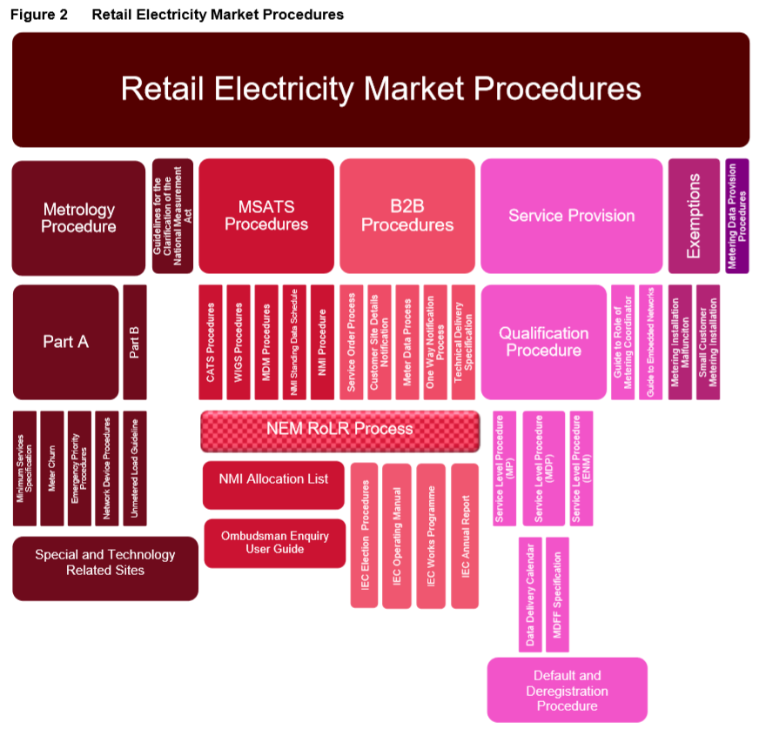

The procedures under consultation in this Metering Procedure Changes Package 1 include:

* Metrology Procedures: Part A
* Metrology Procedures: Part B
* Retail Electricity Market Glossary and Framework
* Meter Data File Format Specification NEM12 & NEM13
* Meter Data Provision Procedure.

These procedures, and associated changes, are described in more detail in Section 6 of this document.

# profiling meter reads to 5-minute trading intervals

Load Profiling is required to determine interval metering data, for settlements for type 6 (‘accumulation’ or ‘basic’) metering installations. The requirements vary from jurisdiction to jurisdiction.

In accordance with section 12.8.2 of Metrology Procedure: Part A[3]:

* Controlled load profiles (CLPs) for each Profile Area must be prepared by AEMO using interval metering data from Controlled Load sample interval meters in accordance with section 11.3.3 and paragraphs (b) and (c).
* The form of profiling that AEMO must use for the metering installations to which the metrology procedure applies, excluding metering installations for Controlled Loads where applicable to a Jurisdiction, is the net system load profile (NSLP).

This section firstly explains the current meter data profiling arrangements. It then sets out AEMO’s proposed changes to profiling to implement the 5MS rule.

## Current Profiling Arrangements

The current profiling arrangements involve two profiling algorithms, which are defined in the Metrology Procedures:

* NSLP – this is used to determine 30-minute energy volumes for accumulation metering (other than those associated with controlled loads in applicable jurisdictions) based on the shape of energy in an area which is not interval metered.
* CLP – this is used to determine 30-minute energy volumes for accumulation metering which is associated with a controlled load in applicable jurisdictions based on a shape determined by a set of sample meters.

The process for calculating the net system load profile is implemented as a series of steps in AEMO’s Meter Data Management (MDM) system, as follows:

1. For each profile area, the energy for the wholesale boundary at each transmission node identifier or ‘TNI’ is determined using 30-minute metering data.
2. The energy associated with all ‘non-wholesale boundary’ meters within the profile area that have 30-minute metering is summed, both for first-tier and second-tier connection points. This includes metering data associated with contestable unmetered loads treated as Type 7 metering installations.
3. The NSLP is determined by subtracting the sum of all 30-minute non-wholesale boundary metering data from the profile area’s wholesale boundary energy volumes. If a CLP has been calculated for the jurisdiction, then the CLP is also “peeled off” the NSLP. The following diagram represents the calculation of the NSLP for a settlement day.

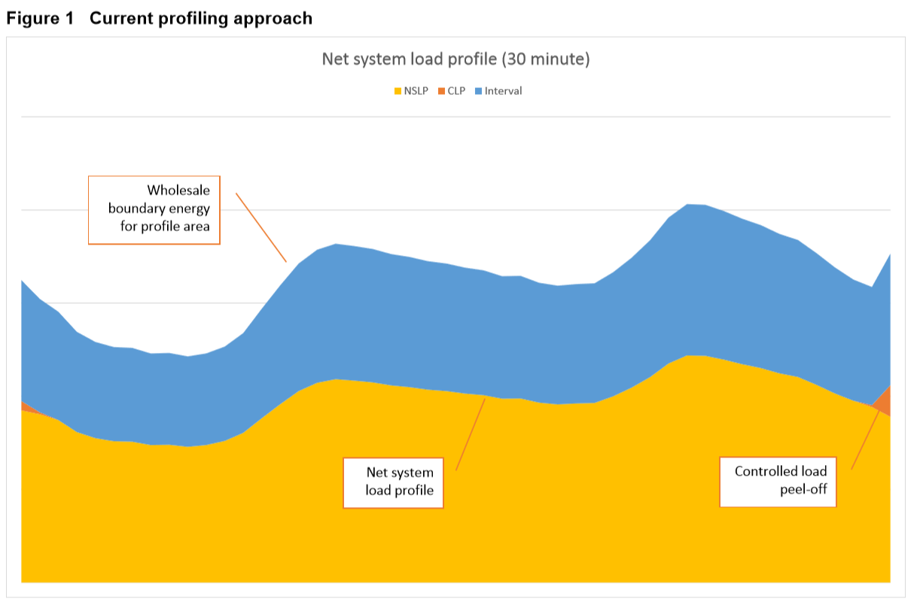

The process of calculating the controlled load profile is performed using the following steps:

1. For each type of controlled load, 30-minute meter data is obtained from sample meters that have been installed at representative connection points.
2. The CLP shape is determined by averaging the energy volumes of the associated sample meters.
3. The CLP is scaled by the total energy volume measured by the accumulation meters that are being profiled by the CLP.

Having prepared both the NSLP and CLP, these profiles are then applied to the energy volumes of all accumulation meters based on the profile type of each data stream.

## Proposed Profiling Arrangements

To support the introduction of five-minute settlement, the profiling arrangements will need to be amended to provide for the following:

* Preparation of load profiles with five-minute granularity for the profiling of 15 and 30-minute interval metering installations and controlled load sample metering installations.
* Application of five-minute load profiles to support the calculation of NSLPs

The process of profiling 15 and 30-minute metering installations is proposed by applying the following steps:

**Part 1** – Preparation of load profiles with five-minute granularity

1. For each profile area, the energy for the wholesale boundary (each TNI) is determined using five-minute metering data.
2. The energy associated with all non-wholesale boundary meters within the profile area that have five-minute metering is summed, both for first-tier and second-tier connection points. This includes metering data associated with contestable Type 7 metering installations. Child connection points for embedded networks are ignored.
3. The energy associated with controlled load sample meters, with 30-minute metering data, is apportioned into 6 equal amounts for each five-minute period. The five-minute controlled load sample meter energy is then summed to determine the ‘Controlled Load Profile’.
4. The energy associated with ‘non-sample’ or basic controlled load meters is summed, both for first-tier and second-tier connection points and then profiled by applying the ‘Controlled Load Profile’ calculated in Step 3.
5. The ’Five-minute load profile’ is then determined by subtracting the sum of all non-wholesale five-minute metering data (calculated in Step 2) and the sum of all controlled load five-minute metering data (calculated in Step 4, where applicable) from the profile area’s wholesale boundary five-minute energy volume (calculated in Step 1).

Formula :

Five-minute load profile = ∑ Wholesale Boundary five-minute metered energy - ∑ Non-Wholesale Boundary five-minute metered energy (including contestable Type 7 metering installations) - ∑ Controlled Load five-minute energy

**Part B** – Application of five-minute load profiles to support the calculation of NSLPs

1. The energy associated with all 15-minute interval meters is summed, both for first-tier and second-tier connection points.
2. The total of the 15-minute metering data (calculated in Step 1) is profiled using the ’Five-minute load profile’ shape (calculated in Step 5 of Part A), which provides a five-minute representation of 15-minute metering data.
3. The energy associated with all 30-minute interval meters is summed, both for first-tier and second-tier connection points.
4. The total of the 30-minute metering data (calculated in Step 3) is profiled using the ’Five-minute load profile’ shape (calculated in Step 5 of Part A), which provides a five-minute representation of 30-minute metering data.
5. The five-minute energy associated with 15 and 30-minute metering data (calculated in Step 6) is subtracted off the energy calculated in Step 4, to derive the net system load profile (NSLP).

|  |
| --- |
| Questions   * What is your view on the proposed profiling approach for 15 and 30-minute non-controlled load meter reads and why? * What is your view on the proposed profiling approach for 30-minute controlled load meter reads and why? * Are there better profiling options to accommodate 5MS, that better achieve the required objectives? What are the pros and cons of these options? How would they be implemented? |

# Metering Data Delivery to AEMO

## Business-to-Market (B2M) Message Exchange

Metering data services are provided by Metering Data Providers (MDPs) under NER 7.10.1, 7.10.3 and 7.15.5[4] and include delivery of metering data and settlements ready data to AEMO.

MSATS is the National Electricity Market’s (NEM) retail system. Meter Data Management (MDM) is the centralised database of metering data within MSATS. This database receives and holds metering data and stores profile information generated internally by MSATS.

MDM accepts and stores all metering data provided to AEMO, which is submitted in the form of metering data notification transactions.

This section firstly explains the current metering data exchange protocols between MDPs and AEMO. It then sets out AEMO’s proposed changes to the protocols to aligning to the B2B processes that are currently used by all other market participants.

### Current Approach

The metering data notification transaction is submitted to MSATS by MDPs in the form of a comma separated values-wrapped aseXML file. There are several validation requirements undertaken on the metering data notification transaction before the data file is accepted by MSATS.

Data is required for all Datastreams in MSATS for any period of time where the Datastream Status Code is set to ‘A’ (Active). MDM stores this data for every Datastream against a certain connection point for settlements purposes.

Business to Market protocols:

* MDPs send Interval and Basic meter reads using the MDM File Format (MDMF).
* Transaction Group of ‘MDMT’ is used to exchange B2M meter read data.
* After meter read validations are performed by AEMO; validation results are delivered to MDPs via variety of acknowledgements as shown below:
  + Message Acknowledgement - aseXML schema validations and file processing validations
  + Transaction Acknowledgement - 1st level validations (only core validations listed):
    - CSV content validation
    - NMI & DataStream suffix validation
    - MDP sending the reads matches the MDP in Standing Data
  + Meter Data Response - 2nd level validations: Replacement read validations.

The following diagram represents the current B2M message exchange between MDPs and AEMO:

|  |
| --- |
| Figure 1 |

### Proposed Approach

AEMO is proposing to transition its current B2M message exchange to more closely align to relevant B2B processes. However, AEMO is not proposing to become a B2B participant. AEMO believes that by unifying the data formats across the industry, it would result in both system and operational efficiencies and reduced new entrant costs.

AEMO proposes to decommission (after a transition period) the existing B2M meter data format and use the same format as B2B (i.e. MDFF).

From a system perspective, this change would ultimately involve AEMO:

* Accepting MDFF (for both Interval & Basic meter reads) & implement new validation rules for MDFF data (MACK, 1st level & 2nd level validations).
* Providing MessageAcknowledgements as a standalone acknowledgement.
* Performing and providing 1st level & 2nd level validations as a single Transaction Acknowledgement (TACK) containing the results of 1st & 2nd level validations, as Retailers currently do.

It is worth noting that AEMO is not proposing to use Provide Meter Data (PMD) or Verify Meter Data (VMD) processes for requesting missing meter data reads. AEMO would instead propose to send participants scheduled RM11 reports to identify missing reads.

The following diagram represents the proposed B2B based message exchange between MDPs and AEMO:

|  |
| --- |
| Figure 2 |

## Interval Meter Data Delivered to MSATS

### Current Arrangements

For interval metering data delivered to MSATS, where the physical meter measures both export and import energy flows, MDPs must ‘Net’ these values prior to sending them to AEMO:

Export (E) – Import (B) = Net (N)

Under Chapter 7 of the NER, MDPs are also obligated to provide AEMO with settlements ready Active (kWh) energy meter reads i.e. reactive or non-energy (kVarh) meter reads are not required to be sent to AEMO.

### Proposed Arrangements

Although not required by the 5MS rule, AEMO is proposing to enhance its systems to support the following metering data being sent to AEMO:

* Register level metering data, if provided by MDPs
  + The objective of this change is to eliminate the need for MDPs to produce net meter data values for settlement purposes. This would reduce, or if universally adopted avoid, different metering data being sent for retail/network billing and market settlement.
* Non-energy metering data, if provided by MDPs
  + The objective of this change is to allow MDPs the option of sending the same metering data files to AEMO as they would other market participants.

AEMO believes that these changes would result in both system and operational efficiencies for MDPs by creating more uniformity between AEMO and other market participants.

|  |
| --- |
| Questions   * What are your views on AEMO transitioning to MDFF and why? * What are your views on AEMO supporting the reception of register level meter data and why? * What are your views on MDPs sending the same files to both market participants and AEMO, energy and non-energy, and why? * What are the main challenges in adopting these proposed changes? How should these challenges be addressed? |

# Drafting for proposed changes

To help stakeholders and other interested parties respond to this Issues Paper, AEMO has published a draft of the procedures included in this consultationincorporating the changes AEMO proposes for consultation. Clean and change-marked versions are available at: http://aemo.com.au/Stakeholder-Consultation.

# Metering Procedures

As mentioned previously, AEMO is responsible for the establishment and maintenance of metering procedures specified in Chapter 7 except for procedures established and maintained under rule 7.17.

This section provides further information regarding the 5MS-related changes that AEMO proposes for each procedure under consultation.

## Metrology Procedures: Part A

The metrology procedure is made in accordance with clauses 7.16.3, 7.16.4 and 7.16.5 of the NER and it is published in two parts, namely:

* Metrology Procedure: Part A - National Electricity Market; and
* Metrology Procedure: Part B - Metering Data Validation, Substitution and Estimation Procedure.

Clause 7.16.3 prescribes the mandatory content, whereas clause 7.16.5 details additional matters that may be addressed in the metrology procedure. Clause 7.16.4 details the process by which AEMO may include jurisdictional metrology material in the metrology procedure, which only applies to type 5, 6 and 7 metering installations.

Metrology Procedure Part A includes:

* Requirements for the provision, installation and maintenance of metering installations
* Obligations on various market participants, including: Metering Coordinators, Financially Responsible Market Participants and Local Network Service Providers
* Responsibilities for metering data services
* Minimum services specification procedures
* Meter churn procedures
* Network devices procedures
* Emergency priority procedures.

At a high level, the proposed changes to this procedure are as follows:

|  |  |
| --- | --- |
| Section | Description |
| 3.9 | The end of each TI must be on the hour (EST) and each continuous period of 5 minutes thereafter. |
| 7 | Removal of South Australia requirement (2), subject to jurisdictional confirmation  Removal of Tasmania requirement (2), subject to jurisdictional confirmation |
| 12.2 (f) | Change to clause reference |
| 12.8.2 (b) | Change in section reference |

## Metrology Procedures: Part B

Metrology Procedure Part B includes:

* The validation and substitution of metering data
* The estimation of metering data
* The method by which accumulated metering data is converted by AEMO into trading interval metering data
* Method by which calculated metering data is produced for unmetered market loads
* Requirements regarding sample meters for controlled loads.

At a high level, the proposed changes to this procedure are as follows:

|  |  |
| --- | --- |
| Section | Description |
| 2.6 | Update to page references |
| 11.2.1 | Update to section reference to Metrology Procedure: Part A |
| 11.2.2 | Update to section reference to Metrology Procedure: Part A |
| 11.2.3 | Update to section reference to Metrology Procedure: Part A |
| 11.3.1 | Update to section reference to Metrology Procedure: Part A  ‘Half hourly’ reference updated to ‘Interval’ |
| 11.3.2 | Update to section references to Metrology Procedure: Part A  Change end dates from ’23:30’ to ‘23:55’ |
| 11.4 | Update to section reference to Metrology Procedure: Part A  ‘Half hourly’ reference in formulas updated to ‘TI’  ‘Half hourly’ reference updated to ‘Five minute’  Updates made to formulas |
| 11.5 | Update to section reference to Metrology Procedure: Part A  Change end dates from ’23:30’ to ‘23:55’ |
| 11.6 | Change end dates from ’23:30’ to ‘23:55’ |
| 12 | New section added to detail the conversion of interval metering data, previous section 12, and following section numbering, have been changed due to this insertion |
| 13.1.4 | Update to section references |
| 13.2.2 | Update to section reference to Metrology Procedure: Part A |
| 13.2.4 | Update to section references  Update to formulas |
| 13.2.5 | Update to formulas |
| 13.2.6 | Update to section references  Update to formulas |
| 13.3 | Update to section references |
| 13.3.2 | Update to section reference to Metrology Procedure: Part A |
| 13.4 | Update to section reference |
| 13.5.2 | Update to section reference to Metrology Procedure: Part A |
| 13.5.4 | Update to section reference  Update to formulas |
| 13.5.5 | Update to formulas |
| 14.1 | Update to section reference |
| 14.3 | Update to section reference |

## Meter Data File Format (MDFF) Specification NEM12 & NEM13

The Meter Data File Format (MDFF) Specification NEM12 & NEM13 specifies the file format requirements for interval metering data (NEM12) and accumulated metering data (NEM13).

The MDFF is used by Metering Data Providers for the provision of metering data to Service Providers and Registered Participants.

At a high level, the proposed changes to this procedure are as follows:

|  |  |
| --- | --- |
| Section | Description |
| 3.3.3 | Included references to five-minute interval metering data |
| 4.3 | NMI data details record (200) - Added ‘5’ to the Interval Length field Definition |
| Appendix H | Section added to include five-minute meter data file example |

## Retail Electricity Market Glossary and Framework

The Retail Electricity Market Glossary and Framework forms part of each of the Retail Electricity Market Procedures.

It contains a dictionary of terms used with the Procedures and a description of each Procedure and supporting documentation, and how they fit together.

At a high level, the proposed changes to this procedure are as follows:

|  |  |
| --- | --- |
| Section | Description |
| 4.4.4 | Removal of NEM12 & NEM13 File Clarifications |
| 5 | Addition of various glossary items, including those from the ‘Meter Data Provision Procedure’ |

## Meter Data Provision Procedure

The Metering Data Provision procedure establishes the minimum requirements for the manner and form in which metering data should be provided to a retail customer (or its customer authorised representative) in response to a request for such data from the retail customer or customer authorised representative.

At a high level, the proposed changes to this procedure are as follows:

|  |  |
| --- | --- |
| Section | Description |
| 1.1 | Changes to NER clause references and minor administrative updates |
| 1.2.1 | Glossary removed and now included in the Retail Electricity Market Procedures – Glossary and Framework document |
| 1.2.2 | Interpretation section removed from the document |
| 1.3 | ‘Retail Electricity Market Procedures – Glossary and Framework’ added as a related document |

# Summary of Matters for Consultation

In summary, AEMO seeks comment and feedback on the following matters:

* AEMO’s proposed approach to profiling 15 and 30-minute interval meter reads:
  + Non-controlled load metering data – being based on a “dynamic” profile.
  + Controlled load profile – applying a simple apportionment of the energy into six equal amounts.
* AEMO more closely aligning metering data delivery to B2B processes.
* AEMO to support receiving register level data streams if they are provided by MDPs
* AEMO to support receiving non-energy data streams if they are provided by MDPs
* Changes to various Metering procedures to support the implementation of the Five-Minute Settlement Rule.

Submissions on these and any other matter relating to the proposals discussed in this Issues Paper must be made in accordance with the Notice of First Stage of Consultation published with this paper by 5.00 pm (Melbourne time) on 28 December 2018.

1. Glossary

|  |  |
| --- | --- |
| Term or acronym | Meaning |
| AEMC | Australian Energy Market Commission |
| B2B | Business to business |
| B2M | Business to market |
| CLP | Controlled load profile |
| MDP | Metering Data Provider |
| MSATS | Market Settlements and Transfer Solution |
| NER | The National Electricity Rules made under Part 7 of the National Electricity Law. |
| NSLP | Net System Load Profile |
| Profile Area | A geographical area comprising a group of one or more TNIs for which a single NSLP is calculated. If part of an LNSP local area is located within the local area of another LNSP, that part of the local area of the first LNSP is considered to be part of the profile area of the second LNSP. |
| TNI | Transmission Node Identifier |

1. Australian Energy Market Commission: https://www.aemc.gov.au/rule-changes/five-minute-settlement
2. See : http://www.aemo.com.au/Electricity/National-Electricity-Market-NEM/Five-Minute-Settlement for details on forums and groups specific to the 5MS program.
3. AEMO. December 2017. http://aemo.com.au/-/media/Files/Electricity/NEM/Retail_and_Metering/Load_Tables/Metrology-Procedure-Part-A-v604.pdf
4. AEMC. https://www.aemc.gov.au/sites/default/files/2018-10/NER%20-%20v113%20-%20Chapter%207.PDF