aseXML SCHEMA CHANGE REQUEST - CR63

August 2018

Life Support
Change request document for Life Support related schema objects

Version Control
Version | Release date | Changes
#1.0 | 15/07/2018 | Initial request
#1.1 | 07/08/2018 | Modified for life support equipment type enumerated list in ElectricityEnumerations.xsd file
#1.2 | 12/10/2018 | Finalised for publication

Contents
Executive Summary 2
1. Heading 1 2
1.1 Heading 2 2
A1. Appendix Heading 1 2
A1.1 Appendix heading 2 2
Glossary 2
Toolbox 2

Tables
Table 1 AEMO1 Table style 2
Table 2 AEMO1 Table style with banded columns 2
Table 3 AEMO2 Table style with first column shown (columns and rows can be banded) 2
Table 4 AEMO3 Table style with first column shown (columns and rows can be banded) 2

Figures
Figure 1 Figure title 2

1 Change Proposal 3
1.1 Description of the proposed change 3
1.1.1 First change description 3
1.1.2 Second change description 3
1.2 Reason for Change 3
1.3 Supplied Documents 3
1.3.1 Business process document 3
1.3.2 Other 3
1.4 Baseline Schema 3
2 Approval Proposal 3
2.1 Proposed Change #1 3
2.1.1 Draft schema 3
2.1.2 Change log 3
2.1.3 Schema change description 3
2.1.4 Impact Summary 3
2.1.5 Developer Test 3
3 Proposal Assessment 3
3.1 Test 3
3.1.1 Test Platforms 3
3.1.2 Test Cases 3
3.1.3 Test Results 3
3.2 Conformance Report 3
4 Issue Register 3
4.1 Status of Issues 3
5 Resolution 3
5.1 ASWG Endorsement 3

Tables
Table 1-1, Proposed Changes 4
Table 2-1 Change Log 5
Table 2-2, Impact Summary 6
Table 3-1, Change Proposal Conformance Details 7
Table 4-1, Issues list 8
Table 5-1, ASWG Vote Results 8

Figures
Figure 2-1 Test Figure 5

Change Proposal
This Change Proposal is to implement Life Support transactions for Electricity and Gas Retail market usage.

Description of the proposed change
The proposed changes are listed in the following table.
Item# | Change Description | Change Type
1 | Add LifeSupportRequest transaction. | New
2 | Add LifeSupportNotification transaction. | New
3 | Add LifeSupportData complex type for use in LifeSupportNotification  transactions | New
4 | Add LifeSupportStatus simple type as enumerated list for use in LifeSupport transactions | New
5 | Add LifeSupportType as simple type as enumerated list for use in LifeSupport transactions | New
6 | Add LifeSupportRequestReason as simple type as enumerated list for use in LifeSupport transactions | New
7 | Add ContactMethod simple type as enumerated list | New
8 | Add UpdateReason simple type as enumerated list | New
Table 1-1, Proposed Changes

Reason for Change
- Enable retailers and network operators to request and transmit details on customers using life support equipment.

Supplied Documents

Other
aseXML_r38.zip

Baseline Schema
The schema used as a basis for this proposal is v37

Approval Proposal

Proposed Change #1

Draft schema
Draft aseXML_r38

Change log
The following changes have been implemented in this draft:
Chg # | Item # | Description of change | Filename
1 |  | Updated schema namespace to ‘urn:aseXML:r38’.  Updated Transactions schema to Transactions_r38.xsd  Updated CustomerDetails schema to CustomerDetails_r38.xsd  Updated Events schema to Events_r38.xsd | aseXML_r38.xsd
2 | 3,4 | Added the following element choices for new transactions.  - LifeSupportRequest  - LifeSupportNotification | Transactions_r38.xsd
3 | 1,2,3,4 | Added r38 release identifier in the Event schema.  File version changed from r37 to r38 | Events_r38.xsd
4 | 1,2 | Add the following simple types  - LifeSupportStatus as enumerated list  - LifeSupportRequestReason as enumerated list  - UpdateReason as enumerated list  - ContactMethod as enumerated list  Add the following complex types  - LifeSupportData  Add the following complex types for new transactions  - LifeSupportRequest  - LifeSupportNotification | CustomerDetails_r38.xsd
5 |  | Add the following simple types  - LifeSupportEquipmentType as enumerated list | ElectricityEnumerations.xsd
Table 2-1 Change Log

Schema change description

aseXML_r38.xsd
- Updated schema namespace to ‘urn:aseXML:r38’.
- Updated Transactions schema to Transactions_r38.xsd
- Updated CustomerDetails schema to CustomerDetails_r38.xsd
- Updated Events schema to Events_r38.xsd

Transactions_r38.xsd
- Modify Transaction complex type:
- Add LifeSupportRequest element
- Add LifeSupportNotification element

Events_r38.xsd
- Add r36 release identifier
<xsd:simpleType name="r38">
<xsd:annotation>
<xsd:documentation>Purpose - Release r36 identifier.</xsd:documentation>
</xsd:annotation>
<xsd:restriction base="ReleaseIdentifier">
<xsd:enumeration value="r38"/>
</xsd:restriction>
</xsd:simpleType>

CustomerDetails_r38.xsd
- Add simple type LifeSupportStatus as enumerated list
<xsd:simpleType name="LifeSupportStatus">
<xsd:annotation>
<xsd:documentation>
Purpose - Define the fixed Life support status used in Life Support notification
</xsd:documentation>
</xsd:annotation>
<xsd:restriction base="xsd:string">
<xsd:enumeration value="Registered - No Medical Confirmation"/>
<xsd:enumeration value="Registered - Medical Confirmation"/>
<xsd:enumeration value="Deregistered - No Medical Confirmation"/>
<xsd:enumeration value="Deregistered - Customer Advice"/>
<xsd:enumeration value="Deregistered - No Customer Response"/>
<xsd:enumeration value="None"/>
</xsd:restriction>
</xsd:simpleType>

- Add simple type LifeSupportEquipmentType as enumerated list
<xsd:simpleType name="LifeSupportEquipmentType">
<xsd:annotation>
<xsd:documentation>
Purpose - Define the fixed Life support equipment types used in Life Support notification
</xsd:documentation>
</xsd:annotation>
<xsd:restriction base="xsd:string">
<xsd:enumeration value="Oxygen Concentrator"/>
<xsd:enumeration value="Intermittent Peritoneal Dialysis Machine"/>
<xsd:enumeration value="Kidney Dialysis Machine"/>
<xsd:enumeration value="Chronic Positive Airways Pressure Respirator"/>
<xsd:enumeration value="Crigler Najjar Syndrome Phototherapy Equipment"/>
<xsd:enumeration value="Ventilator For Life Support"/>
<xsd:enumeration value="Other"/>
</xsd:restriction>
</xsd:simpleType>

- Add simple type LifeSupportRequestReason as enumerated list
<xsd:simpleType name="LifeSupportRequestReason">
<xsd:annotation>
<xsd:documentation>
Purpose - Define the fixed Life support request reasons for a Life Support Request
</xsd:documentation>
</xsd:annotation>
<xsd:restriction base="xsd:string">
<xsd:enumeration value="Confirm Life Support"/>
<xsd:enumeration value="Data Quality Issue"/>
<xsd:enumeration value="No response to rejected LSN"/>
<xsd:enumeration value="Other"/>
</xsd:restriction>
</xsd:simpleType>

- Add simple type UpdateReason as enumerated list
<xsd:simpleType name="UpdateReason">
<xsd:annotation>
<xsd:documentation>
Purpose - Define the reasons for provision of details notification.
</xsd:documentation>
</xsd:annotation>
<xsd:restriction base="xsd:string">
<xsd:enumeration value="Update"/>
<xsd:enumeration value="Reconciliation"/>
</xsd:restriction>
</xsd:simpleType>

- Add simple type ContactMethod as enumerated list
<xsd:simpleType name="ContactMethod">
<xsd:annotation>
<xsd:documentation>
Purpose - Define the basic set of contact methods.
</xsd:documentation>
</xsd:annotation>
<xsd:restriction base="xsd:string">
<xsd:enumeration value="Postal Address"/>
<xsd:enumeration value="Site Address"/>
<xsd:enumeration value="Email Address"/>
<xsd:enumeration value="Phone"/>
</xsd:restriction>
</xsd:simpleType>

Add the following complex types
- LifeSupportData
<xsd:complexType name="LifeSupportData">
<xsd:sequence>
<xsd:element name="NMI" type="NMI"/>
<xsd:element name="SiteAddress" type="Address" minOccurs="0"/>
<xsd:element name="Reason" type="UpdateReason"/>
<xsd:element name="RegistrationOwner" type="YesNo" minOccurs="0"/>
<xsd:element name="Status" type="LifeSupportStatus"/>
<xsd:element name="DateRequired" type="xsd:date" minOccurs="0"/>
<xsd:element name="Equipment" type="LifeSupportEquipmentType" minOccurs="0"/>
<xsd:element name="ManagementContactDetail" type="CustomerDetail" minOccurs="0"/>
<xsd:element name="PreferredContactMethod" type="ContactMethod" minOccurs="0"/>
<xsd:element name="SpecialNotes" type="SpecialComments" minOccurs="0"/>
<xsd:element name="LastModifiedDateTime" type="xsd:dateTime"/>
</xsd:sequence>
</xsd:complexType>
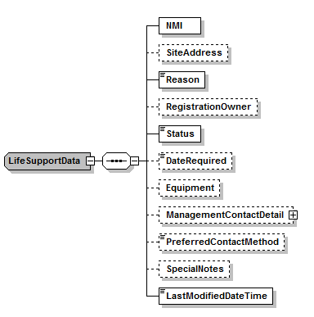

- Add the following complex types for new transaction LifeSupportRequest
<xsd:complexType name="LifeSupportRequest">
<xsd:annotation>
<xsd:documentation>NEM - B2B Electricity - Fully XML tagged; Transaction Group: CUST; Purpose: Request Life support Details- National Electricity B2B Process - Tranche 1 Build Pack </xsd:documentation>
</xsd:annotation>
<xsd:sequence>
<xsd:element name="NMI" type="NMI"/>
<xsd:element name="Reason" type="LifeSupportRequestReason"/>
<xsd:element name="SpecialNotes" type="SpecialComments" minOccurs="0"/>
</xsd:sequence>
<xsd:attribute name="version" type="r38" use="optional" default="r38"/>
</xsd:complexType>
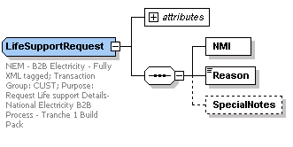

- Add the following complex types for new transaction LifeSupportNotification
<xsd:complexType name="LifeSupportNotification">
<xsd:annotation>
<xsd:documentation>NEM - B2B Electricity - Fully XML tagged; Transaction Group: CUST; Purpose: Notify change of Life support Details- National Electricity B2B Process - Tranche 1 Build Pack </xsd:documentation>
</xsd:annotation>
<xsd:choice>
<xsd:element name="LifeSupportData" type="LifeSupportData"/>
</xsd:choice>
<xsd:attribute name="version" type="r38" use="optional" default="r38"/>
</xsd:complexType>

ElectricityEnumerations.xsd

- Add simple type LifeSupportEquipmentType as enumerated list
<xsd:simpleType name="LifeSupportEquipmentType">
<xsd:annotation>
<xsd:documentation>
Purpose - Define the fixed Life support equipment types used in Life Support notification
</xsd:documentation>
</xsd:annotation>
<xsd:restriction base="xsd:string">
<xsd:enumeration value="Oxygen Concentrator"/>
<xsd:enumeration value="Intermittent Peritoneal Dialysis Machine"/>
<xsd:enumeration value="Kidney Dialysis Machine"/>
<xsd:enumeration value="Chronic Positive Airways Pressure Respirator"/>
<xsd:enumeration value="Crigler Najjar Syndrome Phototherapy Equipment"/>
<xsd:enumeration value="Ventilator For Life Support"/>
<xsd:enumeration value="Other"/>
</xsd:restriction>
</xsd:simpleType>

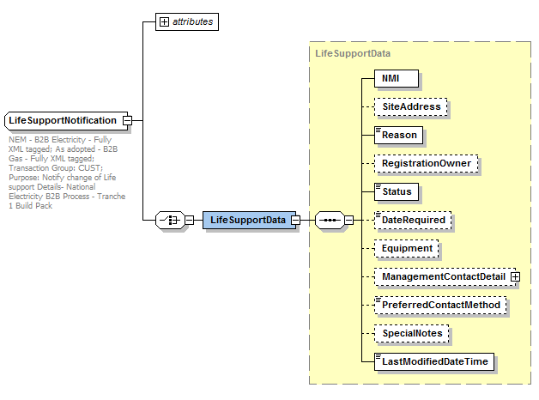

Impact Summary
This table identifies the files, transactions and versioned types that are potentially impacted as the result of these changes, where:
- Modified types - is a full list of types changed by this Change Request
- Derived types – is a list of any types that are derived from a modified type, and are therefore also modified by default
- Versioned types affected – is a list of all versioned types that will need to have the version attribute updated as a result of this Change Request
- Transactions potentially affected – is a list of all transactions that contain a modified type, either directly or via a type substitution
- Schema files affected – is a list of schema files that will be changed in some way as a result of this Change Request.

Modified types | Derived types | Versioned types affected | Transactions potentially affected | Schema files affected
r38 |  |  |  | Events_r38.xsd
 |  |  |  | aseXML_r38.xsd
Table 2-2, Impact Summary

Developer Test

Test Platforms
The new schema has been tested using the following platforms as advised by ASWG:
- XMLSpy 2014

Test Cases
NEMB2B_LifeSupportNotification_Deregistered_r38.xml
NEMB2B_LifeSupportNotification_None_r38.xml
NEMB2B_LifeSupportNotification_Reconciliation_r38.xml
NEMB2B_LifeSupportNotification_Update_r38.xml
NEMB2B_LifeSupportRequest_Other_r38.xml
NEMB2B_LifeSupportRequest_r38.xml

Proposal Assessment

Test
The ASWG ensures that all recommended parsers on relevant platforms can successfully validate the proposed schema.

Test Platforms
Supplied samples have been tested using the following parsers:
- XMLSpy 2010
- MSXML6
- Xerces 2.2.1 and 2.9.1

Test Cases
As per section 2.1.5.2

Test Results
No issues.

Conformance Report
The ASWG completes the conformance report validating each proposed new schema file against the published aseXML guidelines.
Schema Filename | Impacted by Item # | Conformance Details
aseXML_r*.xsd |  | Conforms.
Table 3-1, Change Proposal Conformance Details

Issue Register
This section describes any issues that have arisen and any modifications that are made to the original proposal during the Change Process

Status of Issues
Issue# | Item# | Description and Discussion | Status | Resolution
1
Table 4-1, Issues list

Resolution
The ASWG votes for endorsement of the options identified in section 2, and the voting results are forwarded to AEMO for approval. When 75% of those ASWG members who voted endorse a specific option, this represents an ASWG Recommendation for that option. AEMO will not reject an ASWG Recommendation without first consulting with the ASWG.

ASWG Endorsement
The results of the ASWG vote are as follows:
Date of Vote: 12/10/2018

Option | # Votes | % Vote
Approved | 4 | 100
Rejected | 0
Abstained | 0
Total Members Present | 4
Table 5-1, ASWG Vote Results

Glossary
Term | Definition

Change Type can be one of - New - Enhancement, or - Bug Fix
This section may be repeated if more than one option is considered
Either ‘Open’ or ‘Closed’

